**AQA COMP4**

**PRACTICAL PROJECT**

**JAMES CURRAN**

**9152**

**ILFORD COUNTY HIGH SCHOOL**

CONTENTS

1. Analysis
   1. Company background 3
   2. Current system 3
   3. Prospective end user(s) 6
   4. User needs and limitations 6
      1. Analysis of questionnaire for teachers 6
      2. Analysis of questionnaire for students 7
      3. Summary of needs and limitations 9
   5. Data flow 9
      1. Current system 9
      2. Proposed system 13
      3. Process details 15
   6. Data dictionary of current system 16
      1. Data sources and destinations 17
   7. Possible solutions 18
   8. Data volumes 19
      1. Current system 19
      2. Proposed system 19
   9. Proposed system objectives 19
2. Design
   1. System overview
   2. Modular structure
   3. Data dictionary of proposed system
      1. Variables to be used
      2. Field validation
   4. Program and data storage; file organisation; system compatibility
   5. Proposed algorithms
   6. Classes used
      1. Class diagrams
      2. Brief field and method descriptions
   7. Planned user interfaces
   8. Security
   9. Test plan
      1. Validation
      2. Navigation
      3. Logic
   10. Prototype
       1. Changes made
       2. Prototype source code
3. Technical Solution
4. Testing
   1. Validation
   2. Navigation
   3. Logic
5. Appraisal
   1. Meeting objectives
   2. User feedback
   3. Feedback analysis
   4. Possible extensions
6. Appendix (includes User Manual; Maintenance Guide)
7. Bibliography

1: Analysis

1.1: Company background

Ilford County High School (Figure 1.1) is a medium-sized selective grammar school, sixth form and science college for boys aged 11-18, situated in Barkingside, Redbridge, and Essex. The school admits about 200 students each year. Its sister school, also in Redbridge, is Woodford County High School in Woodford Green.

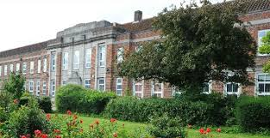Established in 1901 as Park High Grade School, it started off mixed but the girls’ section broke off in 1929. The school is frequently rated as “Outstanding” in Ofsted inspections. Notable former pupils include footballer Sir Trevor Brooking and Kenneth Allen, a Professor of Nuclear Physics at the University of Oxford.

Figure 1.1: Ilford County High School

Most subjects are taught at the school, and teaching is divided into departments for each subject taught. The school’s chemistry department has a particularly high intake due to the majority of students wishing to study medicine. The head of department, Mrs Wardrope, oversees four other teachers and two laboratory assistants. Classes number approximately thirty students each.

1.2: Current system

The chemistry department’s methods of teaching the topic of chemical equilibrium reactions are quite traditional – they have been described by the head of department as ‘chalk and talk’, with information from slideshows produced by the department or textbooks as a teaching aid. Some teachers supplement their lessons with additional media that they have found or produced, such as worksheets or animations.

Because of the nature of the current system, it is essential to observe it first-hand. It was observed that the two main things teachers teach in this topic are how chemical reactions typically work, and the effect of changing conditions such as concentration on a given reaction. These are demonstrated via four main methods:

* Using a specific, real-life example helps students to visualise a reaction and understand it more clearly, as well as engaging them and broadening their knowledge
* 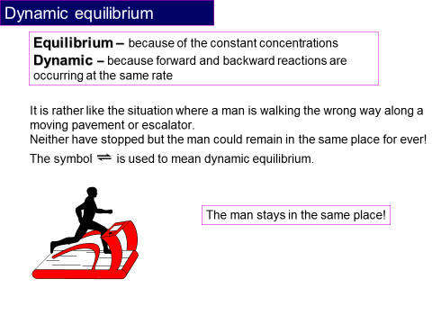Explaining the general principles of equilibrium reactions gives students the basic knowledge that they need to work with any given reaction
* Analogies(see figure 1.2) help to clarify the chemical principles by likening them to things that the students find easier to understand
* Practical exercises allow students to experience what happens during an equilibrium reaction first-hand. The school provide the necessary equipment and chemicals, and give students instructions to follow. For key stage 5 students, practical exercises are devised based on those listed in the ILPAC (Independent Learning Project for Advanced Chemistry) textbook, such as the experiments printed in item 1 of the Appendix. Sometimes they are adjusted to use cheaper chemicals, or ones which react more quickly in the case of experiment 6.2. The experiment is often followed by questions like those shown, to test students’ understanding. Practical exercises are rarely performed because it is difficult to obtain the required conditions (for example, an airtight reaction vessel is ideal).

Figure 1.2: An example of an analogy, used in slideshows produced by the department

The focus of this analysis is on the first two methods, with an aim to improve them. For students studying at A2 level, it is necessary to teach how to calculate the equilibrium constant of a reaction.

In the first case, the inputs are the reactants, products and sometimes the catalyst of an actual reaction. These can be an example from the textbook, or a reaction that the teacher is familiar with. The teacher goes through these processes:

* Finding the formulae of the input chemicals. If the input is given as a formula, the teacher can write the formula without any extra processing. If the input is given as a systematic chemical name (e.g. phenylethene), the teacher uses this information to deduce the formula and write it. If the input is given as a trivial name (e.g. styrene), the teacher finds out the systematic name, if it is not already known, and then deduces the formula.
* Writing the equilibrium equation and reaction data on the board, for the class to see. Equilibrium equations are always written in the form

Reactants ** **Products

where a + separates the formulae of each reactant or product in the equation. When a catalyst is involved, its formula is generally written above or below the double arrow. In general, the teacher will use their knowledge to check that the equation is valid before moving on, but it is sometimes more necessary to know what happens in the reaction rather than its equation. The teacher will often ‘balance’ the equation by adding numbers to the beginning of certain formulae according to their stoichiometric ratio, so that both sides of the equation have the same number of each type of atom. This is necessary when the reaction’s equilibrium constant (Kc) will be calculated.

* Using their knowledge of this topic to deduce what happens during the reaction – reactants react and become products; simultaneously, products react and become reactants. As reactants react, their concentration decreases, and the product concentration increases. However, the decline in concentration is slowed by the conversion of products into more reactants. Later in the reaction, the reactant concentration becomes low enough, and the product concentration becomes high enough, for the concentrations on both sides of the equation to become constant because they are being converted into each other at the same rate. This is what is meant when the reaction is said to be ‘at equilibrium’.
* Calculation of Kc, for higher-level students. This is most often worked through with the students, rather than calculated by the teacher or already known. This and related mathematical calculations are performed using calculators. The calculation of Kc is explained in detail in section 2.5.

In the second case, the input is a change in conditions in an existing reaction. This input comes from the teacher when introducing the topic, but could be suggested by a student in a later lesson. The teacher uses their knowledge to deduce how a reaction with this change compares to the original – the main principle is that the equilibrium position shifts to counteract a change, which increases the rate of one of the reactions.

* When increasing temperature, the rate of the reaction which lowers the temperature is increased. Depending on which reaction lowers the temperature, the concentration of reactants will increase and that of the products will decrease, or vice versa. The opposite will happen if the temperature is decreased. Temperature is the only condition which affects Kc, and it is proportionate to Kc.
* Increasing the concentration (for non-gases) or pressure (for gases) of the reactants causes an increase in the rate of production of products (and vice versa) until the original concentrations or pressures are restored, so that the value of Kc does not change. The opposite happens if one of these conditions is decreased.
* Adding a catalyst allows particles to react which normally would not have enough energy. As a result, concentrations increase and decrease more quickly, so equilibrium is reached more quickly. Increasing the concentration of the catalyst increases the effect.

The output in both cases is verbal information relayed by the teacher to the students, explaining what is happening and why. This tends to be illustrated by diagrams providing an abstraction of the reaction, and/or graphs of concentration of the reactants and products. In the case of changing conditions, diagrams and graphs of a reaction with the change may be compared with those of the same reaction without that change. There may also be questions asked (such as ‘Why did this happen?’, or ‘What would be different if this condition changed?’) to consolidate students’ understanding. Students are encouraged to copy what they have learnt into their exercise books, so that they can be referred to in future lessons or during revision.

The head of department has explained that teachers can demonstrate the basic concept of equilibrium reactions effectively, but the problem is that they find it difficult to get students to visualise the equation process and the effect of changing conditions. The supplementary media mentioned above is found by other teachers to have little scope for customization, to demonstrate different real-life examples.

1.3: Prospective end user(s)

The main end users of this project will be the teachers and students in this school.

I will mainly be working with Mrs Wardrope, as well as the other teachers in the department. Each teacher is in charge of five classes, and there are eight classes in years 11 to 13, where reversible reactions are included in the curriculum. In the classroom, their role is to teach the students the information in the curriculum and help them with points that they don’t understand. A solution should help the teachers to do this in some way.

I will also be distributing questionnaires to the students, as a solution would be used for the teachers to help the students. The role of the students is to do the class work and homework set by the teacher, as well as take in information delivered by the teacher, generally by taking notes. They also need to revise for upcoming tests and exams, and a solution may be useful as revision material.

A solution to the problem could be used by teachers and students in other institutions as well.

1.4: User needs and limitations

The information in this section was compiled from questionnaires distributed to teachers and students. Copies of all received questionnaires can be seen in the appendix (items 2 to 9).

1.4.1: Analysis of questionnaire for teachers

This questionnaire was distributed to all five teachers in the Chemistry department and returned by three of them.

Question 1: Most difficult area(s) of the topic to teach

The most common answers to this question were that students had difficulty visualising the concepts and distinguishing between rate and equilibrium. These answers suggest the usefulness of a simulation in aiding teachers and students. It was also stated that students have difficulty using the chemical equations to solve related problems – it may help to add functionality for solving basic problems using input data.

Question 2: IT usage

All teachers answered that they were able to use computers and judged themselves to have an above average IT ability. Most teachers stated that they were used to educational programs, slideshow software and the most popular Internet browsers.

Question 3: Features of educational software

Frequently suggested features were animation, pictures, reaction graphs, simulation and adjustable conditions. This makes it clear to me that the department is particularly interested in a simulation.

Question 4: Factors which make teaching difficult

One of the factors mentioned was students’ “inability to visualise or understand what is taking place in the reaction”.

1.4.2: Analysis of questionnaire for students

This questionnaire was distributed to seven randomly-selected students in the school, in years 11-13. Five students returned the questionnaire.

Question 1: Key stage

The questionnaire was answered by more students in key stage 5 than 4, so the information provided by the key stage 4 students should hold slightly more weight.

Question 2: Understanding of areas of the subject

Students tended to strongly agree that they already had a solid understanding of the concept of reversible reactions and what happens to them when they reach equilibrium, in a slight contrast with the teachers’ answers. This means that there can be less focus on explaining these topics.

A modal answer could not be determined from the range of answers given on the subject of calculation. When also taking into account the teachers’ opinions on students’ ability to solve related problems, it is clear that the project should be able to perform calculations and output each step of the calculation as well as the results.

Students tended to claim strong understanding of the effects of changes in conditions on an existing reaction, which conflicts with the teachers’ interest in adjustable reaction conditions. It is possible that students outside the sample are less able to understand this point and so this feature should be included.

Figure 1.3: The range of understanding of graphs in the sample

Constructing graphs based on reaction data appears to be the area students find most difficult.

Question 3: IT usage

All students answered that they were able to use computers. When asked to judge their level of ability there was a range of answers, but no one answered “Poor”. All students said they were most used to using the slideshow and word processing software installed on the school computers, and most teachers felt the same way, so software which has a similar user interface to the software they use already would make the project much easier to use.

Figure 1.4: The range of IT ability in the sample

Question 4: Features of educational software

The majority of students mentioned reaction graphs as features they would like to see. Teachers also expressed an interest in the project displaying graphs of reactions. The gathered data makes it very clear that reaction graphs should be a major feature in the project.

Question 5: Factors which impede learning

A significant amount of factors were mentioned by the students in the sample, but none which would prevent them from using a solution. One student mentioned their class’ ‘limited’ amount of practical lessons due to room changes, suggesting that students would benefit from software which mimics a practical exercise.

1.4.3: Summary of needs and limitations

From the information given, the end users’ needs are a system which helps students to understand and visualize the concept and process of reversible reactions, and use equation data to solve problems related to them. The end users also need a low-level user interface. Teachers evidently want this to be done primarily through visuals, which tends to engage students, and students seem like they would benefit from understandable graphs and animations.

The teachers have some limitations. In general teachers did not describe their IT ability as ‘excellent’, so a complex or higher-level interface would not be advisable. Teachers are also slightly limited by the reduction of lesson time by fifteen minutes to one hour, making for less teaching time per week. This makes it difficult to convey enough information in the time frame.

As for the students’ limitations, a variety of IT ability was reported, meaning that a complex or high-level interface is definitely not viable. Furthermore, the room changes for some classes mean that the solution should be easily accessible for use in whichever room the class is in. This is best achieved by being able to run the program on the interactive whiteboards that each room has.

1.5: Data flow

1.5.1: Current system

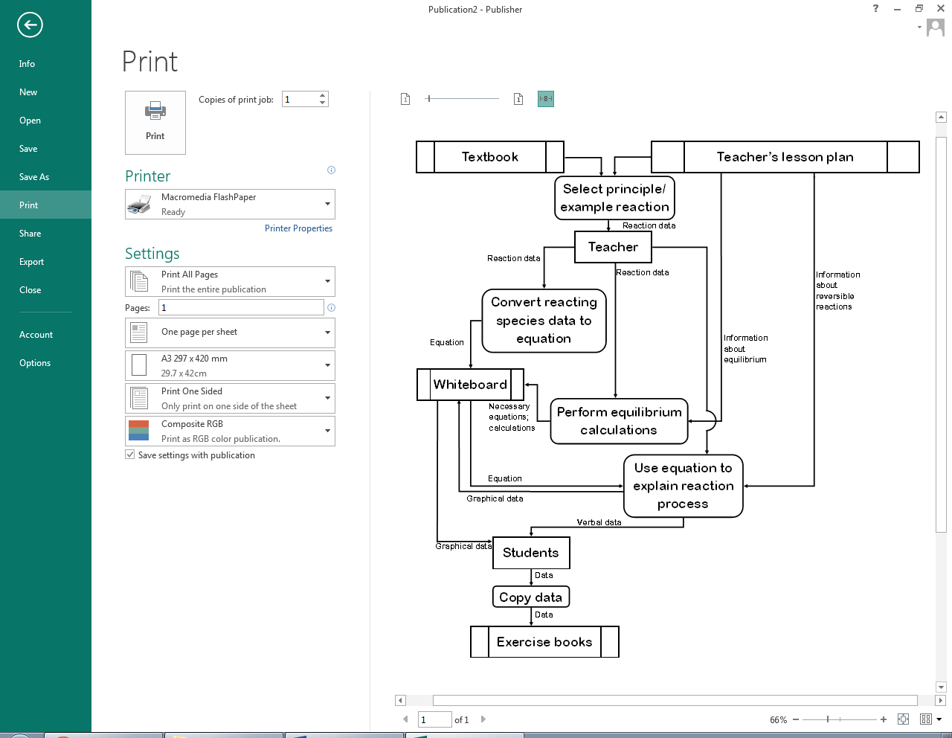

Figure 1.5: Current data flow when demonstrating equilibrium reactions and/or calculations

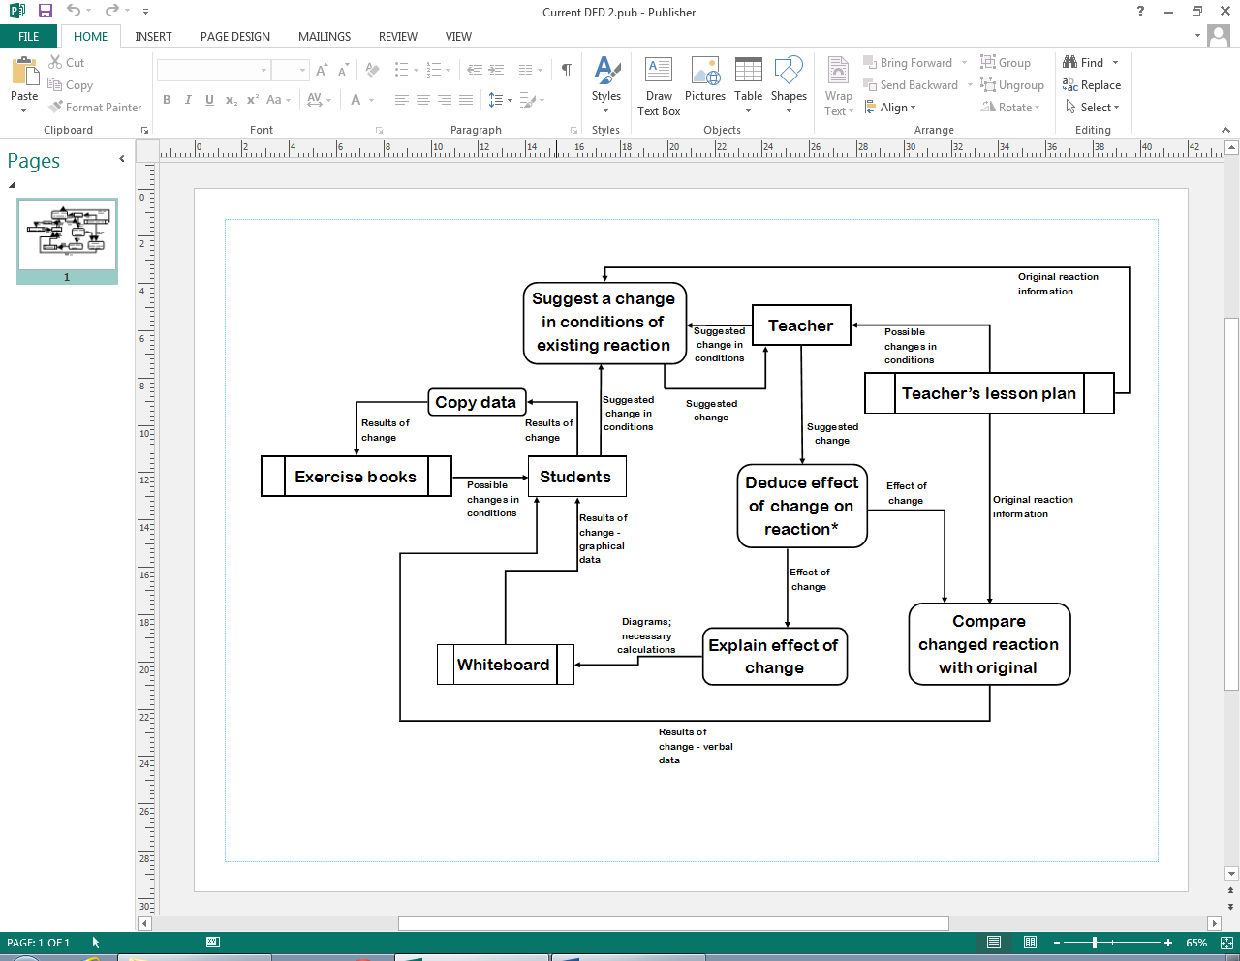

Figure 1.6: Current data flow when demonstrating changes in conditions of an equilibrium reaction.

*See figure 1.7

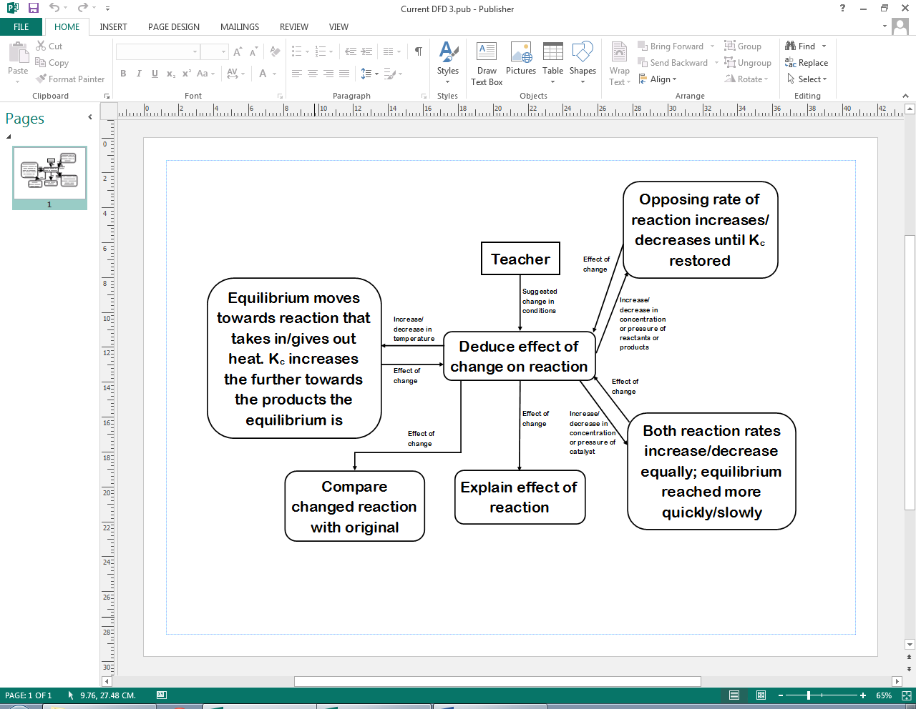

Figure 1.7: In-depth view of the “Deduce effect of change” process in Figure 1.6.

1.5.2: Proposed System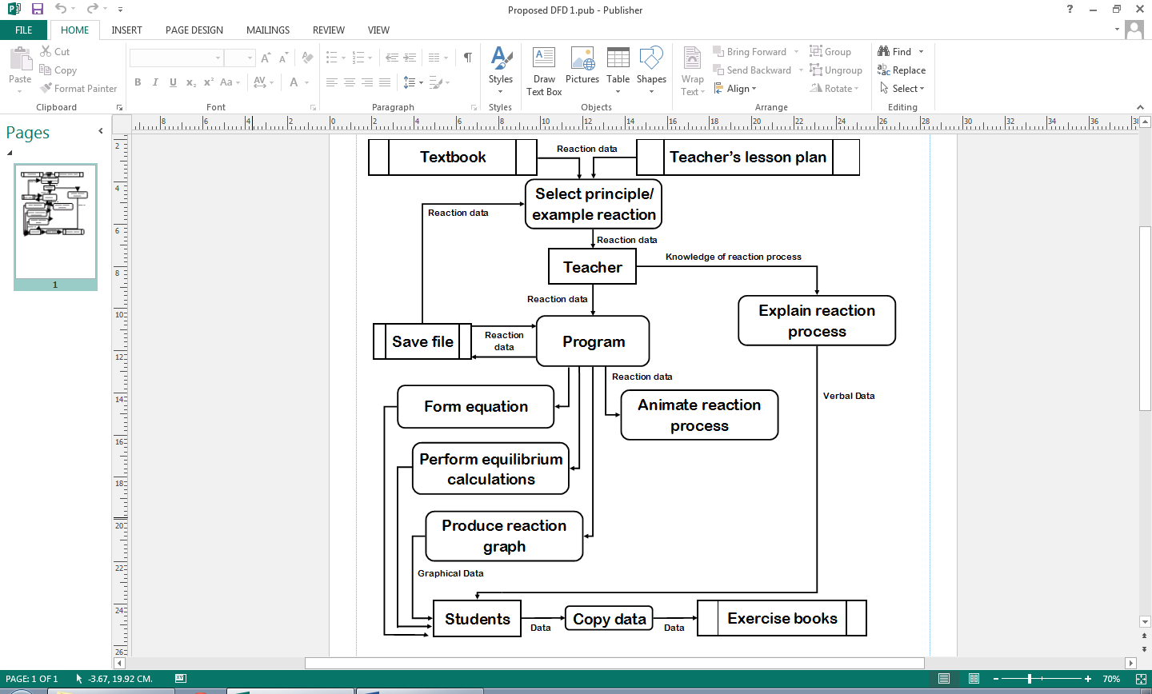

Figure 1.8: Proposed data flow when demonstrating equilibrium reactions and/or calculations.

1.5.3: Process Details

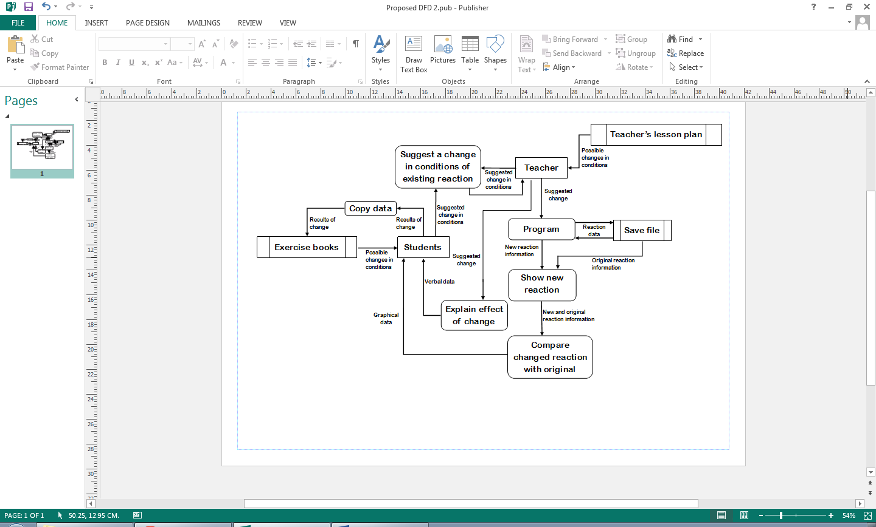This section is a more detailed explanation of the processes involved in the preceding diagrams.

Figure 1.9: Proposed data flow when demonstrating changes in conditions of an equilibrium reaction.

* Select principle/example reaction: if the teacher wishes to teach in general terms then they will teach in terms of reactants A and B and products C and D. They could instead teach using a real-life example, which can be recalled from the teacher’s memory or suggested by a student. The teacher needs to make sure that the reaction is suitable – a reversible reaction, which has no exceptions to the rules that the teacher is teaching.
* Convert reacting species data to equation: the specific data required to form an equation is the formula and stoichiometric ratio of each reacting species. More information on how an equation is formed can be found in section 1.2.
* Perform equilibrium calculations: the value of Kc is calculated using the system described in section 2.4. Concentration is measured in moles per cubic decimetre (mol dm-3) so if, for example, there are 3 reactants and 1 product, the units are mol3 dm-9/mol dm-3 = mol2dm-6.
* Use equation to explain reaction process: the equation is not strictly needed to explain the process as all the information comes from the teacher’s knowledge, but it is helpful for students if the teacher makes reference to the equation when explaining.
* Copy data: students manually copy down the information on the whiteboard or delivered by the teacher into their exercise books. GCSE students most often are expected to copy all information, but as teaching is more in-depth at A-Level and sometimes goes beyond the syllabus, A-Level students often only copy the information which is part of the syllabus.
* Suggest a change in conditions of existing reaction: a change is suggested in one of the following conditions - concentration/pressure, catalyst presence/quantity or temperature. This would be suggested by a teacher if they are teaching or a student if they have a question.
* Compare changed reaction with original: generally by writing reaction data side-by-side, the teacher can compare the old and new reaction and point out any differences to the students.
* Explain effect of change: using their knowledge of reversible reactions, the teacher explains to the students the implication of a change in conditions. A summary of what they would say for a particular change is provided in figure 1.5. Effect on Kc is only discussed at A-Level.
* Program: the software application which is the proposed system, used in conjunction with teaching.
* Form equation: Converts the formulae and stoichiometric ratios of each reacting species into a formula that summarises the reaction.
* Animate reaction process: produces a short animation representing the current reaction.
* Show new reaction: this consists of producing the animation and graph of the new reaction.
* Compare changed reaction with original: the new and original reaction data is shown together on the same screen, possibly by superimposition or side-by-side comparison.

1.6: Data dictionary of current system

Teaching and learning about equilibrium reactions involves processing a significant amount of qualitative and quantitative data. Limits on certain items of data are in accordance with the limits used in lessons; for example, students only work with values to two decimal places. A solution would need to make use of all this data.

|  |  |  |  |  |  |
| --- | --- | --- | --- | --- | --- |
| Field Name | Field Purpose | Field Type | Maximum Field Size | Example Data | Validation |
| Formula | Identifies a reactant, catalyst or product by the number of atoms of each element | String | 25 characters | “H2O2” | Teacher checks if a formula makes chemical sense, but this is a complicated process if they have not heard of the formula |
| Amount | The amount of a substance, measured in moles | Unsigned Float | 3 digits, including 2 decimal places | 3.25 | Must be more than 0.00 |
| Volume | The amount of space the system takes up, measured in cubic decimetres (dm3). One mole of gas occupies 24 dm3. | Unsigned Float | 4 digits, including 2 decimal places | 18.50 | Must be more than 00.00 |
| Concentration (non-gases); pressure (gases) | The amount of a reactant, product or catalyst per unit volume, measured in moles per dm3 | Unsigned Float | 4 digits, including 2 decimal places | 10.04 | Calculated from amount and volume |
| Kc | Equilibrium constant of a reversible reaction at a constant temperature | Signed Float | Between 1010 and 10-10 | 0.24 | Calculated from concentrations of products and reactants |
| Temperature | The average kinetic energy of the particles in the system, measured in Kelvin | Unsigned Integer | 3 digits | 273 | Must be more than 000 and less than 1000 |
| Position of equilibrium | Describes whether reactants, products or neither are being produced at a higher rate than the other | String | 6 charact-ers | “Middle” | Determined by concentrations, Kc and whether the reaction is endothermic |
| Endothermic | Describes whether, during production of products, energy is taken in overall | Boolean | - | True | - |
| Stoichiometric Ratio | The ratio of a molecule to other molecules required for them to react | Integer | 1 digit | 3 | Must be between 1 and 9 inclusive |

1.6.1: Data sources and destinations

|  |  |  |
| --- | --- | --- |
| Field Name | Source | Destination |
| Formula | Lesson plan/textbook | Equation |
| Amount | Lesson plan/textbook | Textbook/ Concentration calculation |
| Volume | Lesson plan/textbook | Textbook/ Concentration calculation |
| Concentration/Pressure | Volume and Amount | Textbook/Kc change deduction |
| Kc | Concentration; Stoichiometric Ratio | Textbook |
| Temperature | Lesson plan/textbook | Textbook/Kc change deduction |
| Position of Equilibrium | Conditions | Textbook |
| Endothermic | Lesson plan/textbook | Kc change deduction |
| Stoichiometric Ratio | Formula | Equation; Kc calculation |

1.7: Possible solutions

One possible solution to this problem is to use more practical exercises, so that students can experience first-hand how reversible reactions behave. However, it is very difficult in a school laboratory to create the necessary conditions for an equilibrium reaction. Furthermore, acquiring the chemicals and equipment for such a high proportion of students to each perform an experiment may take too much time and would be extremely costly. There is also a high chance of experimental errors made by the students, which may cause them to misunderstand how these reactions behave. In addition, some chemicals present a health and safety risk – see the “HAZARD WARNING” section in item 1 of the Appendix.

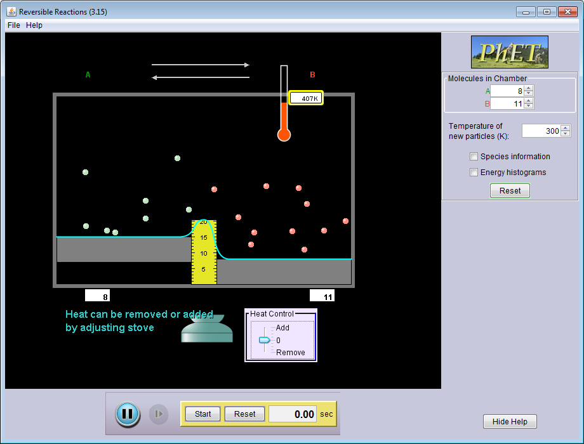Another possible solution is to use this simulation application (see figure 1.10), produced by the University of Colorado, which is downloadable for free and immediately available. It presents information concisely, including information that is not measurable via school equipment. It provides an understandable model of reactions and the effects of changes in conditions. On the other hand, it has a number of flaws, most notably the severely limited help function and lack of user guide. Very little is explained and the user is left to their own devices. This means that an inexperienced student using the application would have to rely on a lot of explanation from the teacher, so while useful as a teaching aid it is inappropriate as revision software. It also provides features such as histograms and average particle speed, but this is not necessary for students at the school. Furthermore it does not appear to take concentration, multiple reactants/products or the equilibrium constant into account, so it is not useful for key stage 5 students.

Figure 1.10: A simulation of reversible reactions

The third possible solution is the development of special-purpose software for simulating reversible reactions. The main disadvantage is that it would not be immediately available as, due to only one person working on the program, it would take a significant amount of time to produce. In addition, many bugs may be present. As the solution is a simulation it will not be a perfect representation of this type of reaction, but a major advantage is that it can be run with any conditions, any number of times. There is a bespoke element to this solution in that features are based on the opinions, needs and limitations of the department and its students (see section 1.4), and the end users can be worked closely with throughout development, making it not too simplistic or detailed. This would enable the software to be closely based on the curriculum and therefore very useful. Programs are installed on the school’s application server, allowing them to be used from any computer connected to the network (at least one computer in each classroom would in effect be able to use this solution, addressing the issue of not always being able to use the lab rooms). The caveat of this is that the program will not be usable should the server become unavailable, but this very rarely occurs.

The third solution is the one which will be implemented, because it is free and safe, unlike using the chemicals and equipment. It also fits what the department requires better than software produced without the school’s involvement. A user guide will also come with the software, so that users will know how to use it. These benefits outweigh the drawbacks mentioned above.

1.8: Data volumes

1.8.1: Current system

The current system does not store any data outside of the lesson, except for slideshows and other media. A significant amount of data is processed during the lesson, but not as much as in the proposed system. Formulae/chemical names, concentrations and volume, temperature and stoichiometric ratios are all processed during the lesson. Data is not processed for graph construction because graphs are always sketched.

1.8.2: Proposed system

Being a simulation, the software would not need to store a lot of data – at most, some reaction data entered by the user so that they do not have to enter it every time they want to run a simulation, and possibly the data of some previous simulations so that they can be compared with one another. However, it would have to process a lot of data to produce the simulation, including calculation of Kc, concentrations/pressures of the reacting species and the positions of objects on-screen for animations. The department’s computers are not very powerful and the calculations are more important, so graphics must be clear but not resource-intensive.

1.9: Proposed system objectives

The proposed system’s objectives must be met by the 23rd of February, 2015, in time for the topic to be taught to the current year 11 students.

1. The program must be able to save and load files that it has created one at a time, within two seconds for each file. The program files must consist of a maximum of five separate reactions.
2. The program must be compatible with and run smoothly on the school’s computer systems. It must also have a similar-looking interface to the general-purpose software the school uses.
3. The program must be able to produce a simple 30-second animation, using a grid of coloured squares to represent a given reversible reaction, in colours selected by the user.
4. The program must be able to produce a graph of concentration of reactants and products against time for a given reversible reaction, which displays in colours selected by the user, progresses alongside the animation and is plotted at the same rate.
5. The program must be able to correctly calculate Kc for a given chemical reaction and output the steps involved in its calculation, as well as displaying whether Kc has increased, decreased or not changed when a condition is changed.
6. The user must be able to compare two reactions side-by-side in the same window.
7. The user must be able to select colours from a colour palette to represent the reactants and products in a particular reaction.
8. The user must be able to print all data related to the reactions being compared, in colour or black and white, on A4 paper.

Following a meeting to discuss the prototype, the following objectives were added:

1. The program must have options to toggle the visibility of descriptive labels in reaction windows at runtime. The labels must be hidden by default and are shown or hidden immediately by pressing a toggle button.
2. Users must be able to enter chemical formulae using normal, superscript and subscript text.
3. The program must allow users to attempt to balance the reaction equation for themselves, by entering stoichiometric ratios for each reacting species.
4. The program must be able to calculate the stoichiometric ratios of a given reversible reaction.
5. The program must be able to compare its calculated ratios against those the user entered, and immediately display whether or not the user is correct.
6. The program must be able to produce a graph of rate of the forward and backward reactions against time for a given reversible reaction, which displays in colours selected by the user, progresses alongside the animation and is plotted at the same rate.

Agreement of the proposed system objectives can be found in the Appendix, item 10.

2. Design

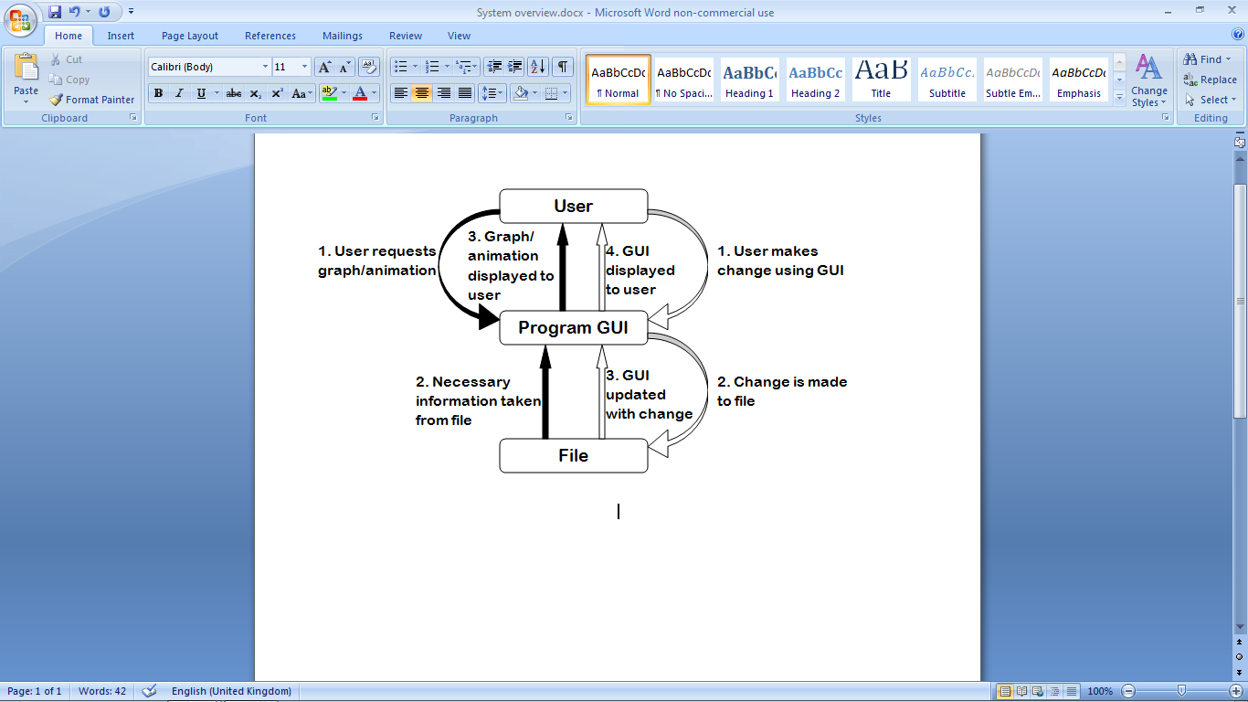2.1: System overview

The design of the system will be an object-oriented, GUI-based application written in the Python programming language, using the PyQt application framework. The interface will be used to manipulate the current file’s object information (the conditions of the reactions). Whenever this information is manipulated, the changes will be  
reflected on the interface. The  
interface will also be used to produce graphs and animation, using some of the current file’s information. The relationship between the user, file and interface is demonstrated in figure 2.1. The program will be centred on a time-driven simulation of a reversible reaction, represented by the animation. The simulation should not be event-driven, because no events occur during the reaction. The main system processes are outlined below:

Figure 2.1: The entities which interact in the system at the top level.

Program startup

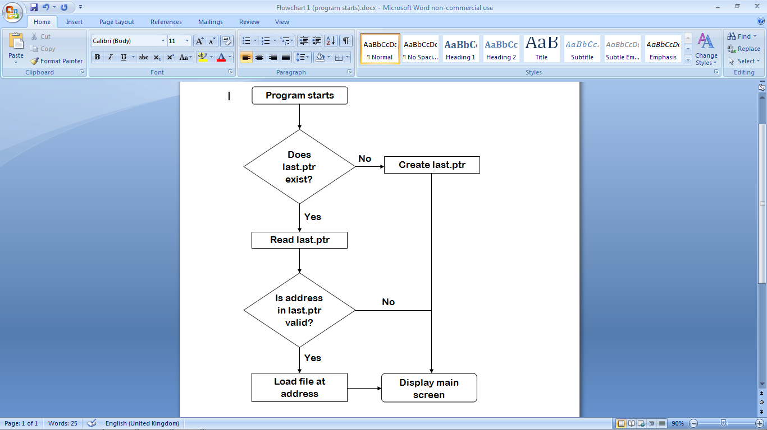

Opening a new file

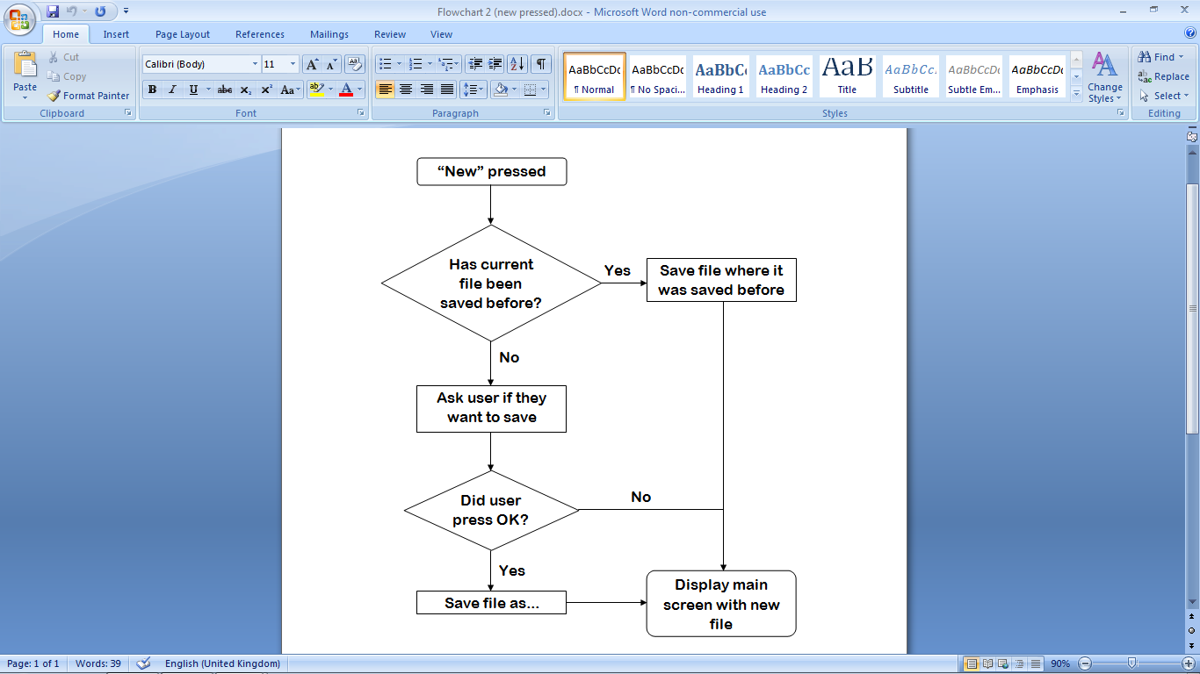

Showing a graph

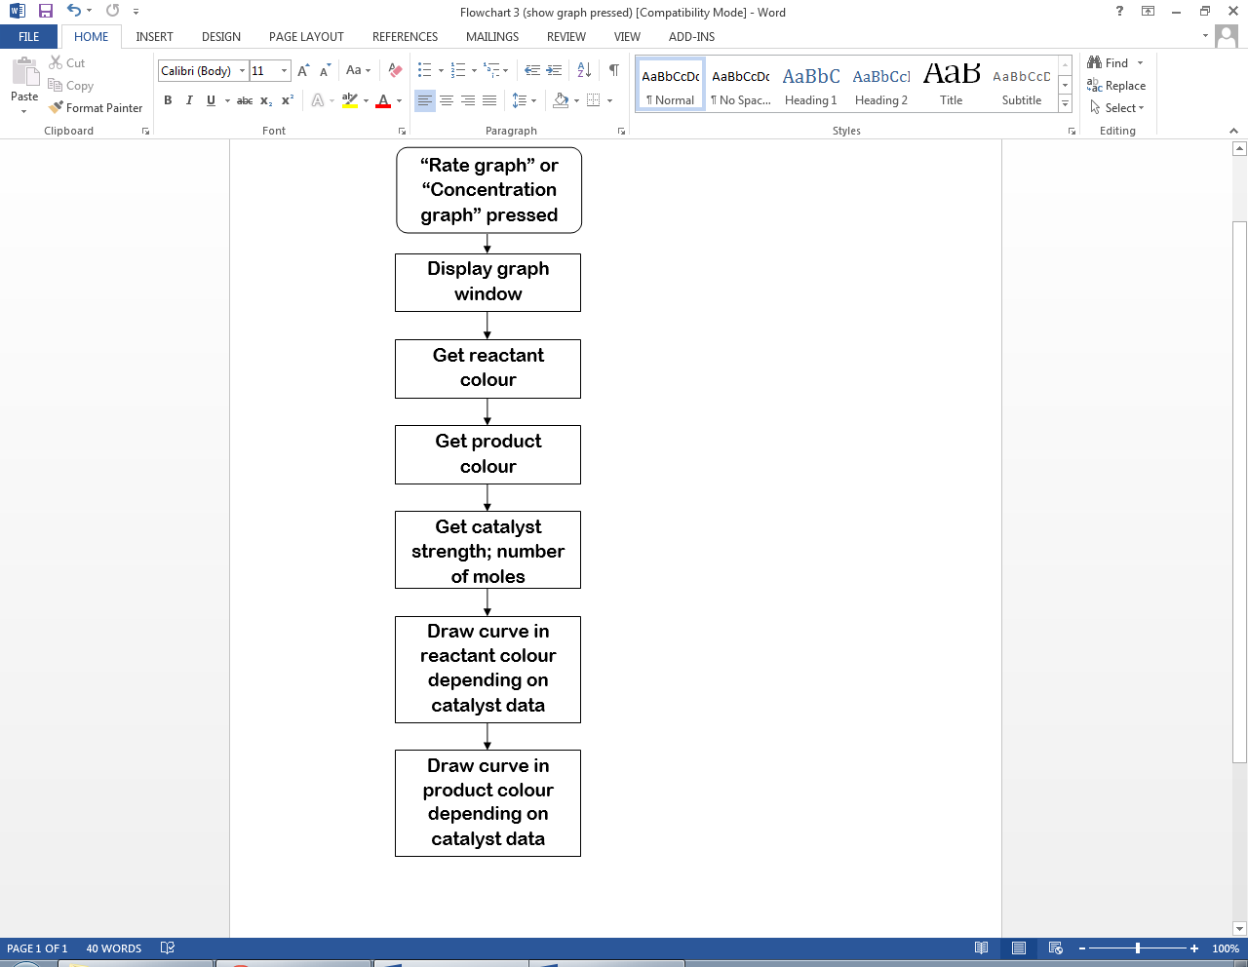

Starting an animation

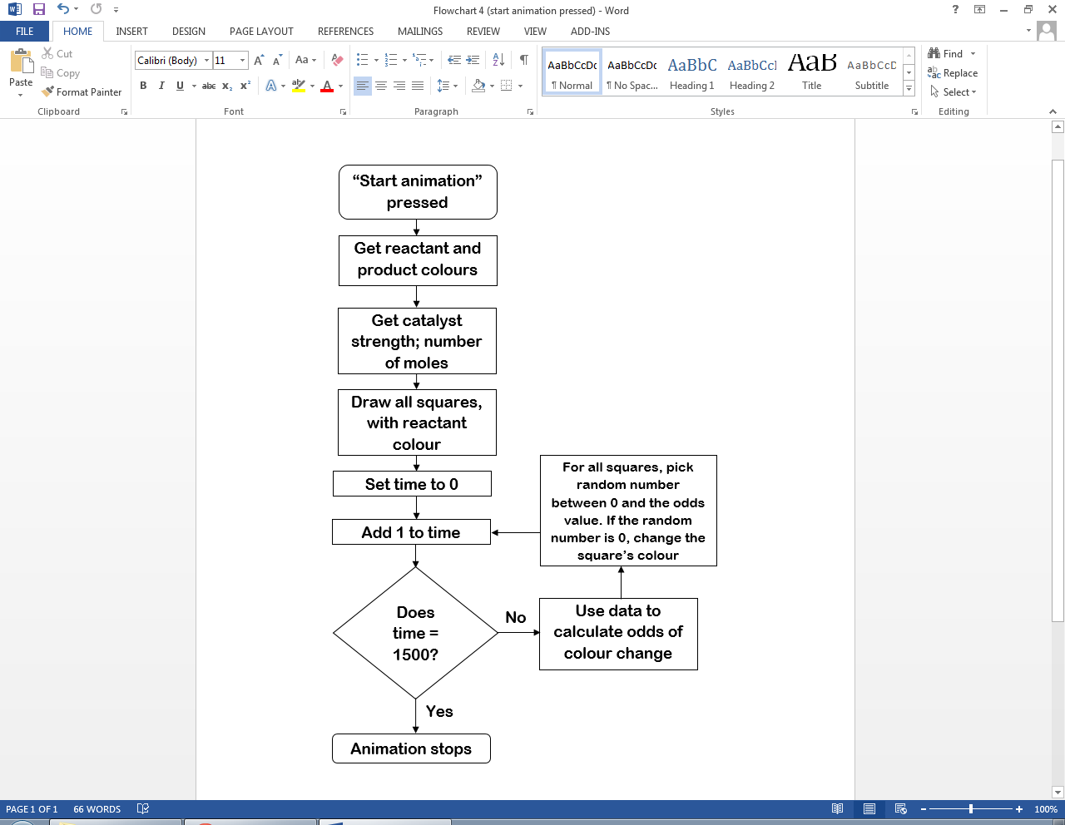

2.2: Modular structure

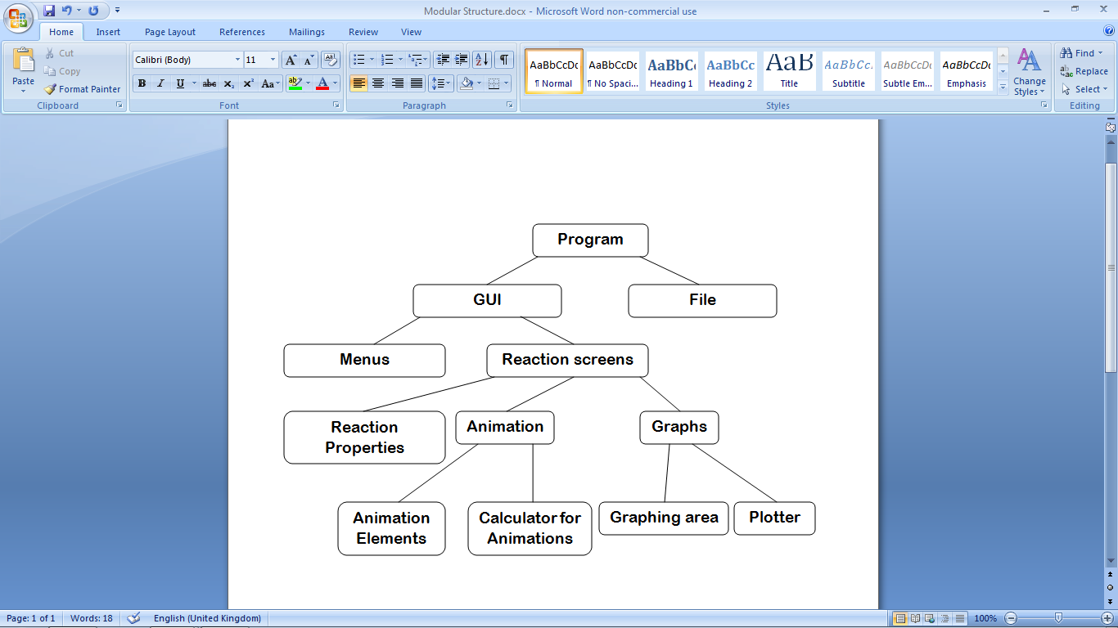The modules making up the proposed system should group together as in figure 2.2.

Figure 2.2: The modular structure of the proposed system.

The modules “Calculator for Animations” and “Plotter” operate by reading data from the current file, and use the data to control “Animation Elements and the “Graphing Area” respectively. The “Reaction Properties” module reads data from, and writes data to, the file. Below is the hierarchy of the menu module.

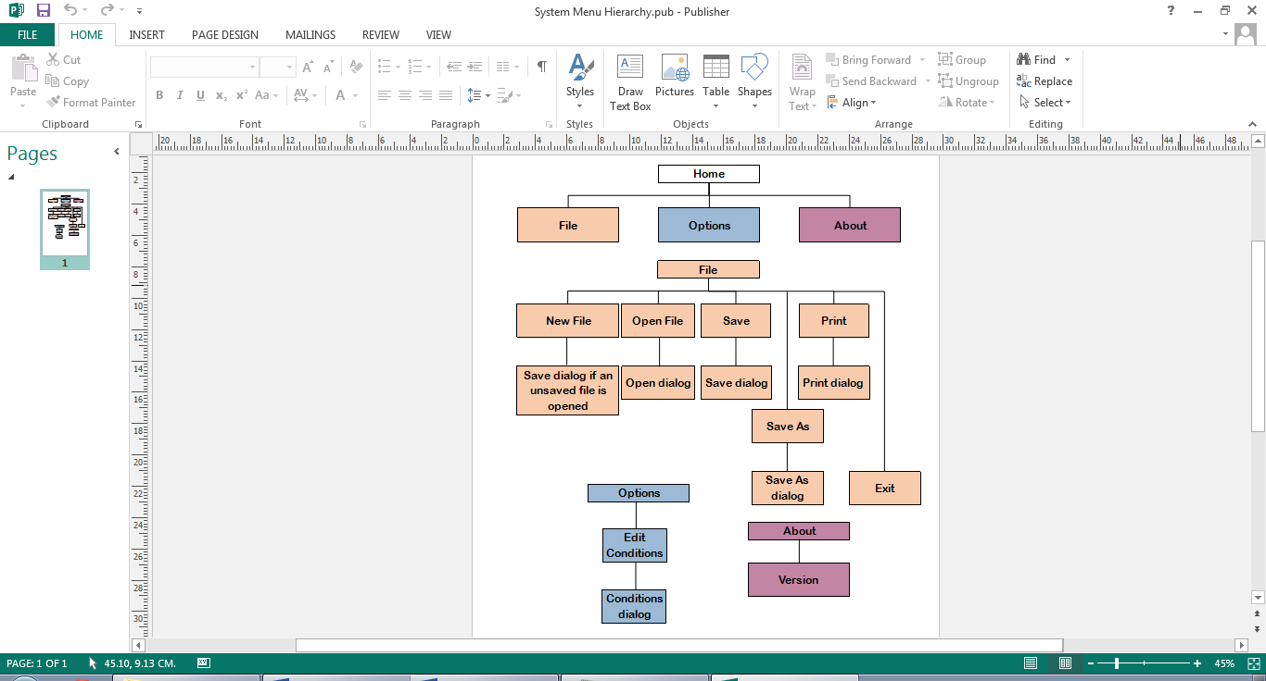

Figure 2.3: The menu hierarchy of the proposed system.

2.3: Data dictionary of proposed system

2.3.1: Variables to be used

PyQt’s text input system only supports plain text, so to enter subscript and superscript text, users must enter _ and ^, as exemplified by the data dictionary.

Long-term stored properties

|  |  |  |  |  |  |
| --- | --- | --- | --- | --- | --- |
| Field Name | Field Purpose | Field Type | Maximum Field Size | Example Data | Validation |
| Formula | Identifies a reactant, catalyst or product by the number of atoms of each element | String | 25 charact-ers | “H_2O_2” | Validated by regular expression |
| Moles | The amount of a substance, measured in moles, when the reaction is at equilibrium | Float | 4 digits, including 2 decimal places | 3.25 | Must be between 0.00 and 100.00 exclusive |
| Volume | The amount of space the system takes up, measured in cubic decimetres (dm3). One mole of gas occupies 24 dm3. | Float | 4 digits, including 2 decimal places | 18.50 | Must be between 00.00 and 100.00 exclusive |
| Temperature | The average kinetic energy of the particles in the system, measured in Kelvin | Integer | 3 digits | 273 | Must be more than 000 and less than 1000 |
| Endothermic | Describes whether, during production of products, energy is taken in overall | Boolean | - | True | - |
| Stoichiometric Ratio | The ratio of a molecule to other molecules required for them to react | Integer | 1 digit | 3 | Must be between 1 and 9 inclusive |
| Efficacy | Factor by which the catalyst alters reaction rate | Float | 10 | 4 | - |

Short-term local variables

|  |  |  |  |  |  |
| --- | --- | --- | --- | --- | --- |
| Name | Purpose | Type | Maximum size | Example data | Validation |
| reactants | All reactants selected to be used in the reaction | List (Reactant) | 3 items | - | Valid if all data in each used reactant object are valid |
| products | All products selected to be used in the reaction | List (Product) | 3 items | - | Valid if all data in each used product object are valid |
| rvalues | All numerical values to do with the reactants. Items with even indices are concentrat-ions; items with odd indices are stoichiomet-ric values | List (float) | 6 items | [14.5, 3.00, 24.24, 5.00, 22.25, 4.00] | Valid if the formula and number of moles of each used reactant, and the reaction volume, are valid |
| pvalues | All numerical values to do with the products. Items with even indices are concentrat-ions; items with odd indices are stoichiomet-ric values | List (float) | 6 items | [0.4, 2.00, 1.6, 8.00, 1.8, 9.00] | Valid if the formula and number of moles of each used product, and the reaction volume, are valid |
| kcvalue | Shows the calculation needed to obtain a value for Kc. | String | 70 characte-rs | “Value of Kc = (0.4)^2 (1.6)^8 (1.8)^9 / (14.5)^3 (24.24)^5 (22.25)^4” | Valid if all items in rvalues and pvalues are valid |
| concentrat-ion | Amount of a reactant, product or catalyst per unit volume, measured in moles per dm3 | Float | 4 digits, including 2 decimal places | 10.04 | Valid if number of moles and reaction volume are valid |
| rproducts-um | Total of the stoichiomet-ric values of each used reactant | Integer | 27 | 14 | Valid if all odd-numbered items in rvalues are valid |
| pproducts-um | Total of the stoichiomet-ric values of each used product | Integer | 27 | 8 | Valid if all odd-numbered items in pvalues are valid |
| kc | Equilibrium constant of a reversible reaction at a constant temperature | Float | Between 1010 and 10-10 | 0.24 | Valid if concentrat-ions of products and reactants are valid |
| numerator | Product of concentrat-ions of each product to the power of its stoichiomet-ric value | Float | (99.999)3 = 9.97e+53 | 242.88 | Valid if all values in pvalues are valid |
| denominat-or | Product of concentrate-ions of each reactant to the power of its stoichiomet-ric value | Float | 9.97e+53 | 359.66 | Valid if all values in rvalues are valid |
| value | Value of Kc, without units | Float | (99.999)3 / (0.019)3 = 9.97e+107 (reversib-le reactions actually never have values this high) | 20.38 | Valid if numerator and denominat-or are valid |
| power | The power of the moles units. This multiplied by -3 is the power of the volume units. The result of pproducts-um minus rproducts-um | Integer | 2 | -1 | Valid if pproducts-um and rproducts-um are valid |
| newformula | HTML version of formula string, using tags instead of special characters | String | 105 characters | “CaCl <sub>2 </sub>” | Valid if formula passed in is valid |
| change | Factor that the graph changes by | Float | 10 | 0.5 | Valid if all catalyst data is valid |
| eqmpoint (in DrawCurve method) | X coordinate where the graph becomes level | Integer | 300 | 145 | Valid if less than 301 and more than 0 |
| newSquare | The next Square object to be added to the animation’s array of them | Square | - | - | All Square objects instantiated in the algorithm so must be valid |
| eqmpoint (in PlayAnimat-ion method) | Number of updates until chance of a colour change is equal for both colours | Integer | 750 | 624 | Valid if less than 751 and more than 0 |
| time | Number of updates since the animation was started | Integer | 1499 | 345 | Valid if less than 1500 and more than 0 |
| chance | Odds of a square changing colour (1 in 5 if chance = 5) | Integer | 200 | 130 | Valid if more than 0 and less than 201 |

2.3.2: Input validation checks

Checks need to be performed for the values in the first table of section 2.3.1. If these values are valid, the values in the second table will also be valid. If values are not selected from a list of valid values, they are entered as strings in text boxes, so instead of checking the data type entered, the string is validated and converted into the appropriate data type off-screen.

|  |  |  |  |  |  |  |  |  |  |  |  |  |  |  |  |  |  |  |  |  |  |  |  |  |  |  |  |  |  |  |  |  |  |  |  |  |  |
| --- | --- | --- | --- | --- | --- | --- | --- | --- | --- | --- | --- | --- | --- | --- | --- | --- | --- | --- | --- | --- | --- | --- | --- | --- | --- | --- | --- | --- | --- | --- | --- | --- | --- | --- | --- | --- | --- |
| |  |  |  |  | | --- | --- | --- | --- | | **Field Name** | **Validation Checks** | **Description** | **Error message** | | Formula | If used: Presence; Length; Regex | Must be 1-25 characters long and fit the regex | “The formula of [chemical] must be 1-25 characters long inclusive.”/”The formula of [chemical] is invalid.” | | Moles | If used: Presence; Range; Regex | Must be between 0.01 and 99.99 inclusive and fit the regex | “The number of moles of [chemical] must be between 0.01 and 99.99 inclusive, with up to 2 decimal places.” | | Volume | Presence; Range; Regex | Must be between 0.01 and 99.99 inclusive and fit the regex | “The reaction volume must be between 0.01 and 99.99 inclusive, with up to 2 decimal places.” | | Temperature | Presence; Range | Must be between 1 and 999 inclusive | “The temperature must be a whole number between 1 and 999 inclusive.” | | Endothermic | Lookup(Endothermic, Exothermic; default setting is Endothermic) | If Endothermic is selected, set to true. If not, set to false | - | | Efficacy | Lookup(Good, Poor, Inhibitor; default setting is Good) | If used: if Good selected, Efficacy is set to 10; Poor, set to 4; Inhibitor, set to 0.5. If not used, set to 1 | - | | Stoichiometric Ratio (when entering conditions) | Range | Must be between 2 and 9. If not entered, set to 1. If larger than 9, Formula will be invalid anyway | - | | Stoichiometric Ratio (when attempting to balance equation) | Lookup (1-9; default value is 1) | - | - | |  |
|  |  |
|  |  |
|  |  |
|  |  |

2.4: Program and data storage; file organisation; system specification

The system will be compiled as a standalone binary application, installed by an installer file which will be distributed via mastered DVD-ROM. This is because the distribution medium should only have one purpose, which is to provide the installer that needs to be run. Being mastered means the installer cannot be edited, and malicious files cannot be added. A DVD-ROM is useful because they have a relatively small amount of memory, which suits the relatively small size of the installer. The DVD-ROM is also reusable, in case there is an error with the installation. The end user specifies an installation directory on their system when they run the installer.

Each file will consist of a list of reaction objects, and an integer index of the last reaction in the file that had been viewed. Each file will be saved using a binary dump with serial storage provided by Python’s pickle module, as they are not required to be read by any other programs. No images or videos will be saved, so file sizes should not exceed 5 KB. The user will be able to choose where to save files via a “Save As...” dialog.

The resulting standalone application will be compatible with any computer which runs a Linux, Windows NT (or later) or Mac OSX (or later) operating system. Two applications will be developed; one compatible with 32-bit systems and the other with 64-bit systems. The only peripherals required will be a standard keyboard, a standard mouse and a display unit which supports resolutions of at least 1024x768. All school computers fit these criteria, as they are mostly 32-bit systems, and all of them have monitors supporting 1024x768 resolution and run on Windows 7 Professional edition. The program should require no more than 128MB of disk space for storage and 50MB of RAM while running – all school computers easily meet this requirement.

2.5: Proposed algorithms

Calculating Kc

The ShowWorking() function is in the Reaction class and uses its properties. It ouputs a worked calculation of the value and units of the given reaction’s equilibrium constant. The process is as follows:

1. The reactants and products lists are initialized as empty.
2. For each reactant and product in the reaction, the algorithm checks if they are used. If so they are appended to the corresponding list. From here on “reactants” and “products” only refers to the ones in these lists.
3. The formula for concentration is printed.
4. The reaction’s volume is printed.
5. The pvalues and rvalues lists are initialized as empty.
6. For each product in turn, its concentration is printed, its concentration is appended to pvalues and its stoichiometric value is appended to pvalues.
7. For each reactant in turn, its concentration is printed, its concentration is appended to rvalues and its stoichiometric value is appended to rvalues.
8. A string kcvalue is initialized as “Value of Kc =” and a stepper x is initialized as 0.
9. Using the stepper and the two lists, the kcvalue string gradually has the whole of the right-hand side of the equation appended to it; so that it resembles the string “Value of Kc = (<concentration)^<stoichiometric value> / (<concentration)^<stoichiometric value>”
10. The total of the stoichiometric ratios for each product is calculated.
11. The total of the stoichiometric ratios for each reactant is calculated.
12. Concentration is measured in mol dm-3. The overall units are found by dividing the product of the units of concentration of the products by the product of the units of concentration of the reactants. In the algorithm, the power of the moles is the total of the ratios of the products minus that of the reactants. The power of the volume is this multiplied by -3. Calculating the units the second way yields the same result and is more efficient. The calculation of the units is printed out.
13. The algorithm now calculates Kc itself. For each product, the algorithm takes its concentration and multiplies it to the power of its stoichiometric ratio. The Numerator variable is the product of all these values. The Denominator is the result of the same process with each reactant. The units are calculated the same way as earlier. The value and units of Kc are then printed out.

The end user may sometimes need to display working with the answer, and sometimes only the answer, so this function may be split into a ShowWorking() and a GetKc() function. In this case, the GetKc() function is independent and ShowWorking() would call GetKc().

FUNCTION ShowWorking

reactants 🡨 []

products 🡨 []

FOR x 🡨 0 TO self.Reactants.length - 1 DO

IF self.Reactants[x].GetUsed() THEN

reactants.append(self.Reactants[x])

ENDIF

ENDFOR

FOR x 🡨 0 TO self.Products.length - 1 DO

IF self.Products[x].GetUsed() THEN

products.append(self.Products[x])

ENDIF

ENDFOR

OUTPUT "Concentration = moles / volume"

OUTPUT "Volume = "+str(self.Volume)+" dm^3"

pvalues 🡨 []

rvalues 🡨 []

FOR x 🡨 0 TO products.length – 1 DO

OUTPUT "Concentration of " + products[x].GetFormula() + " = " + str(products[x].GetConcentration(self.Volume))+" mol dm^-3"

pvalues.append(products[x].GetConcentration(self.Volume))

pvalues.append(products[x].GetSRatio())

ENDFOR

FOR x 🡨 0 TO reactants.length – 1 DO

OUTPUT “Concentration of " + reactants[x].GetFormula()+" = "+str(reactants[x].GetConcentration(self.Volume))+" mol dm^-3"

rvalues.append(reactants[x].GetConcentration(self.Volume))

rvalues.append(reactants[x].GetSRatio())

ENDFOR

kcvalue 🡨 "Value of Kc ="

x 🡨 0

WHILE x < pvalues.length DO

kcvalue 🡨 kcvalue + " ("+str(pvalues[x])+")^"

x 🡨 x + 1

kcvalue 🡨 str(pvalues[x])

x 🡨 x + 1

ENDWHILE

kcvalue 🡨 kcvalue + " /"

x 🡨 0

WHILE x < len(rvalues) DO

kcvalue 🡨 kcvalue + " ("+str(rvalues[x])+")^"

x 🡨 x + 1

kcvalue 🡨 kcvalue + str(rvalues[x])

x 🡨 x + 1

ENDWHILE

OUPUT kcvalue

rproductsum 🡨 0

FOR x 🡨 0 TO reactants.length - 1 DO

rproductsum += reactants[x].GetSRatio()

ENDFOR

pproductsum 🡨 0

FOR x 🡨 0 TO products.length – 1 DO

pproductsum 🡨 pproductsum + products[x].GetSRatio()

ENDFOR

OUTPUT “There are "+str(len(reactants))+" reactants, with units mol dm^-3."

OUTPUT "The product of these units is mol^"+str(rproductsum)+" dm^"+str(rproductsum * -3)+"."

OUTPUT “There are "+str(len(products))+" products, with units mol dm^-3."

OUTPUT “The product of these units is mol^"+str(pproductsum)+" dm^"+str(pproductsum * -3)+"."

OUTPUT "The product units must be divided by the reactant units, so"

numerator 🡨 1

FOR x 🡨 0 TO products.length – 1 DO

numerator 🡨 numerator * (products[x].GetConcentration(self.Volume) ** products[x].GetSRatio())

ENDFOR

denominator 🡨 1

FOR x 🡨 0 TO reactants.length – 1 DO

denominator 🡨 denominator * (reactants[x].GetConcentration(self.Volume) ** reactants[x].GetSRatio())

ENDFOR

value 🡨 numerator / denominator

power 🡨 pproductsum - rproductsum

OUTPUT "Kc = "+str(value)+" mol^"+str(power)+" dm^"+str(power * -3)

END

The GetSRatio function is part of the ReactingSpecies class and uses its properties. It returns the reacting species’ value in the equation’s stoichiometric ratio – the smallest integer ratio of each molecule to the other molecules for a reaction to occur. The algorithm uses error handling to obtain this value. In effect, if a number is specified at the beginning of the formula, this will be the value. If no number is specified, the value is taken to be 1. This value is hardly ever above 9 at this stage so only the first character is examined.

FUNCTION GetSRatio

TRY

RETURN int(self.Formula[0])

EXCEPT

RETURN 1

ENDTRY

END

The GetKcChange function is in the Reaction class. It is used to get an abstract change in Kc when any condtions are adjusted. Kc is only constant for a particular reaction at a particular temperature, so an abstract change is useful as the user avoids having to entire a whole new set of reaction data.

Kc only changes in a reaction when the temperature is changed, which is why the temperature difference is the only parameter. The temperature difference is equal to the temperature of the “new” left-hand side reaction minus that of the “old” right-hand side reaction.

FUNCTION GetKcChange(TemperatureChange : int)

IF TemperatureChange == 0 THEN

RETURN ‘not changed’

ELSE

IF TemperatureChange < 0 THEN

IF Endothermic == FALSE THEN

RETURN ‘increased’

ELSE

RETURN ‘decreased’

ENDIF

ELSE

IF Endothermic == FALSE THEN

RETURN ‘decreased’

ELSE

RETURN ‘increased’

ENDIF

ENDIF

ENDIF

END

The GetFormulaForLabels function is in the Species class. It returns the species’ formula (which was entered by the user as plain text) in a HTML-based format so that it can be displayed conventionally to the end user. It does this by making a copy of the formula. It replaces every instance of “_x” with “<sub>x</sub> and every instance of “^x” with “<sup>x</sup>” where x is an integer. This results in the formula having superscript and subscript characters in the right places.

FUNCTION GetFormulaForLabels

x 🡨 0

newformula 🡨 ""

WHILE x < self.Formula.length DO

IF self.Formula[x] == "_" THEN

newformula 🡨 newformula + "<sub>"

x 🡨 x + 1

newformula 🡨 newformula + self.Formula[x]

newformula 🡨 newformula + "</sub>"

ELSE

IF self.Formula[x] == "^" THEN

newformula 🡨 newformula + "<sup>"

x 🡨 x + 1

newformula 🡨 newformula + self.Formula[x]

newformula 🡨 newformula + "</sup>"

ELSE

newformula 🡨 newformula + self.Formula[x]

ENDIF

ENDIF

x 🡨 x + 1

ENDWHILE

RETURN newformula

END

The ValidateVolume function uses regular expressions and exception handling to validate the volume string entered by the user. Because the acceptable values for the number of moles are the same as those for the volume, this function can be applied to the number of moles as well.

Note: when implemented, rather than being a separate function this was written as part of a larger algorithm to validate all input data.

FUNCTION ValidateVolume(volume : str)

TRY

IF float(volume) < 0.01 OR float(volume) > 99.99 THEN

OUTPUT "Volume must be between 0.01 and 99.99 inclusive."

ELSE

TRY

IF volume DOES NOT MATCH "[0-9]?[0-9]\.[0-9][0-9]?" THEN

OUTPUT "Volume must be between 0.01 and 99.99 inclusive, and must have a maximum of 2 decimal places."

EXCEPT

OUTPUT “Volume must be between 0.01 and 99.99 inclusive, and must have a maximum of 2 decimal places."

ENDIF

EXCEPT

OUTPUT "Volume must be a decimal number."

ENDTRY

END

The DrawCurve function is responsible for drawing the concentration or reaction rate graphs. All of these graphs have roughly the same shape: two curves which start at either end of the y axis and flatten out either in the middle (rate) or near the middle (concentration). However, the catalyst data causes the steepness of both curves to change: more of a stronger catalyst makes the curves steeper; more of a weaker catalyst makes the curves less steep. The algorithm uses the catalyst strength and number of moles to calculate eqmpoint (the point on the x axis where the curves flatten out). Then the PyQt pen system will be used to draw the axes, then an arc from x = 0 to x = eqmpoint, then from x = eqmpoint to x = 300 where the graph ends, for both curves.

FUNCTION DrawCurve

IF self.Reaction.GetCatalyst().GetUsed() THEN

change 🡨 self._reaction.GetCatalyst().GetEfficacy()

ELSE

change 🡨 1

ENDIF

eqmpoint 🡨 150 / change

IF change > 1 THEN

eqmpoint -= 0.1 * self.Reaction.GetCatalyst().GetInitialMoles()

ELSE

IF change < 1 THEN

eqmpoint += 0.1 * self.Reaction.GetCatalyst().GetInitialMoles()

ENDIF

self.Plotter.Pen.setPenColour(0, 0, 0)

self.Plotter.Pen.drawLine(0, 0, 0, 200)

self.Plotter.Pen.drawLine(0, 200, 300, 200)

self.Plotter.Pen.setPenColour (self.Reaction.GetReactantColour())

self.Plotter.Pen.moveTo(0, 0)

self.Plotter.Pen.drawArcTo(0, -100 + self.Plotter.GetFinalY(), eqmpoint * 2, 200 - (2 * self.Plotter.GetFinalY()), 180, 90)

self.Plotter.Pen.drawLineTo(300, 100 - self.Plotter.GetFinalY())

self.Plotter.Pen.setPenColour (self.Reaction.GetProductColour()))

self.Plotter.Pen.moveTo(0, 200)

self.Plotter.Pen.drawArcTo(0, 100 + self.Plotter.GetFinalY(), eqmpoint * 2, 200 - (2 * self.Plotter.GetFinalY()), 180, -90)

self.Plotter.Pen.drawLineTo(400, 120 + self.Plotter.GetFinalY())

END

The PlayAnimation function sets up the elements of the animation and performs the calculations required to display each frame. First, the 100 squares are constructed and drawn, laid out in a 10x10 grid. Then an eqmpoint value is calculated, very similarly to the last algorithm. The value determines the number of the frame in the animation where the chance of any square changing colour is equal. Then, each frame, each square’s Draw() function is called. When a square’s Draw() function is called, whether it changes colour depends on the chance parameter – see the function beneath PlayAnimation. Until equilibrium this chance is lower for squares with the product colour than squares with the reactant colour, which is consistent with the shape of the rate graph.

FUNCTION PlayAnimation

FOR x 🡨 0 TO 99 DO

newSquare 🡨 Square(200+((x % 10) * 20), 120 + ((x // 10) * 20)

self.Squares.append(newSquare)

newSquare.Draw(painter, -1)

ENDFOR

eqmpoint 🡨 750

IF self.Reaction.GetCatalyst().GetUsed() THEN

efficacy 🡨 self.Reaction.GetCatalyst().GetEfficacy()

eqmpoint 🡨 eqmpoint / efficacy

IF efficacy > 1 THEN

eqmpoint 🡨 eqmpoint - 0.5 * self.Reaction.GetCatalyst().GetMoles()

ELSE

IF efficacy < 1 THEN

eqmpoint 🡨 eqmpoint + 0.5 * self.Reaction.GetCatalyst().GetMoles()

ENDIF

ENDIF

ENDIF

FOR time 🡨 0 TO 1499 DO

chance 🡨 100

IF time < eqmpoint THEN

chance 🡨 chance + int(100 - ((time / eqmpoint) * 100))

ENDIF

FOR x 🡨 0 TO 99 DO

self.Squares[x].Draw(chance)

ENDFOR

ENDFOR

END

FUNCTION Draw(chance : int)

IF chance > 0 THEN

IF (self.CurrentColour == self.ReactantColour AND randrange(chance) == 0) OR (self.CurrentColour == self.ProductColour AND randrange(201 - chance) == 0) THEN

IF self.CurrentColour == self.ReactantColour THEN

self.CurrentColour 🡨 self.ProductColour

ELSE

self.CurrentColour 🡨 self.ReactantColour

ENDIF

ENDIF

ENDIF

self.DrawSelf()

END

2.6: Classes used

2.6.1: Class diagrams

These are the classes which will be used to implement the chemical concepts:

**Reaction**

Public: ReactingSpeciesLimit : int

Private:

Temperature : int

Reactants : list (Reactant)

Products : list (Product)

Catalyst : Catalyst

Volume : float

Endothermic : boolean

ReactantColour : QColor

ProductColour : QColor

Public:

GetKc

GetKcChange

GetTemperature

SetTemperature

GetReactants

SetReactants

GetProducts

SetProducts

GetCatalyst

SetCatalyst

GetVolume

SetVolume

GetEndothermic

SetEndothermic

GetReactantColour

SetReactantColour

GetProductColour

SetProductColour

Species

Private:

Formula : String

Moles : float

Used : boolean

Public:

GetConcentration

GetFormula

SetFormula

GetFormulaForLabels

GetMoles

SetMoles

GetUsed

SetUsed

Catalyst

Private:

Efficacy

Public:

GetEfficacy

SetEfficacy

GetEfficacyAsString

ReactingSpecies

Public:

GetSRatio

Product

Reactant

2.6.2: Brief field and method descriptions

Most get and set methods are not described here as they simply return or set their corresponding property.

Reaction

* ReactingSpeciesLimit: Maximum number of reactants, and maximum number of products, per reaction. Will be set to 3
* Temperature: the temperature the reaction takes place at, measured in K
* Reactants: All reactants in the Reaction object, including ones that aren’t selected to be used
* Products: All products in the Reaction object, including ones that aren’t selected to be used
* Catalyst: The reaction’s catalyst
* Volume: The reaction vessel capacity, measured in dm3
* Endothermic: If true, the reaction takes in heat when products are formed. If false, it gives out heat
* ReactantColour: The colour that represents the reactants
* ProductColour: The colour that represents the products
* GetKc: Returns the reaction’s equilibrium constant
* GetKcChange: When conditions are changed, returns whether Kc has increased, decreased or not changed when conditions are changed.

Species

* Formula: The species’ chemical formula
* Moles: the number of moles at equilibrium
* Used: Whether or not the species is selected for use in the reaction
* GetConcentration: Returns the species’ concentration (number of moles divided by vessel volume)
* GetFormulaForLabels: Returns HTML-friendly version of formula, for proper display

ReactingSpecies

* GetSRatio: Returns the reacting species’ stoichiometric value

Catalyst

* Efficacy: The factor by which the reaction speeds up
* GetEfficacyAsString: Verbal description of Efficacy (10 = good; 4 = poor; etc.)

2.7: Planned user interfaces

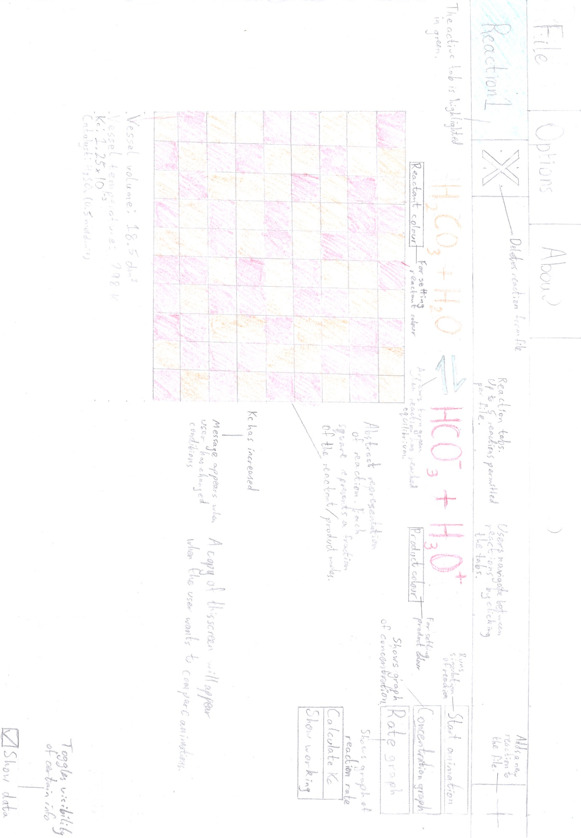

Figure 2.4: The planned reaction window screen.

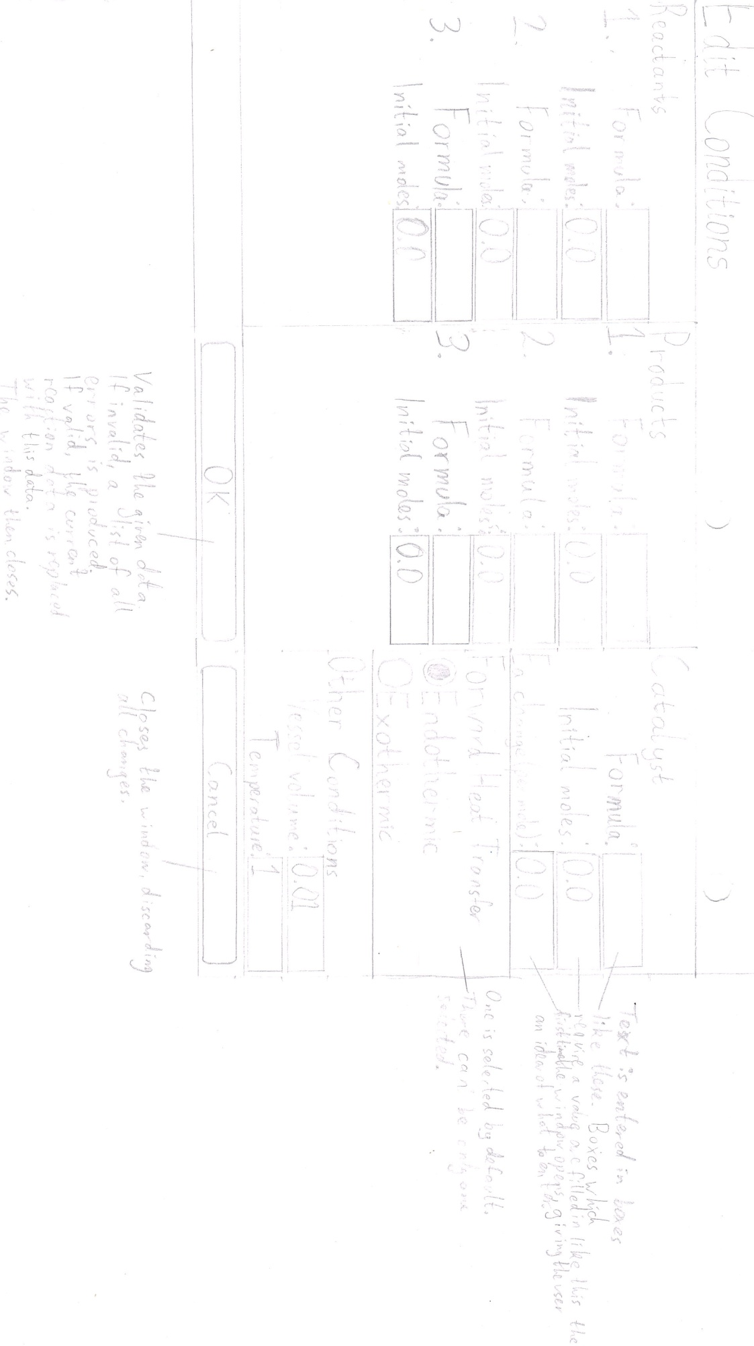

Figure 2.5: The planned conditions dialog screen.

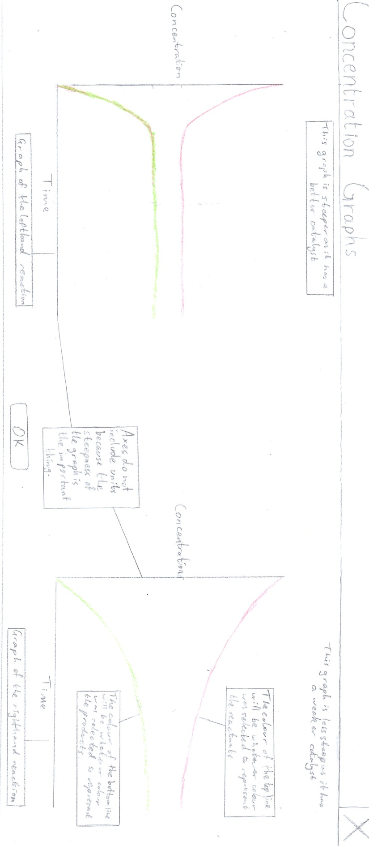

Figure 2.6: The planned screen for concentration graphs. The same screen is shown for rate graphs, except “Concentration” is replaced with “Rate” and the graphs meet in the middle.

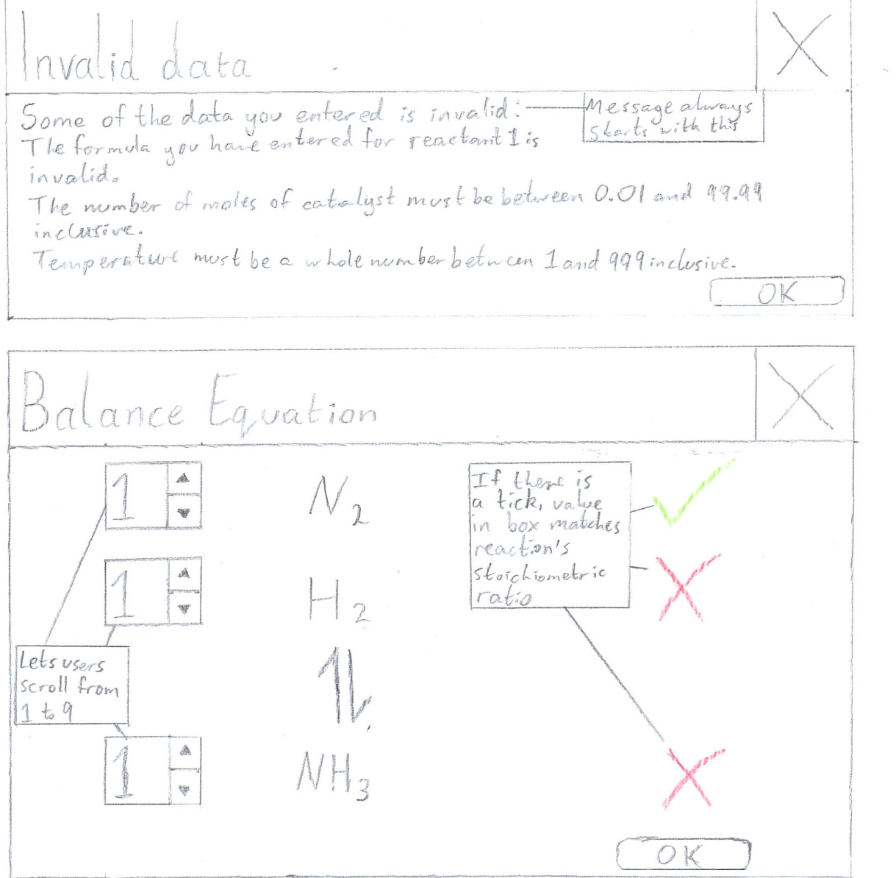

Figure 2.7: The planned error box for when the user enters invalid data. With every item of invalid data, the list of error messages is added to. The window should resize to fit the entire list onto it.



Figure 2.8: The planned screen for when users attempt to balance the reaction equation.

2.8: Security

The program will not need to store any personal or otherwise sensitive data, so no file encryption will be used. However, before distribution the program will be compiled to binary to avoid the source code being edited, which could make the program unusable.

2.9: Test plan

The test strategy for validation will be comparing the result to a dry run of each algorithm, because the algorithms used are easy for humans to perform and check. Navigation requires black-box testing because it will be handled by the application framework, the source code of which is unavailable. Logic must also be tested with a black-box method because the simulation involves thousands of calculations being performed each time, as well as random number generation, so white-box and dry-run testing are practically impossible.

2.9.1: Validation

All user input required to produce each simulation will be entered in text boxes in the Conditions dialog (see Figure 2.4). These text boxes are the only areas where users cannot select from predetermined valid values, so these are the only areas where input validation will take place. Data entered as a string may be converted internally to other data types. Invalid input data will prevent the window from closing when the “OK” button is pressed.

|  |  |  |  |
| --- | --- | --- | --- |
| Test number | Description | Test type; input data | Expected result |
| 1 | The formula of each reactant, product and the catalyst must be 1-25 characters long inclusive, and must fit R1 | N; “2NaCl” | If all other data valid, window closed, reaction updated and user can continue |
| 2 | E; “2N@C&” | Message explaining that the formula is invalid |
| 3 | E; “” | Message explaining the accepted formula length |
| 4 | B; “H” | If all other data valid, window closed, reaction updated and user can continue |
| 5 | B; “CH_3COO(CH_2)_4C_1_0H_2_1” | If all other data valid, window closed, reaction updated and user can continue |
| 6 | Number of moles must be between 0.01 and 99.99 inclusive, and in the float format. There must be 1-2 digits before and after the decimal point, i.e. it must fit R2 | N; “24.53” | If all other data valid, window closed, reaction updated and user can continue |
| 7 | E; “101.42” | Message explaining the accepted range |
| 8 | E; “-4.24” | Message explaining the accepted range |
| 9 | E; “” | Message explaining that a decimal number must be entered |
| 10 | E; “6” | Message explaining that a decimal number must be entered |
| 11 | E; “4. | Message explaining that a decimal number must be entered |
| 12 | E; “3.14159” | Message explaining that there should be a maximum of two decimal places |
| 13 | E; “sixteen” | Message explaining that a decimal number must be entered |
| 14 | B; “99.99” | If all other data valid, window closed, reaction updated and user can continue |
| 15 | B; “0.01” | If all other data valid, window closed, reaction updated and user can continue |
| 16 | Volume must be between 0.01 and 99.99 inclusive, and in the float format. There must be 1-2 digits before and after the decimal point, i.e. it must fit R2 | N; “13.37” | If all other data valid, window closed, reaction updated and user can continue |
| 17 | E; “133.75” | For a value larger than the range, a message explaining the accepted range |
| 18 | E; “-42.69” | For a value smaller than the range, a message explaining the accepted range |
| 19 | E; “” | Message explaining that a decimal number must be entered |
| 20 | E; “72” | Message explaining that a decimal number must be entered |
| 21 | E; “72.” | Message explaining that a decimal number must be entered |
| 22 | E; “1.234” | Message explaining that there should be a maximum of two decimal places |
| 23 | E; “fourteen” | Message explaining that a decimal number must be entered |
| 24 | B; “99.99” | If all other data valid, window closed, reaction updated and user can continue |
| 25 | B; “0.01” | If all other data valid, window closed, reaction updated and user can continue |
| 26 | Temperature must be an integer between 0 and 1000 exclusive | N; “450” | If all other data valid, window closed, reaction updated and user can continue |
| 27 | E; “2000” | Message explaining accepted range |
| 28 | E; “-200” | Message explaining accepted range |
| 29 | E; “” | Message explaining that an integer must be entered |
| 30 | E; “Boiling” | Message explaining that an integer must be entered |
| 31 | B; “1” | Window closed, reaction updated and user can continue |
| 32 | B; “999” | Window closed, reaction updated and user can continue |

2.9.2: Navigation

Navigation will be done via buttons and menus, using the left mouse button.

The “File” menu

|  |  |  |
| --- | --- | --- |
| Test number | Description | Expected navigation |
| 1 | On clicking “New” | Popup box asking user if they want to save |
| 1a) | On clicking “Yes” in popup box | “Save As...” dialog if not saved before; none if saved before. Popup box closed; left reaction window reset |
| 1b) | On clicking “No” in popup box | Popup box closed; left reaction window reset |
| 2 | On clicking “Open” | “Open...” dialog |
| 3 | On clicking “Save” | None |
| 4 | On clicking “Save as” | “Save As...” dialog |
| 5 | On clicking “Print” | “Print” dialog |
| 6 | On clicking “Exit” | Closes program |

The “Options” menu

|  |  |  |
| --- | --- | --- |
| Test number | Description | Expected navigation |
| 7 | On clicking “Edit Conditions” | “Edit Conditions” dialog |
| 7a) | On clicking “Cancel” in “Edit Conditions” dialog | Closes dialog window (no changes made) |
| 7b) | On clicking “OK” in “Edit Conditions” dialog (with invalid data) (“Students attempt to balance equation” unchecked) | “Invalid Data” dialog |
| 7b)i) | On clicking “OK” in “Invalid Data” dialog | Closes dialog window |
| 7c) | On clicking “OK” in “Edit Conditions” dialog (with invalid data) (“Students attempt to balance equation” checked) | “Invalid Data” dialog |
| 7d) | On clicking “OK” in “Edit Conditions” dialog (with valid data) (“Students attempt to balance equation” unchecked) | Closes dialog window; reaction window updated |
| 7e) | On clicking “OK” in “Edit Conditions” dialog (with valid data) (“Students attempt to balance equation” checked) | “Balance Equation” dialog |
| 7e)i) | On clicking “OK” in “Balance Equation” dialog | Closes dialog window and “Edit Conditions” dialog |

The “About” menu

|  |  |  |
| --- | --- | --- |
| Test number | Description | Expected navigation |
| 8 | On clicking “Version [version of program]” | None |

The reaction windows

The buttons which appear for the left and right reaction viewing widgets function exactly the same way, so only the results for the buttons in the left widget are included.

|  |  |  |
| --- | --- | --- |
| Test number | Description | Expected navigation |
| 9 | On clicking “Set reactant colour” | “Select Color” dialog |
| 10 | On clicking “Set product colour” | “Select Color” dialog |
| 11 | On clicking “Concentration Graphs” | “Compare Graphs” window |
| 12 | On clicking “Rate Graphs” | “Compare Graphs” window |
| 13 | On clicking “Close” in “Compare Graphs” window | Closes window |
| 14 | On clicking “Calculate Kc” | None (displays text when “Show data” is checked) |
| 15 | On clicking “Show working” | A small box showing working in plain text |
| 16 | On clicking “Start animation” | None |
| 17 | On clicking “Compare reaction” | None (right reaction window updated) |
| 18 | On clicking “+” (open tab) button | None |
| 19 | On clicking “X” (close tab) button when only 1 reaction in file | None |
| 20 | On checking / unchecking “Show data” box | None |

2.9.3: Logic

Animation

Note: “Time taken” refers to the time taken from the first frame with at least 1 square with the product colour to the first frame where at least 50 squares have the product colour.

|  |  |  |
| --- | --- | --- |
| Test number | Description | Expected outcome |
| 1 | Comparing good catalyst at 25 and 75 moles | Less time taken at 75 moles |
| 2 | Comparing poor catalyst at  25 and 75 moles | Less time taken at 75 moles |
| 3 | Comparing unused catalyst at 25 and 75 moles | No effect on animation |
| 4 | Comparing inhibitor catalyst at 25 and 75 moles | Less time taken at 25 moles |
| 5 | Comparing time taken by animation with each catalyst at 50 moles | In order of least to most time taken: good; poor; unused; inhibitor |

Graphs

|  |  |  |
| --- | --- | --- |
| Test number | Description | Expected curve steepness |
| 6 | Comparing good catalyst at 25 and 75 moles | Steeper at 75 moles |
| 7 | Comparing poor catalyst at 25 and 75 moles | Steeper at 75 moles |
| 8 | Comparing unused catalyst at 25 and 75 moles | No effect on curve |
| 9 | Comparing inhibitor catalyst at 25 and 75 moles | Steeper at 25 moles |
| 10 | Good catalyst  Poor catalyst  No catalyst  Inhibitor catalyst | In order of steepest to least steep curve: good; poor; unused; inhibitor |
| 11 | Testing if graph plots alongside animation | Point where curves flatten out should appear at the time reaction reaches equilibrium |

Calculations

|  |  |  |
| --- | --- | --- |
| Test number | Description | Expected outcome |
| 12 | Showing working for Kc | For the inputs in the cross-reference, final Kc value of 228.921 mol-2 dm6 (not calculated precisely) |
| 13a) | Current reaction has lower temperature than reaction being compared (endothermic reaction) | Message saying Kc has decreased |
| 13b) | Current reaction has lower temperature than reaction being compared (exothermic reaction) | Message saying Kc has increased |
| 14a) | Current reaction has higher temperature than reaction being compared (endothermic reaction) | Message saying Kc has increased |
| 14b) | Current reaction has higher temperature than reaction being compared (exothermic reaction) | Message saying Kc has decreased |
| 15a) | Current reaction has same temperature as reaction being compared (endothermic reaction) | Message saying that Kc has not changed |
| 15b) | Current reaction has same temperature as reaction being compared (exothermic reaction) | Message saying that Kc has not changed |

2.10: Prototype

2.10.1: Changes made

The program prototype had very few features. These included file handling and a tabbed window for reactions.

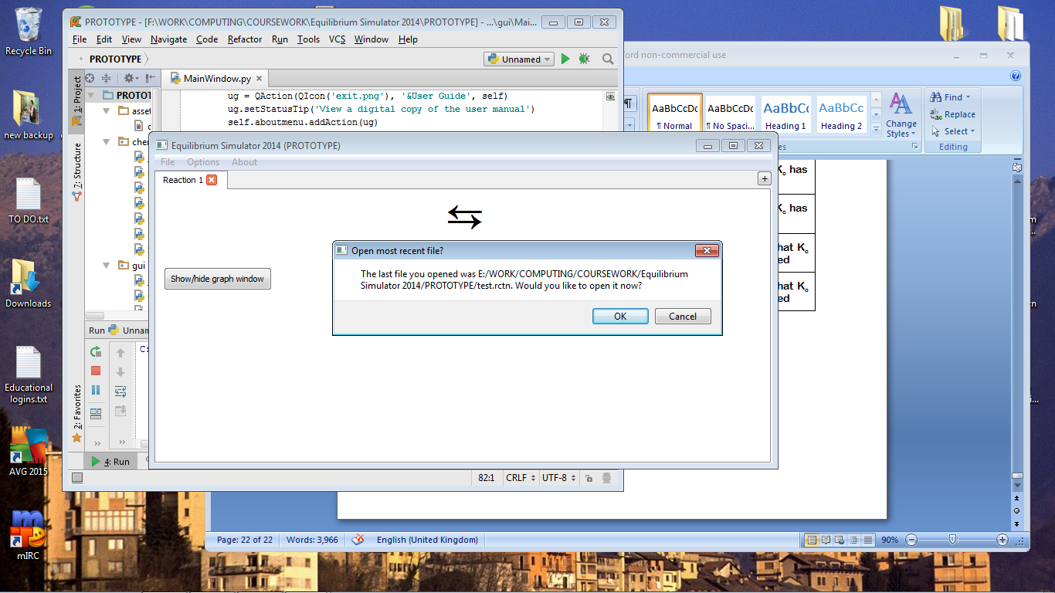

Figure 2.9: The prototype’s main screen.

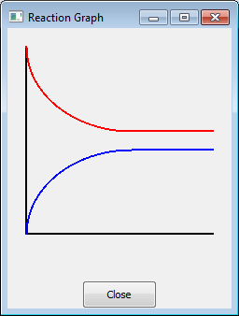

The graphing system worked well, but side-by-side comparison had not been implemented, as well as the graph axes not being labelled.

In the “Edit Conditions” dialog, some changes had to be made. Firstly chemicals would not be used in reaction calculations if the number of moles was set to 0.0, but they would still appear in the equation and have their formulae validated. This would not have been satisfactory for demonstrating reactions with a smaller number of reactants or products, or no catalyst, so a checkbox solution was developed instead. Validation had also not yet been implemented.

Figure 2.10: The prototype graph window.

The end user pointed out that as the method of entering superscript and subscript characters was not intuitive, some brief instructions would be useful. Furthermore, teachers and students are highly unlikely to know the precise strength of a catalyst per mole, so it was suggested that users select catalyst strength from four possible options: good (speeds up reaction rate by a lot); poor (speeds up reaction rate but not by as much); and inhibitor (slows down reaction). The fourth option would be not to use a catalyst. Lastly, the double arrow symbol used did not fit the convention, so a different symbol was found.

At this point, the end user also requested that Undo and Redo functions be added to the program for when changes are made to a reaction.

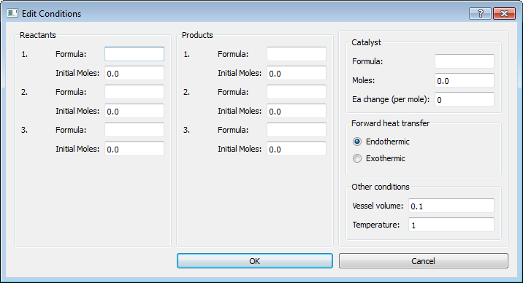

Figure 2.11: The prototype conditions dialog.

2.10.2: Prototype source code

__init__.py

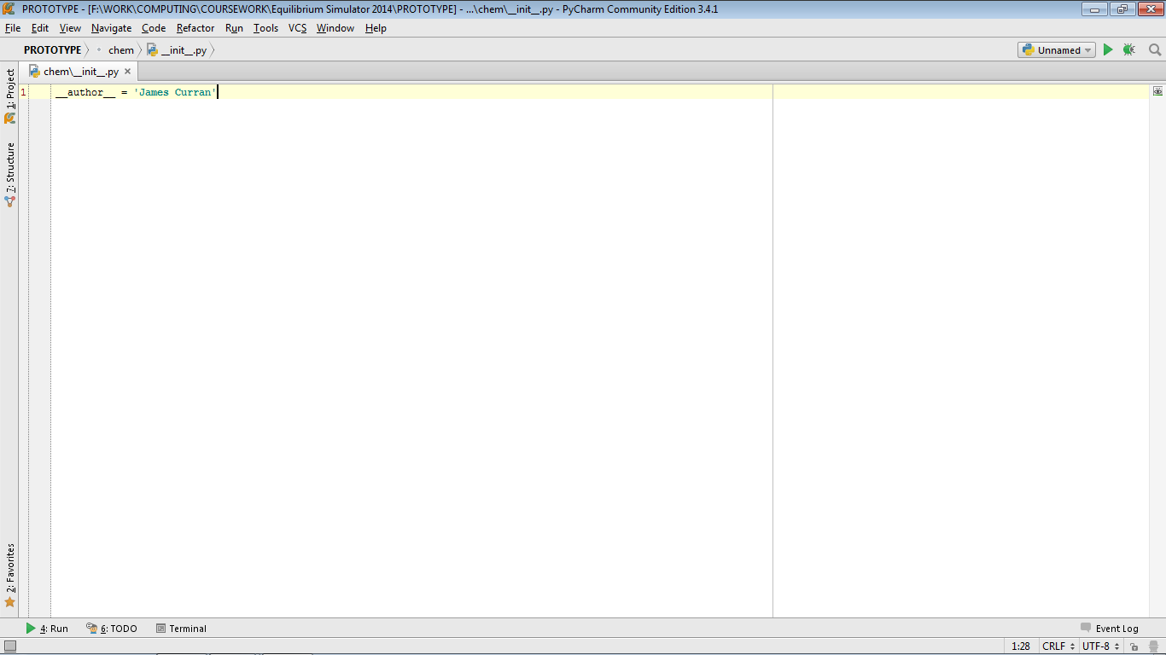

Catalyst.py

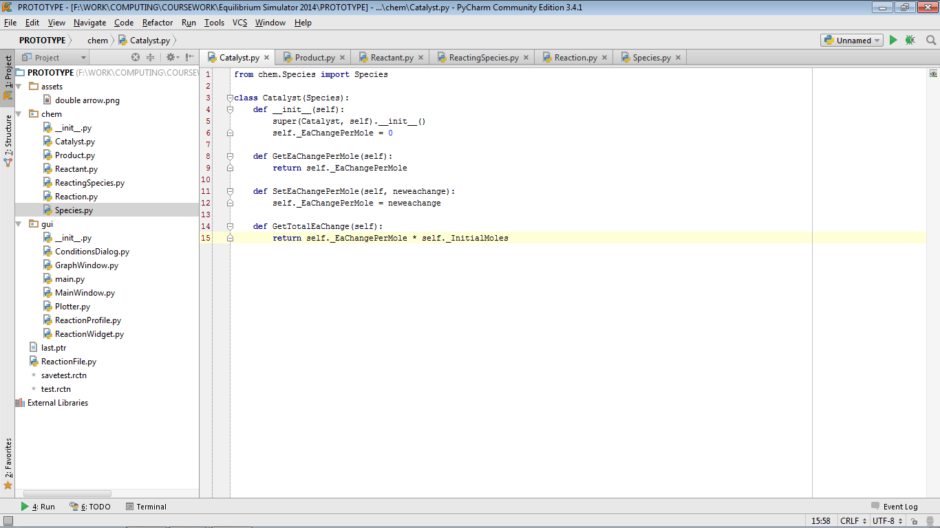

Product.py

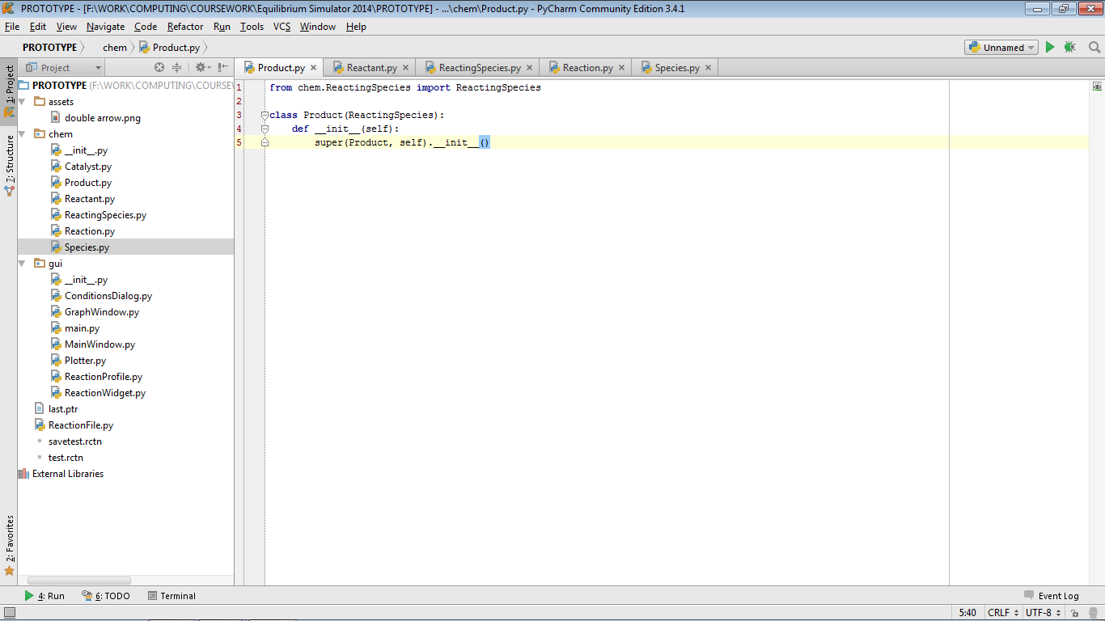

Reactant.py

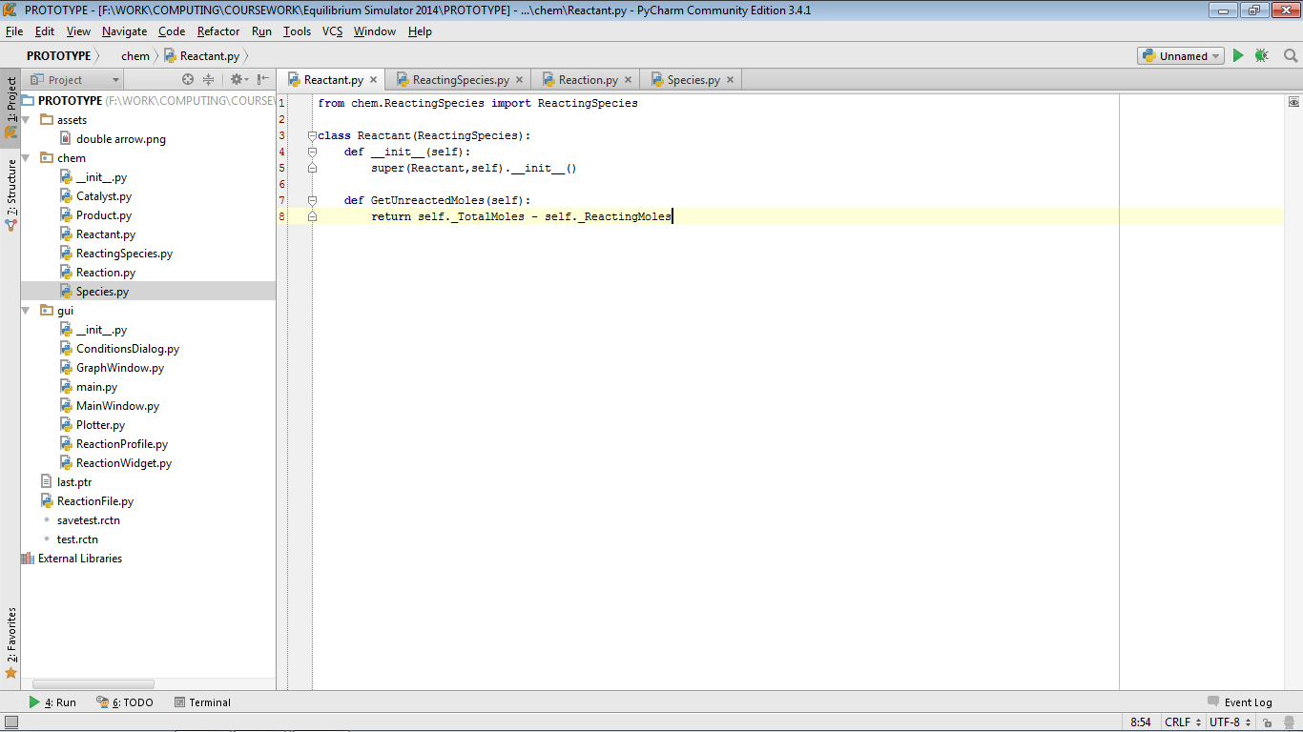

ReactingSpecies.py

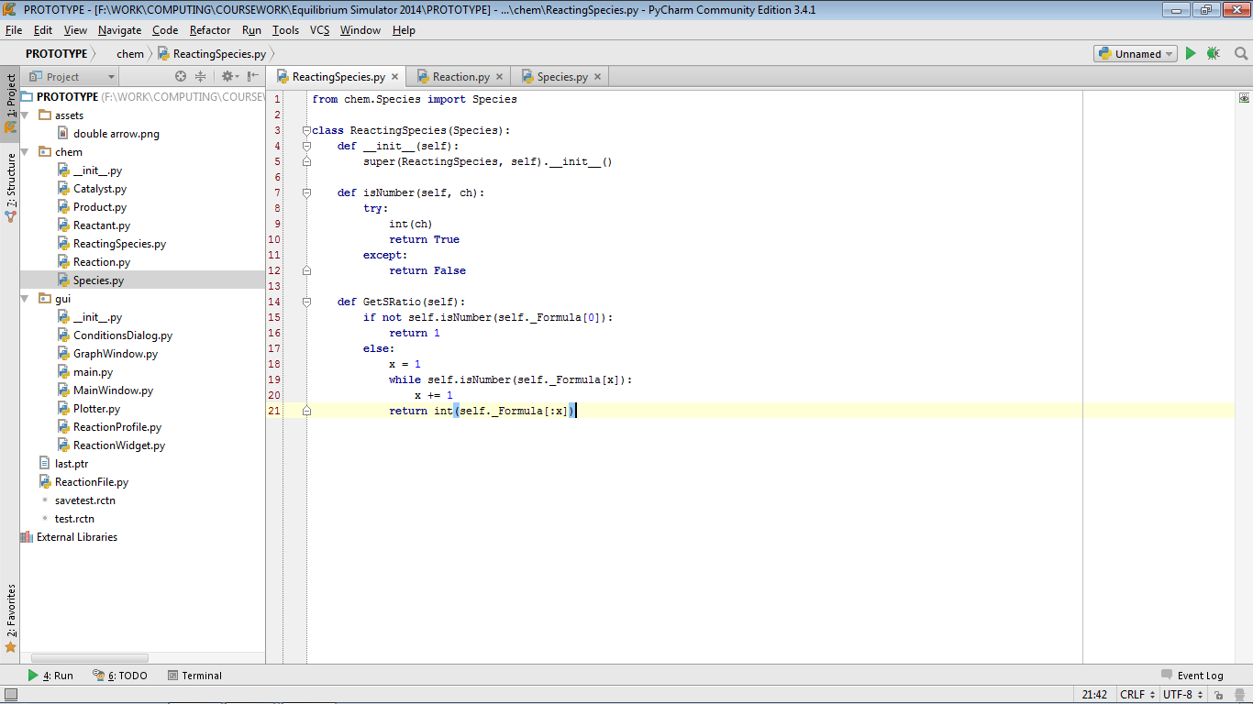

Reaction.py (part 1)

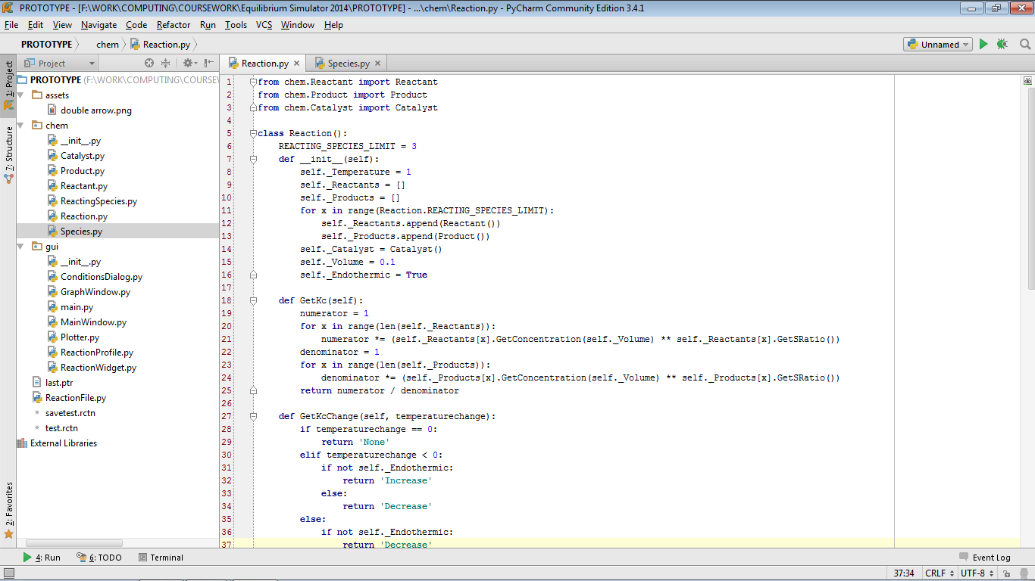  
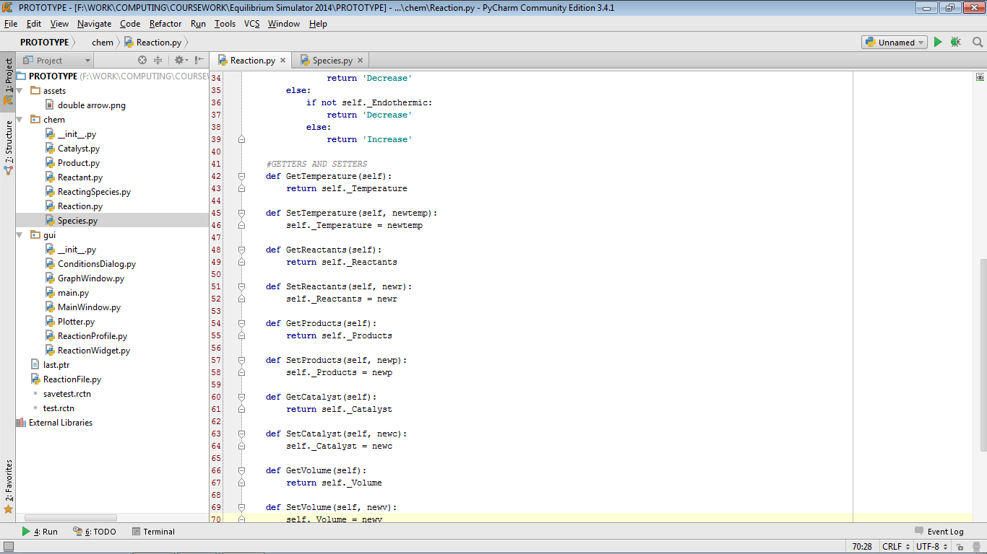

Reaction.py (part 2)

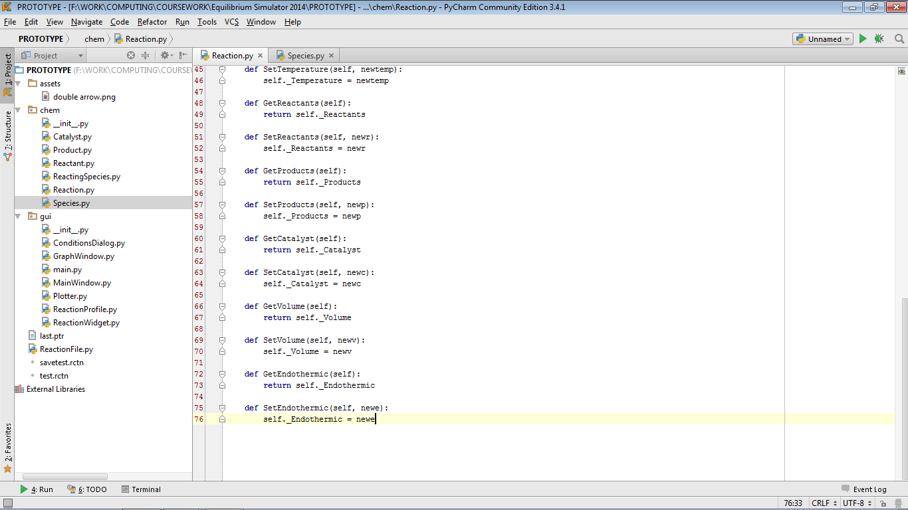

Species.py

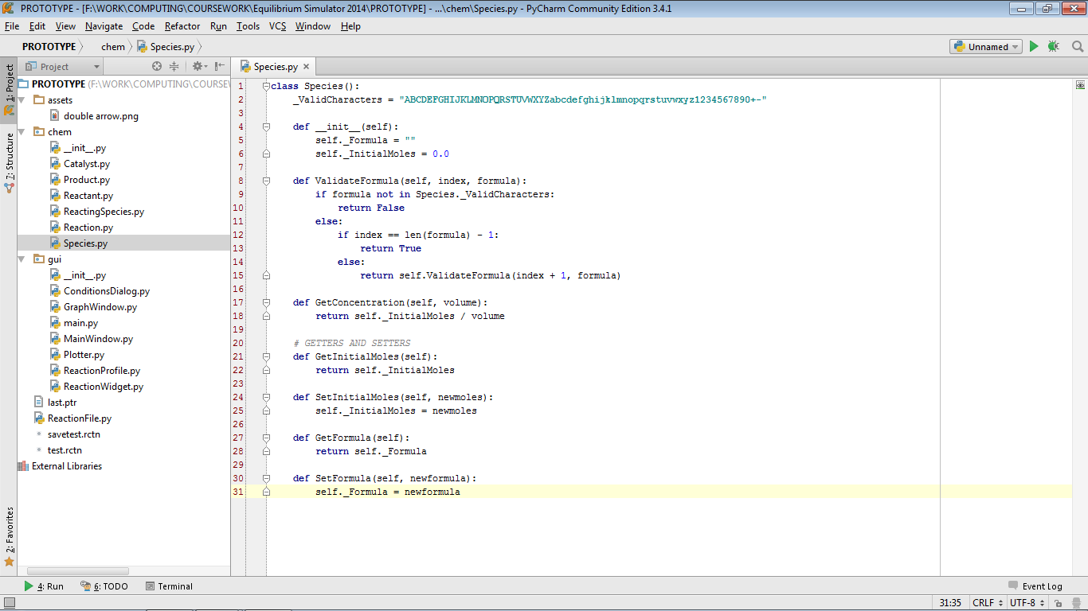

ConditionsDialog.py (part 1)

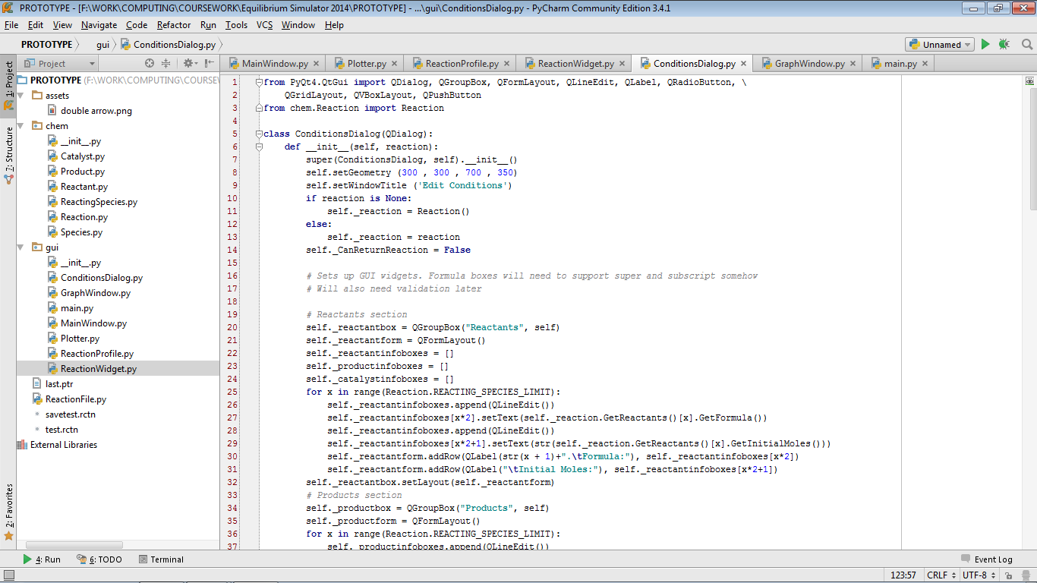  
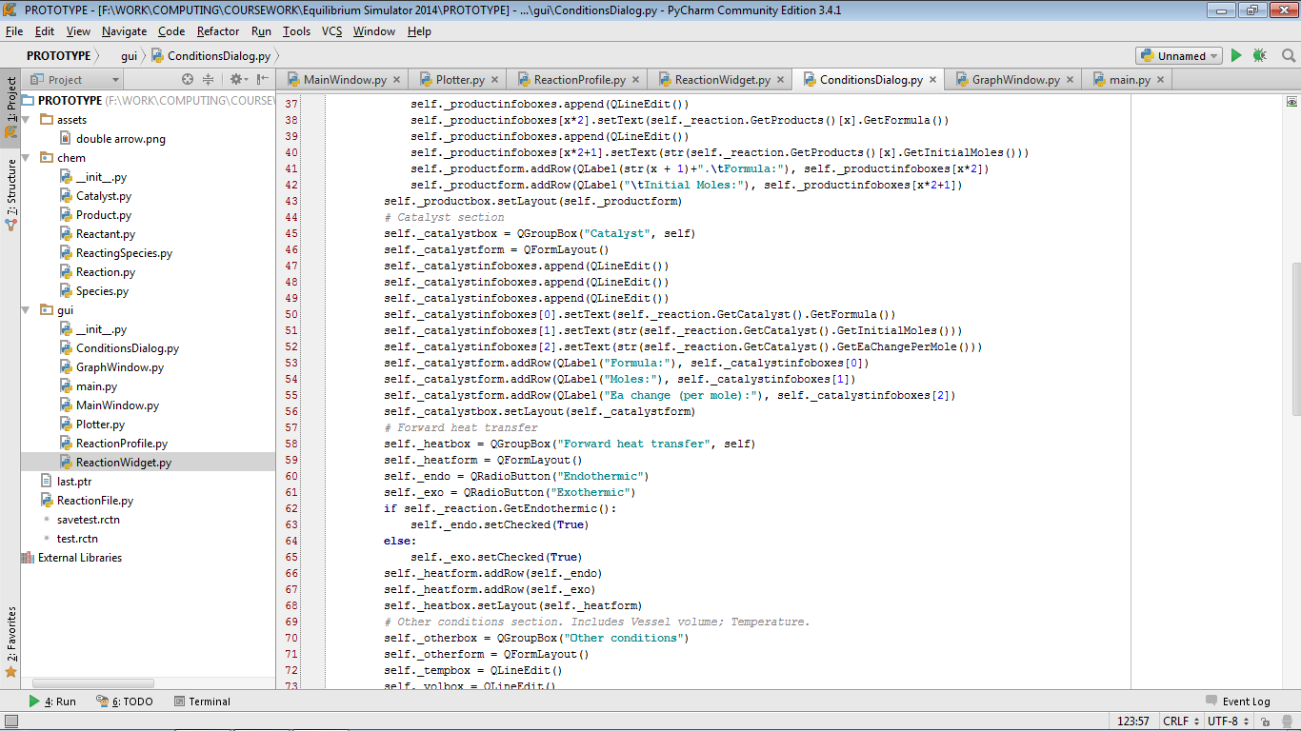

ConditionsDialog.py (part 2)

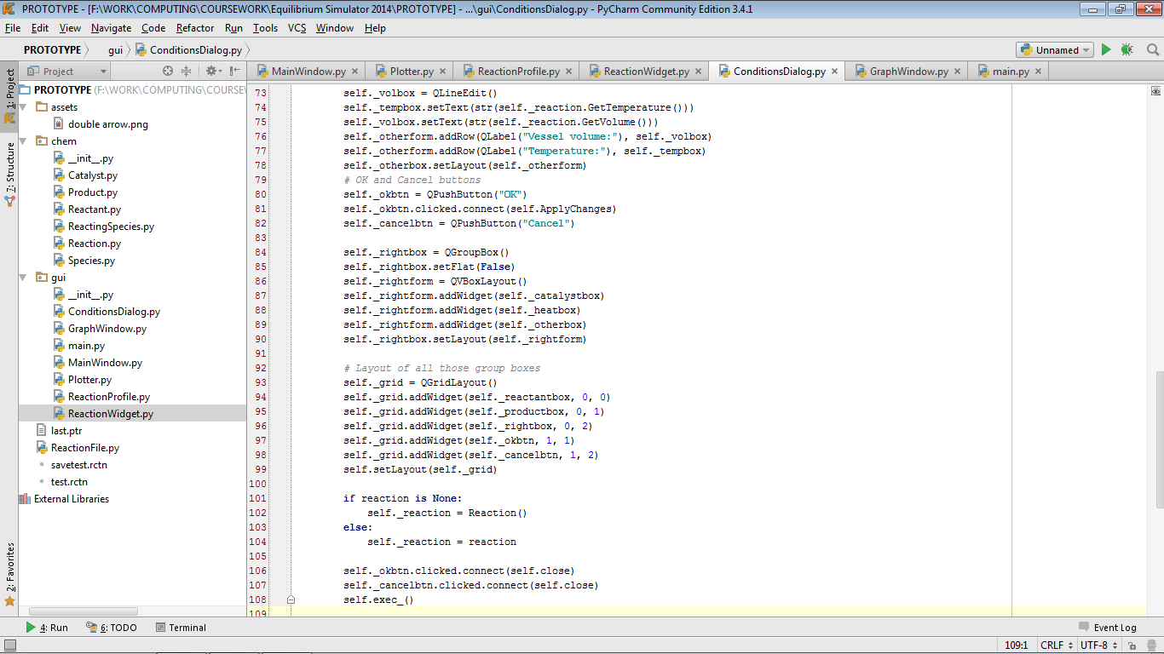  
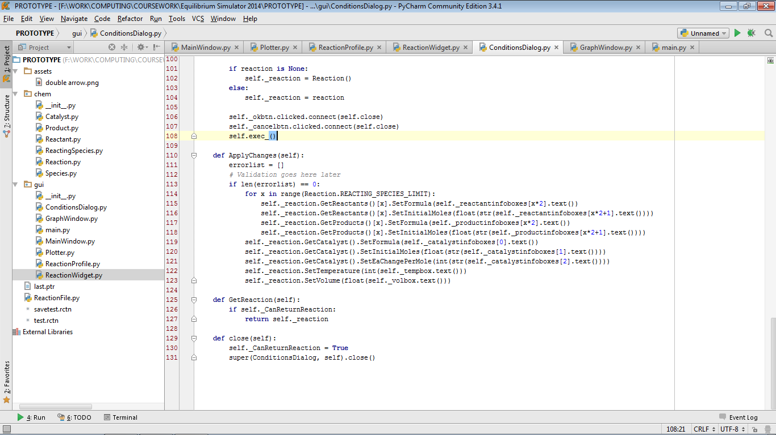

GraphWindow.py

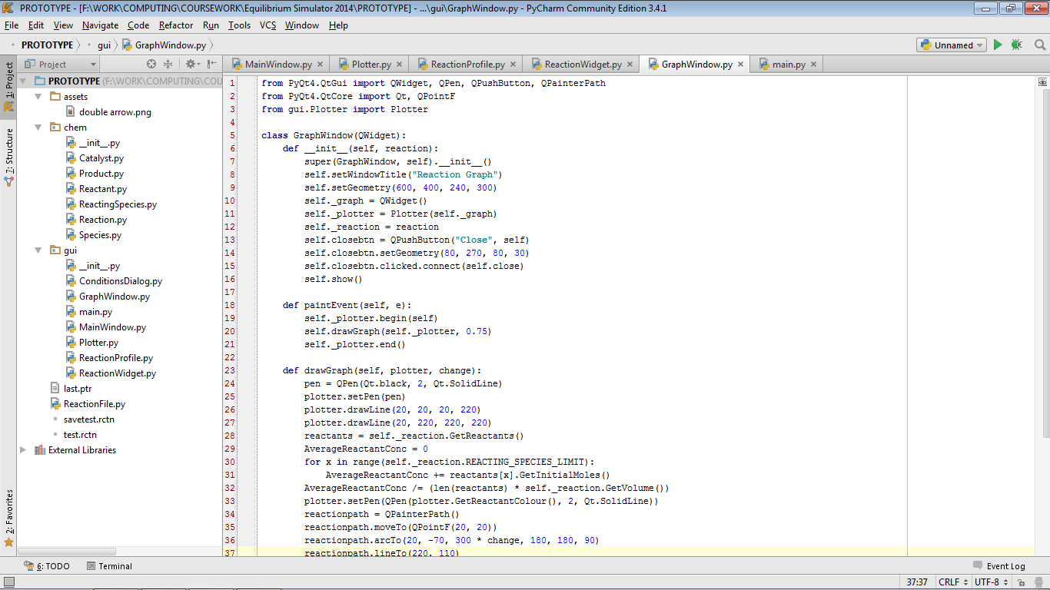  
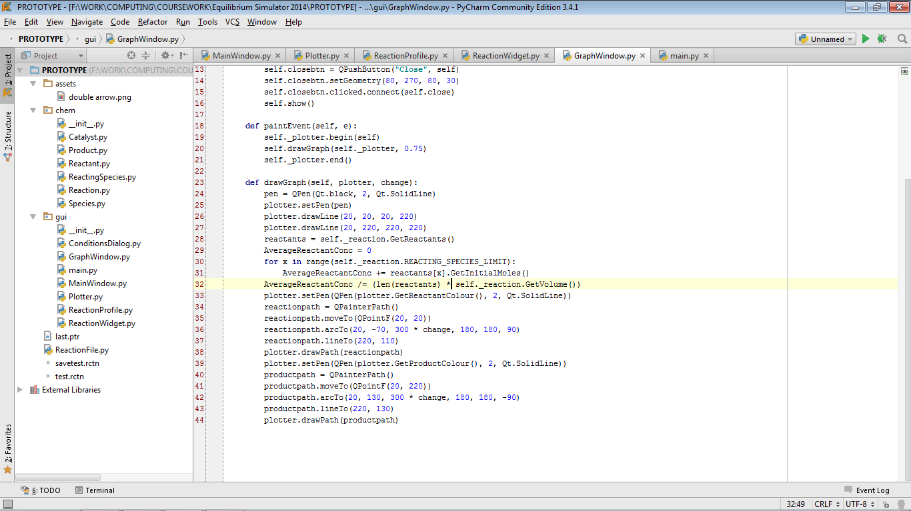

main.py  
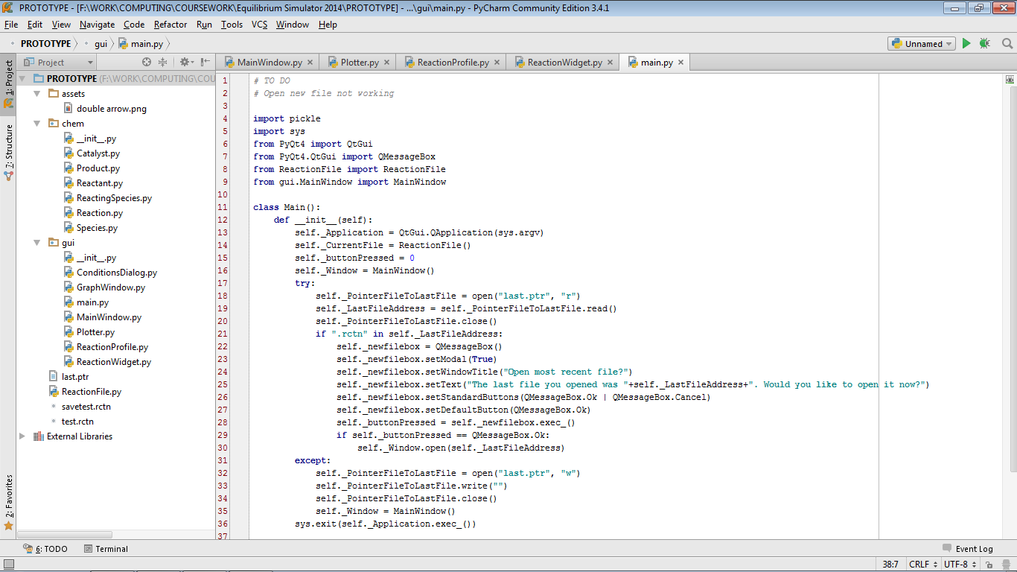  
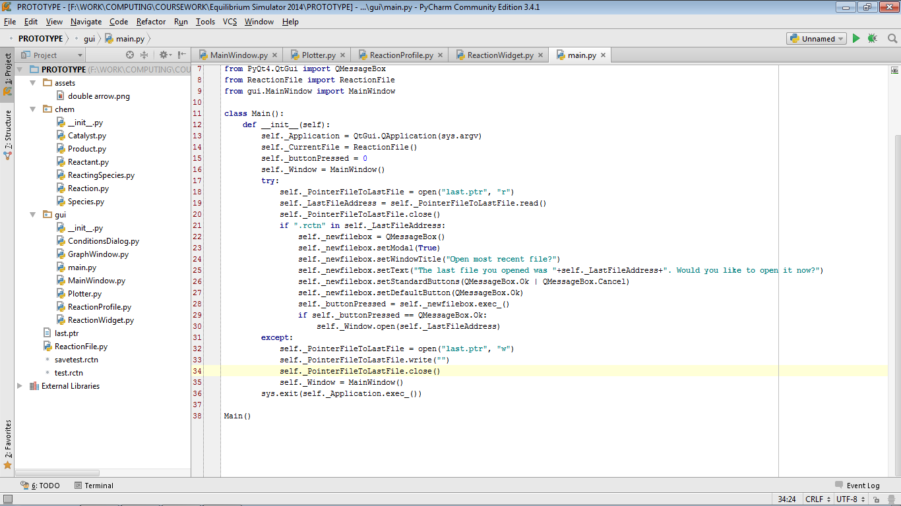

MainWindow.py (part 1)

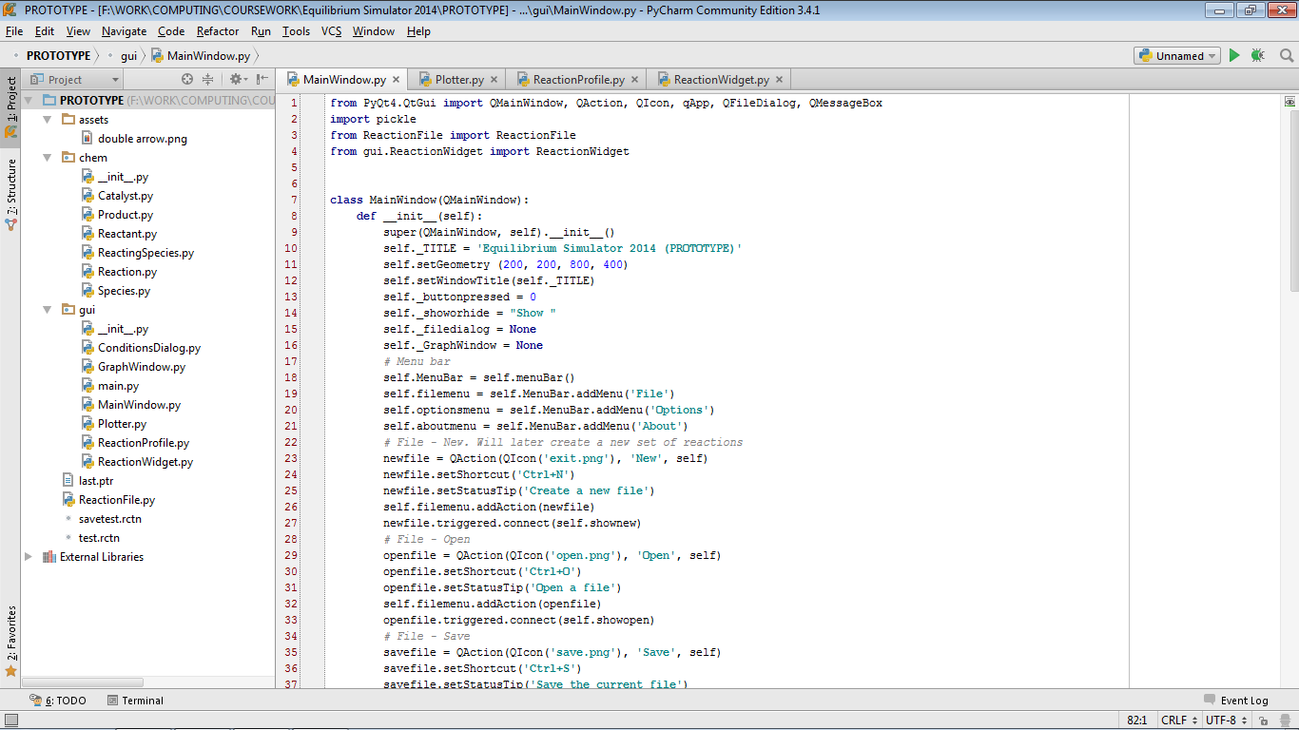

MainWindow.py (part 2)

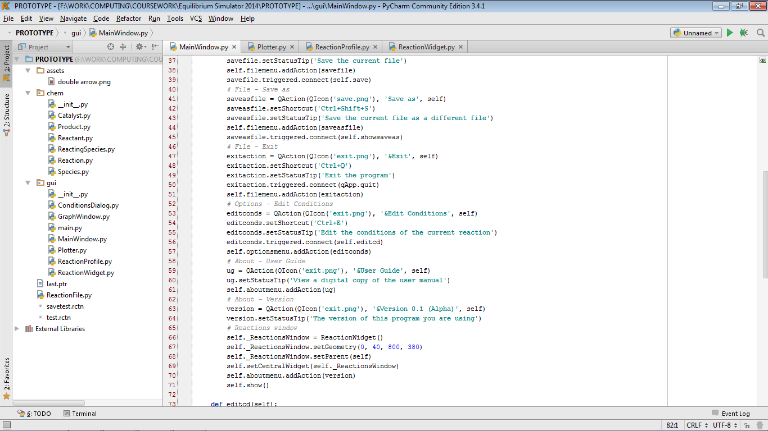  
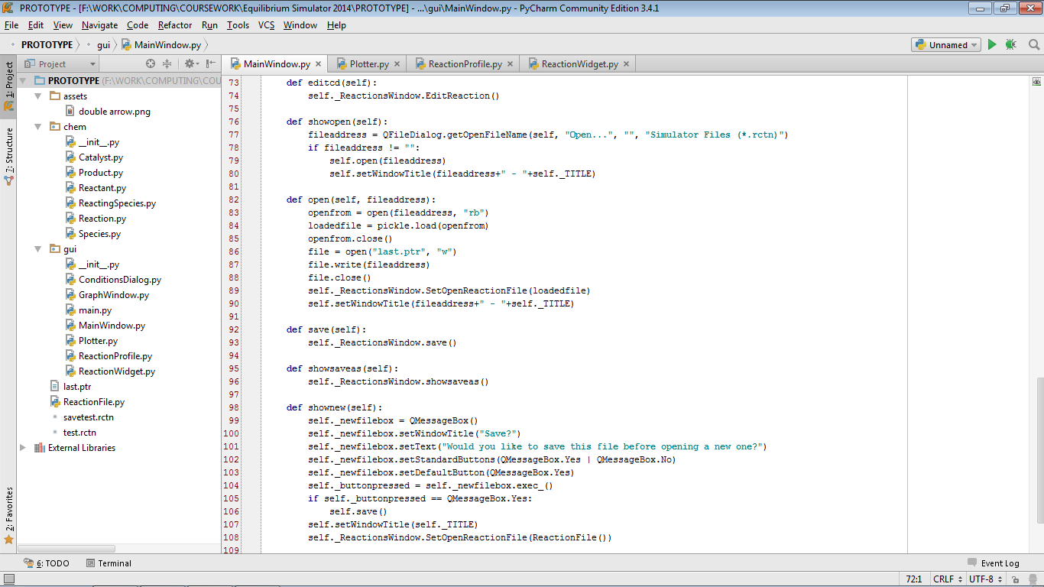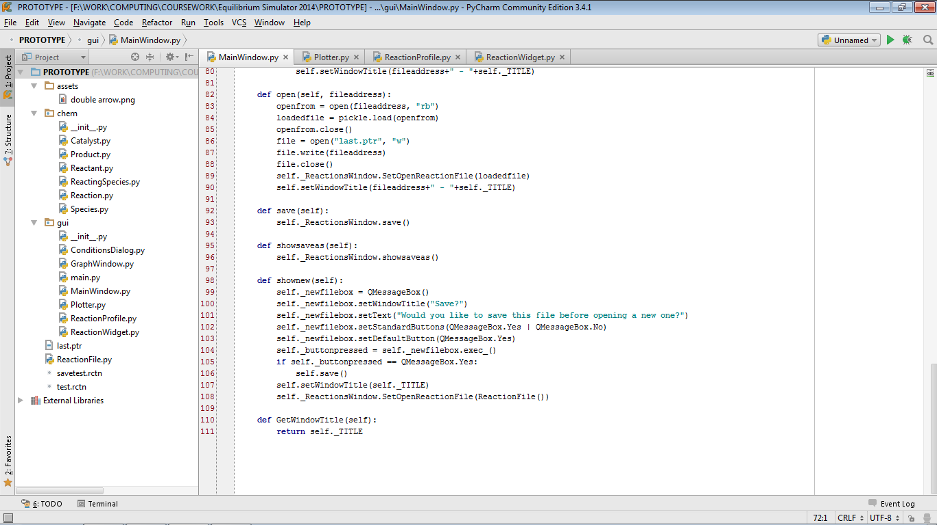

Plotter.py (part 3)

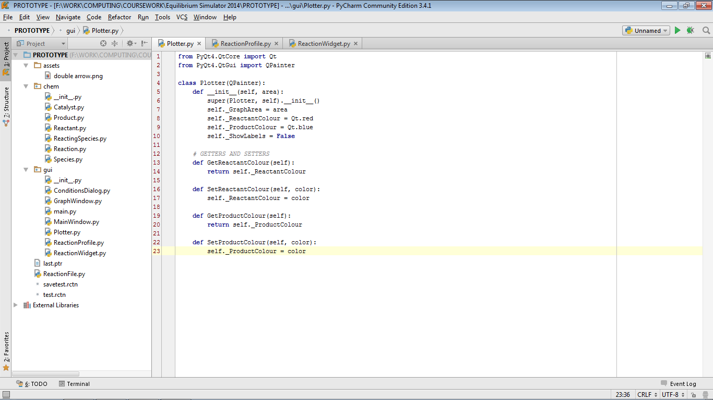

ReactionProfile.py

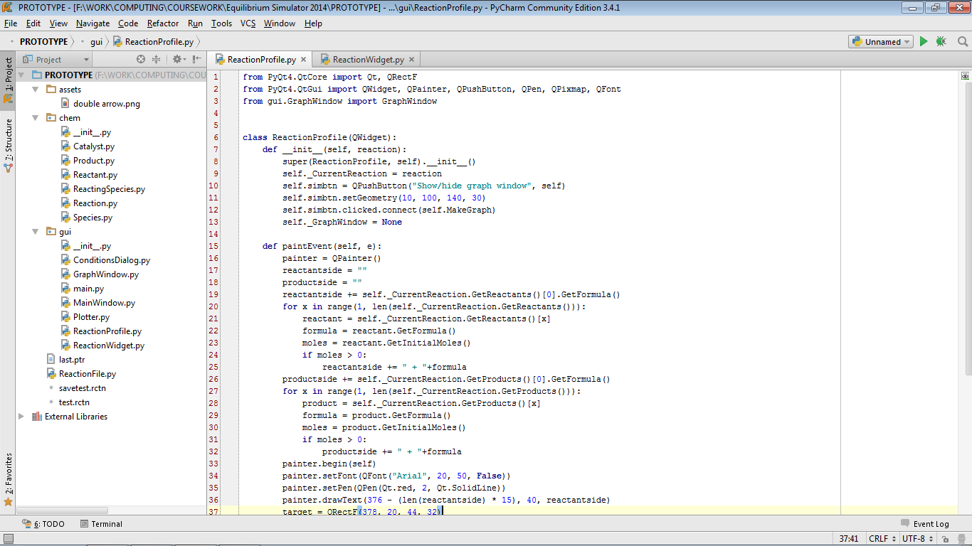  
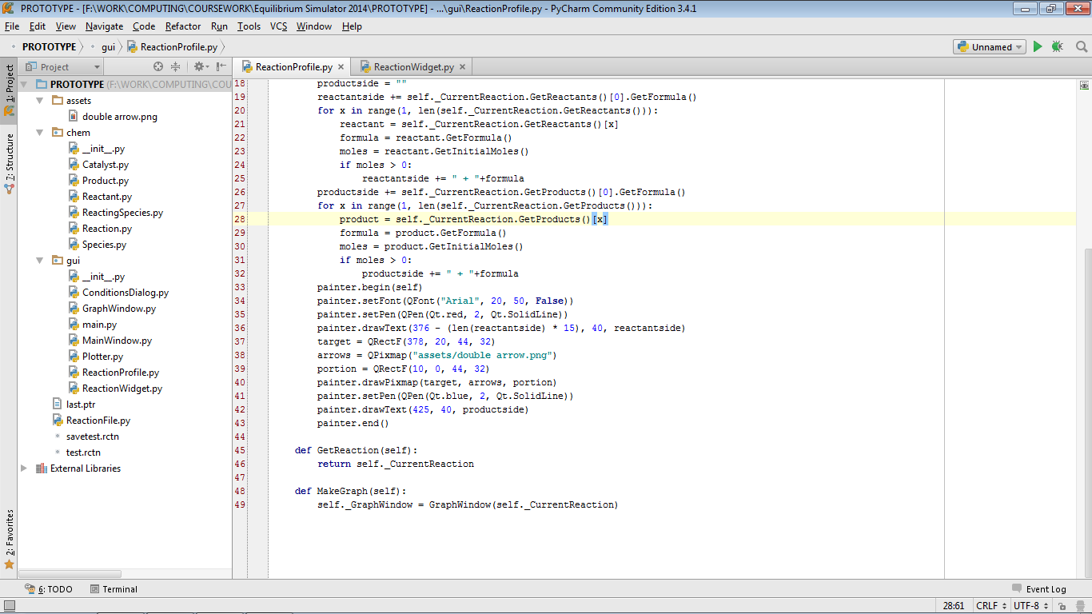

ReactionWidget.py

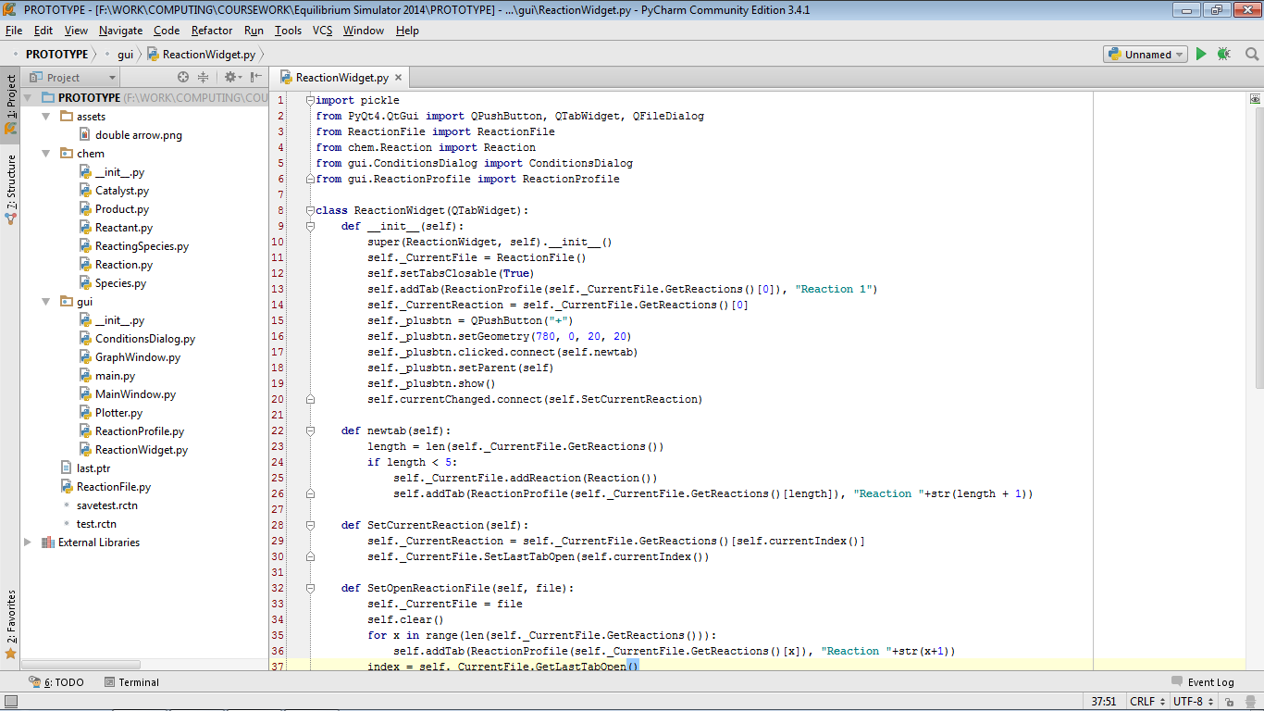  
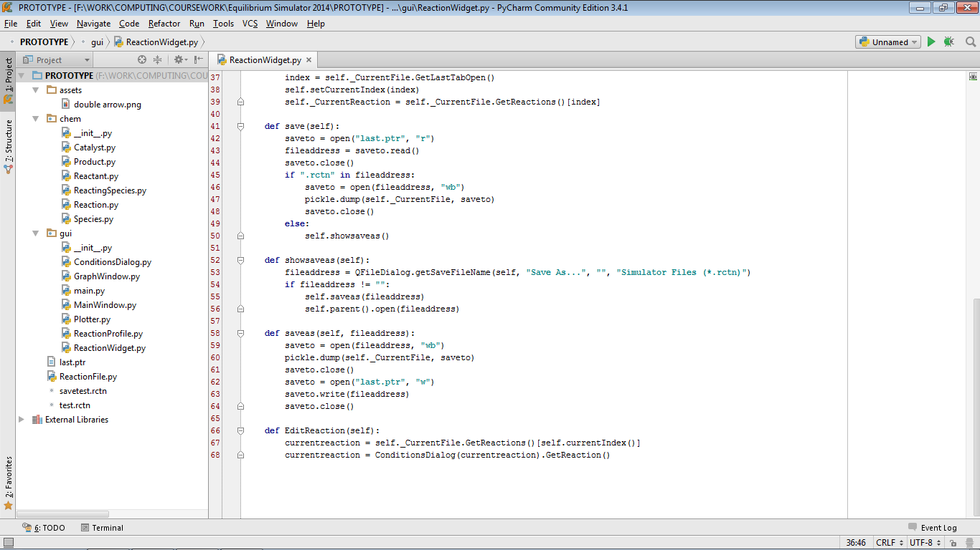

ReactionFile.py

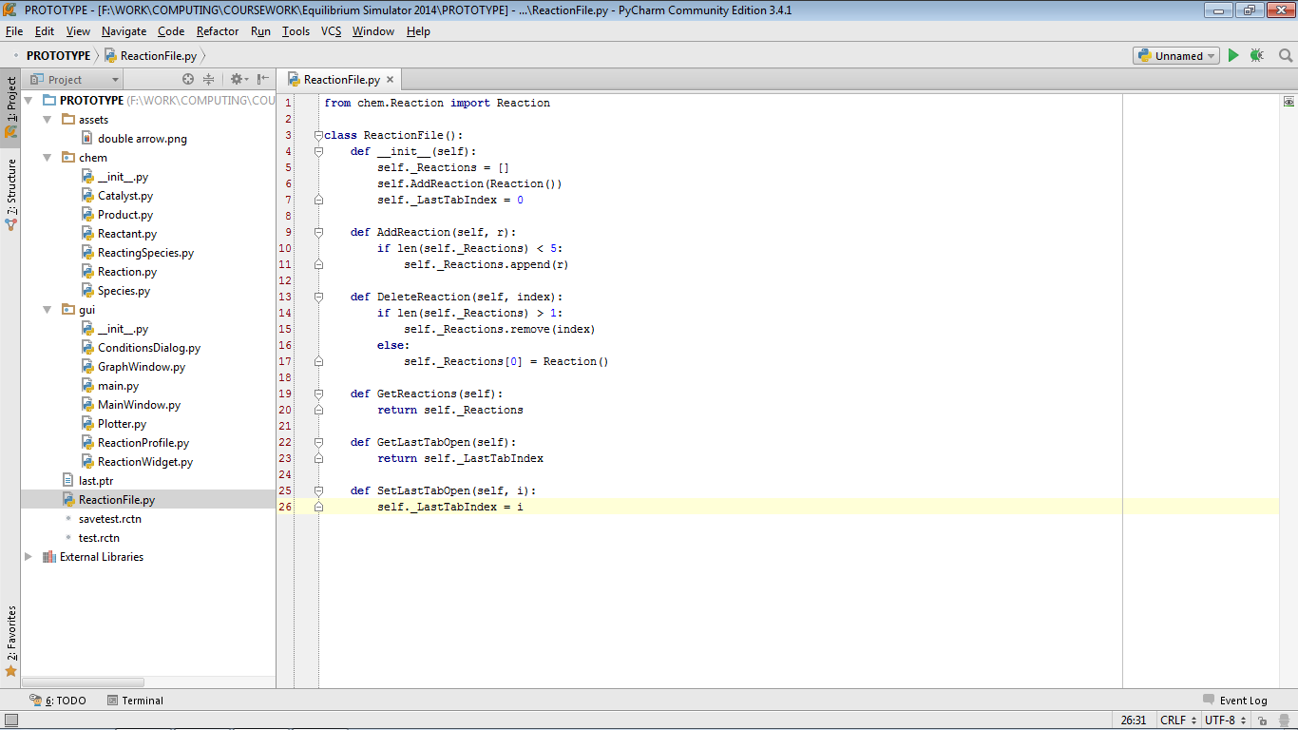

3: Technical Solution

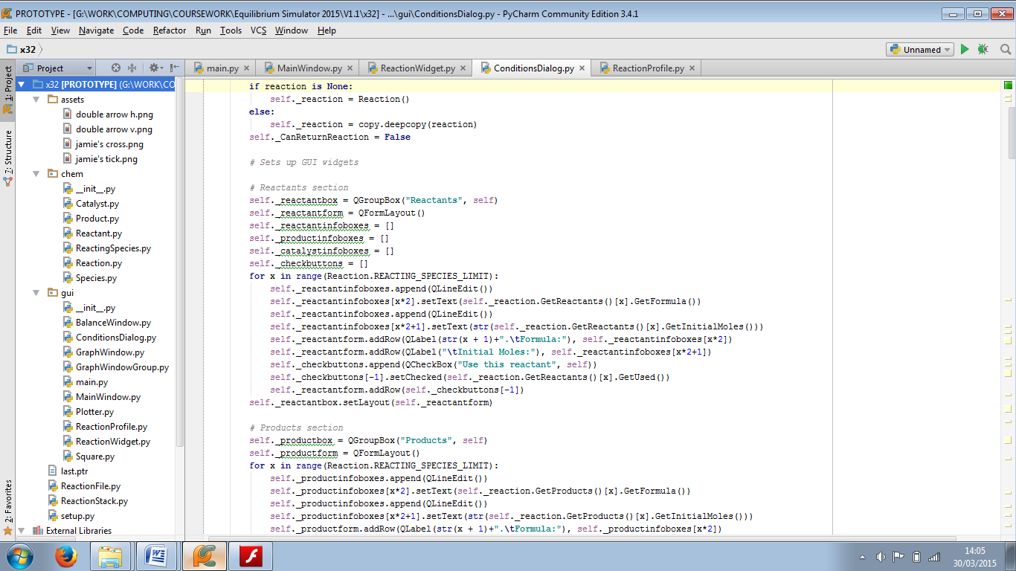The program’s source code and asset files are organised according to the file structure in figure 3.1.

The “assets” folder contains some image files to make the program more user-friendly. The “chem” package contains the classes that represent aspects of the reaction. The “gui” package contains all the classes that make up the program’s graphical user interface, as well as main.py (this is the first file to be run, and it starts the entire application). The __init__.py files are there to describe the folder to Python as a package that it can run code from.

Outside the folders are ReactionFile.py, which describes the structure of a reaction file, and ReactionStack.py, which provides stacks to hold alternate versions of reactions when the Undo or Redo functions are used. Also included is setup.py: the build script used to compile the program into a standalone binary application.

Item 11 of the Appendix consists of images of the program’s source code, and setup.py, at the time of distribution to the end user.

Figure 3.1: The program’s file and folder structure

4: Testing

4.1: Validation

4.1.1: Tests performed

Validation does not need to be performed in all areas where users enter input, because in many cases the user can only enter pre-selected values which are known to be valid, using widgets such as drop-down menus, checkboxes or radio buttons. No validation is programmed for entering file names for saving and opening, as the program’s framework does this already. However, validation needs to be performed in the conditions dialog, as this is the only other area of the application which gives users opportunities to enter whatever data they want.

All text boxes for entering the name of a chemical are created the same way and use the same validation algorithm. Also, all text boxes for entering the number of moles of a chemical are created the same way and use the same validation algorithm. This is why only the test results for reactant 1 are provided.

Validation is only carried out on the reactants, products or catalyst which the user selects to use in the reaction, so that the user is not forced to unnecessarily enter valid data for all available chemicals if the user does not want to use some of them.

When each input area is tested, all other input areas are given valid data to make the result more clear.

Two regex expressions were used for validation:

* R1, for chemical formulae:   
  [2-9]?(\(([A-Z][a-z]?(_[0-9])*)+\)(_[0-9])*|[A-Z][a-z]?(_[0-9])*)+((\^[0-9])*\^(\+|-))?
* R2, for decimal numbers: [0-9]?[0-9]\.[0-9][0-9]?

Key to test types: N = normal; E = erroneous; B = boundary

|  |  |  |  |
| --- | --- | --- | --- |
| Test number | Test type; input data | Result | Cross-reference |
| 1 | N; “2NaCl” | Pass | Figure 4.1.1 |
| 2 | E; “2N@C&” | Pass | Figure 4.1.2 |
| 3 | E; “” | Pass | Figure 4.1.3 |
| 4 | B; “H” | Pass | Figure 4.1.4 |
| 5 | B; “CH_3COO(CH_2)_4C_1_0H_2_1” | Pass | Figure 4.1.5 |
| 6 | N; “24.53” | Pass | Figure 4.1.6 |
| 7 | E; “101.42” | Pass | Figure 4.1.7 |
| 8 | E; “-4.24” | Pass | Figure 4.1.8 |
| 9 | E; “” | Pass | Figure 4.1.9 |
| 10 | E; “6” | Pass | Figure 4.1.10 |
| 11 | E; “4. | Pass | Figure 4.1.11 |
| 12 | E; “3.14159” | Pass | Figure 4.1.12 |
| 13 | E; “sixteen” | Pass | Figure 4.1.13 |
| 14 | B; “99.99” | Pass | Figure 4.1.14 |
| 15 | B; “0.01” | Pass | Figure 4.1.15 |
| 16 | N; “13.37” | Pass | Figure 4.1.16 |
| 17 | E; “133.75” | Pass | Figure 4.1.17 |
| 18 | E; “-42.69” | Pass | Figure 4.1.18 |
| 19 | E; “” | Pass | Figure 4.1.19 |
| 20 | E; “72” | Pass | Figure 4.1.20 |
| 21 | E; “72.” | Pass | Figure 4.1.21 |
| 22 | E; “1.234” | Pass | Figure 4.1.22 |
| 23 | E; “fourteen” | Pass | Figure 4.1.23 |
| 24 | B; “99.99” | Pass | Figure 4.1.24 |
| 25 | B; “0.01” | Pass | Figure 4.1.25 |
| 26 | N; “450” | Pass | Figure 4.1.26 |
| 27 | E; “2000” | Pass | Figure 4.1.27 |
| 28 | E; “-200” | Pass | Figure 4.1.28 |
| 29 | E; “” | Pass | Figure 4.1.29 |
| 30 | E; “Boiling” | Pass | Figure 4.1.30 |
| 31 | B; “1” | Pass | Figure 4.1.31 |
| 32 | B; “999” | Pass | Figure 4.1.32 |

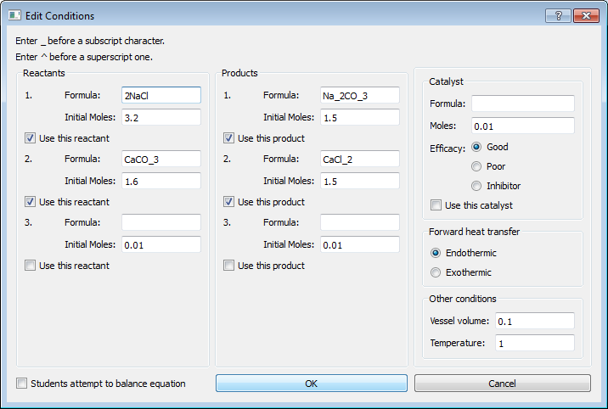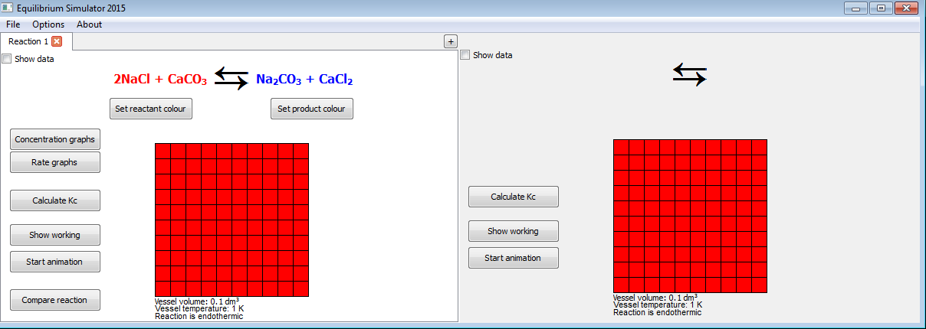

Figure 4.1.1: Window (left) closes, reaction updates and user can continue

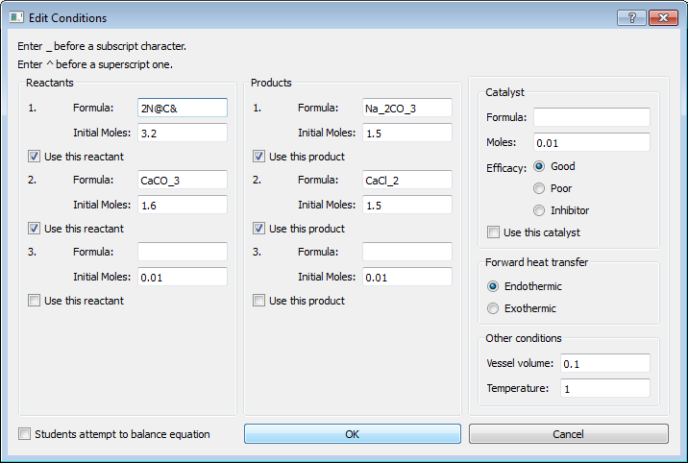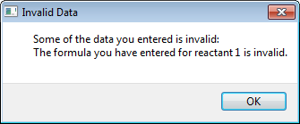

Figure 4.1.2: Popup box appears (right), explaining that formula is invalid

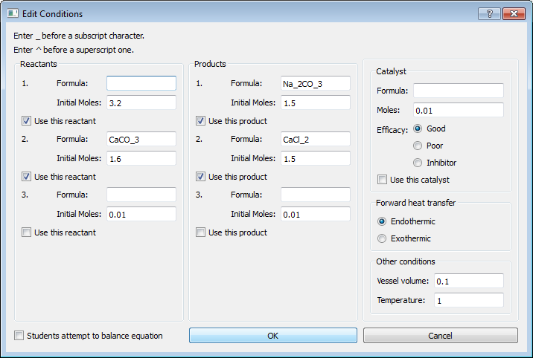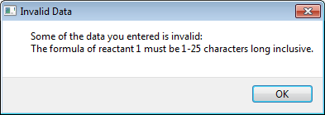

Figure 4.1.3: Popup box appears (right), explaining the accepted formula length

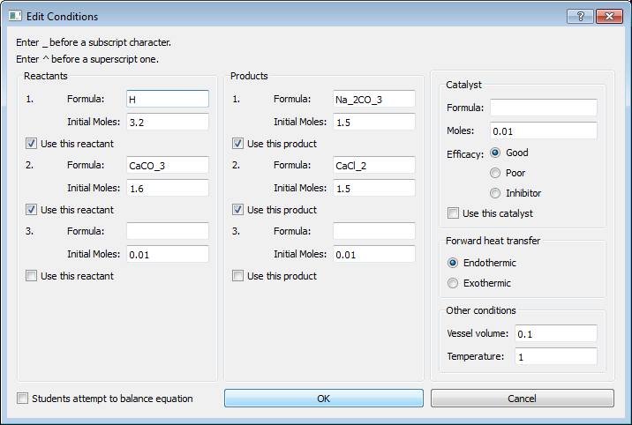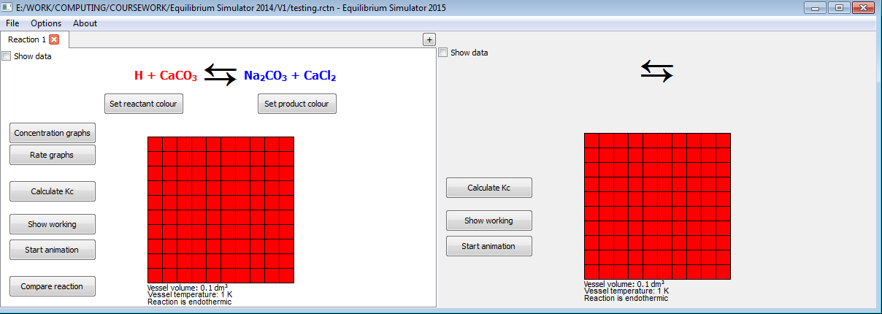

Figure 4.1.4: Window (left) closes, reaction updates and user can continue

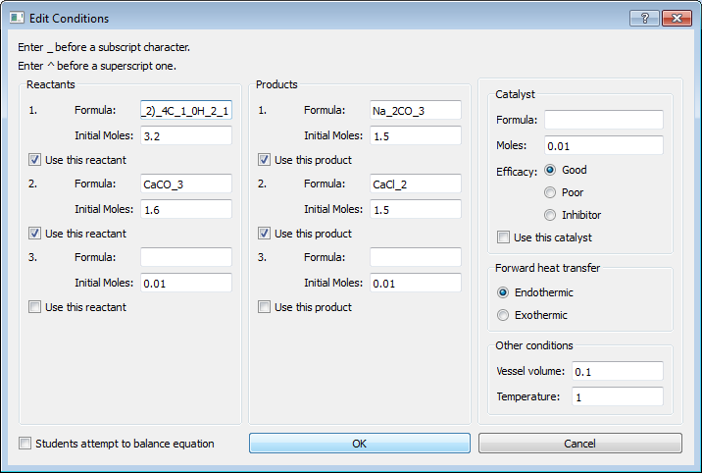 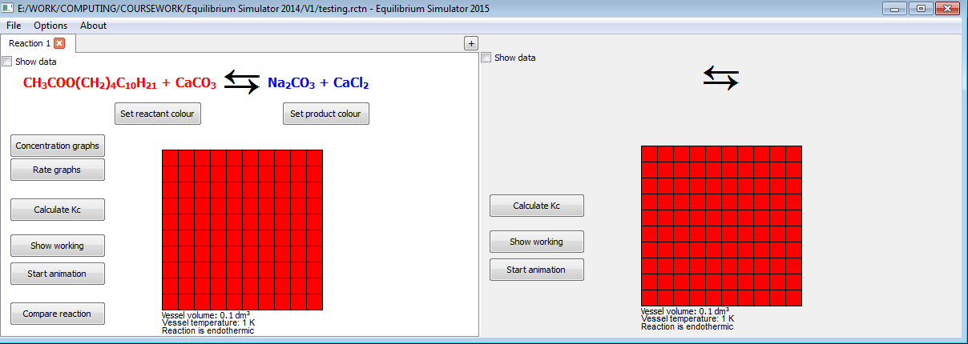

Figure 4.1.5: Window (left) closes, reaction updates and user can continue. Full string used: CH_3COO(CH_2)_4C_1_0H_2_1

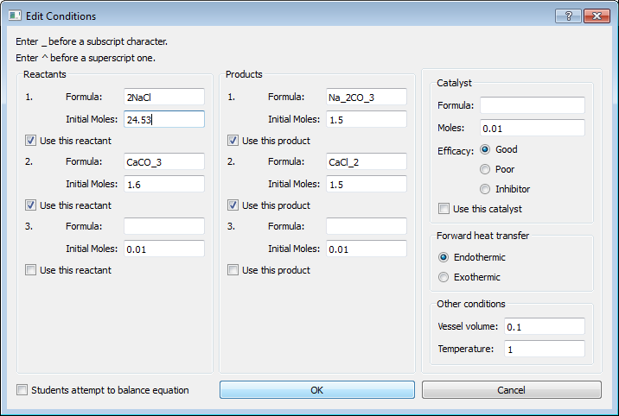 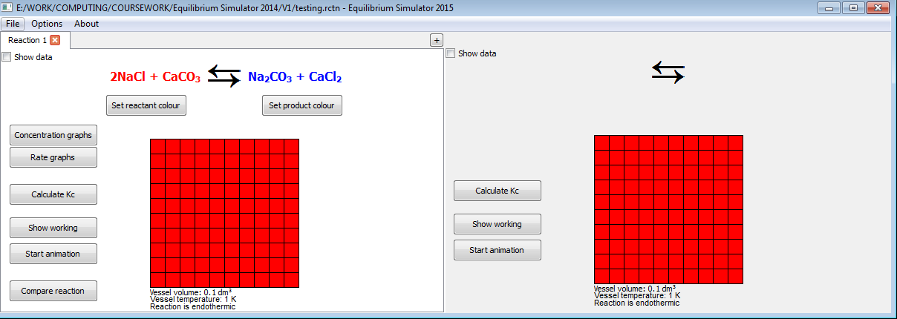

Figure 4.1.6: Window (left) closes, reaction updates and user can continue

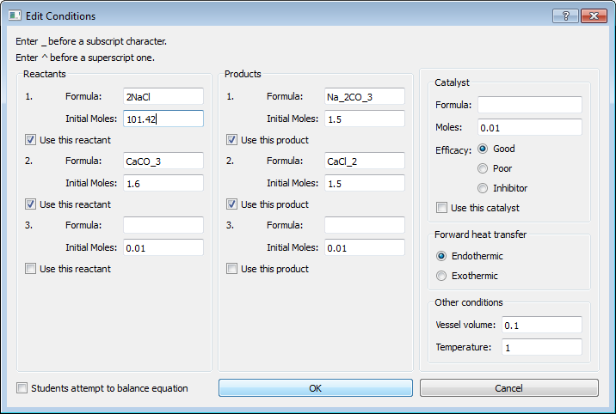 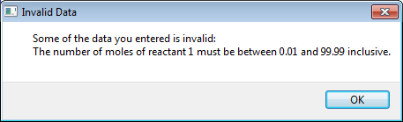

Figure 4.1.7: Popup box appears (right), explaining the accepted range

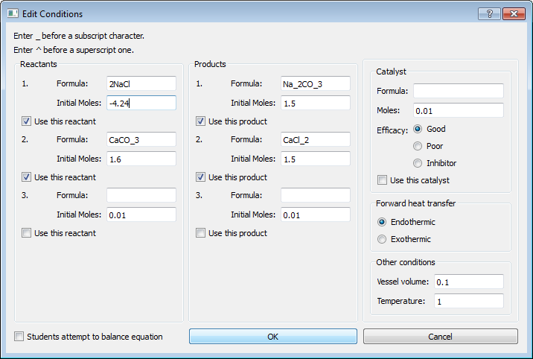 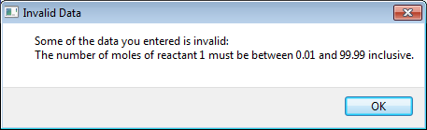

Figure 4.1.8: Popup box appears (right), explaining the accepted range

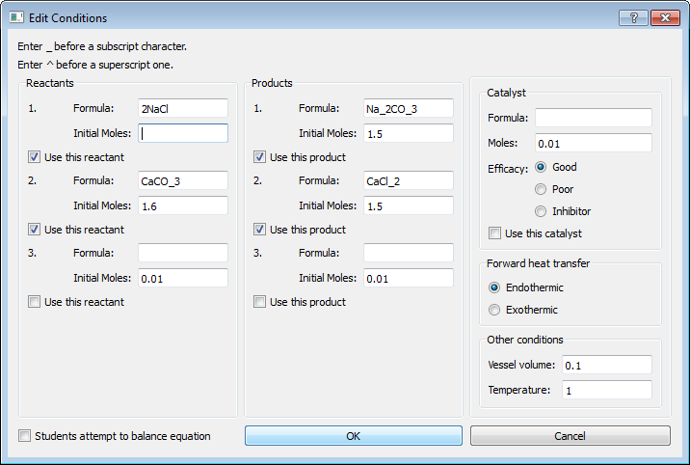 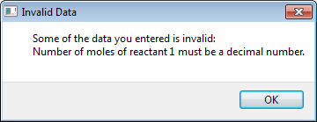

Figure 4.1.9: Popup box appears (right), explaining that a decimal number must be entered

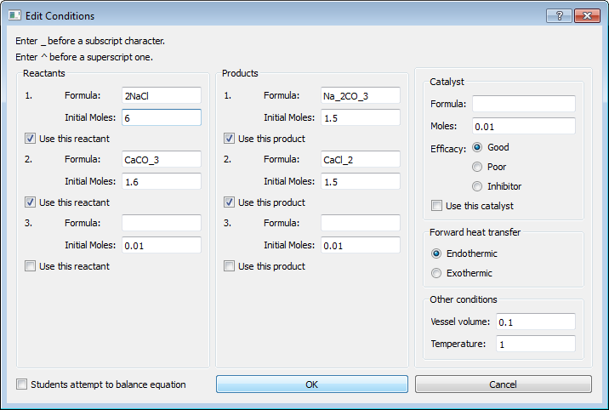 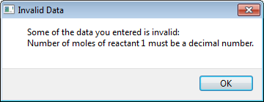

Figure 4.1.10: Popup box appears (right), explaining that a decimal number must be entered

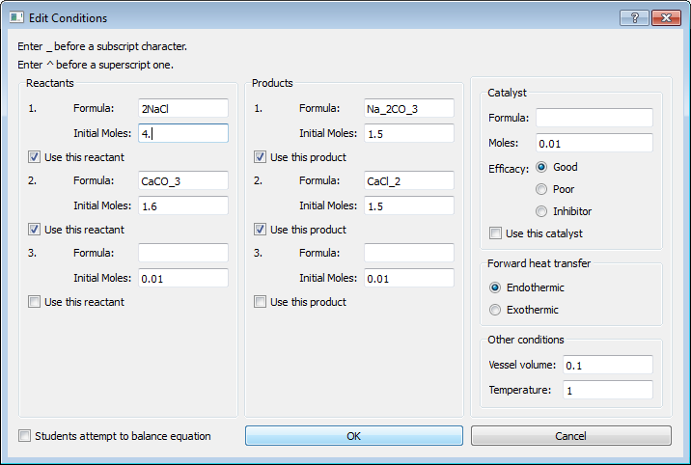 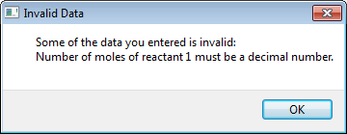

Figure 4.1.11: Popup box appears (right), explaining that a decimal number must be entered

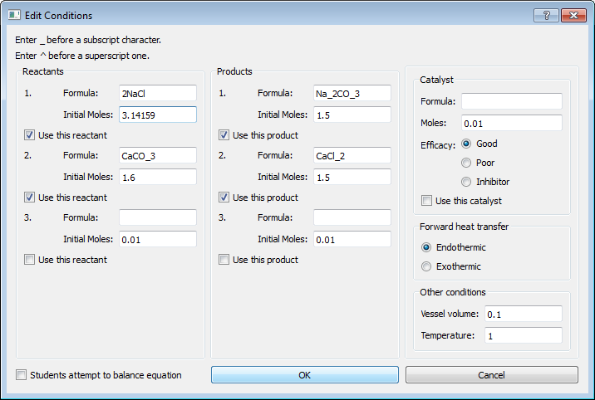 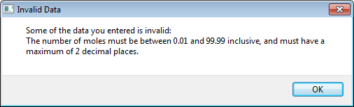

Figure 4.1.12: Popup box appears (right), explaining the accepted value range and precision

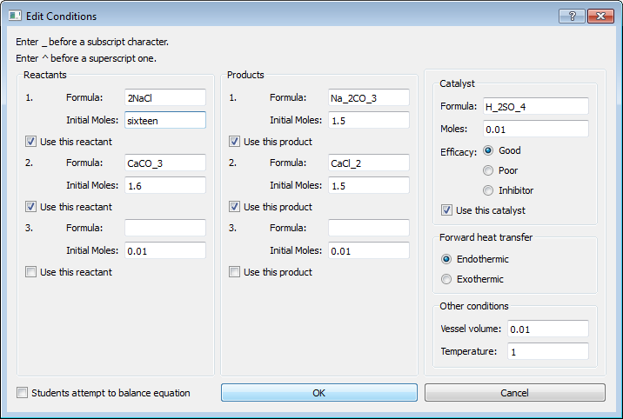 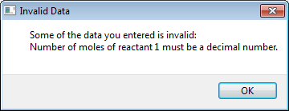

Figure 4.1.13: Popup box appears (right), explaining that it must be a decimal number

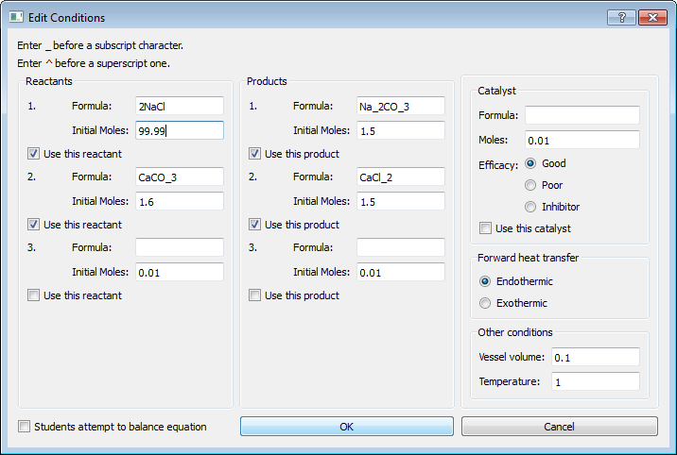 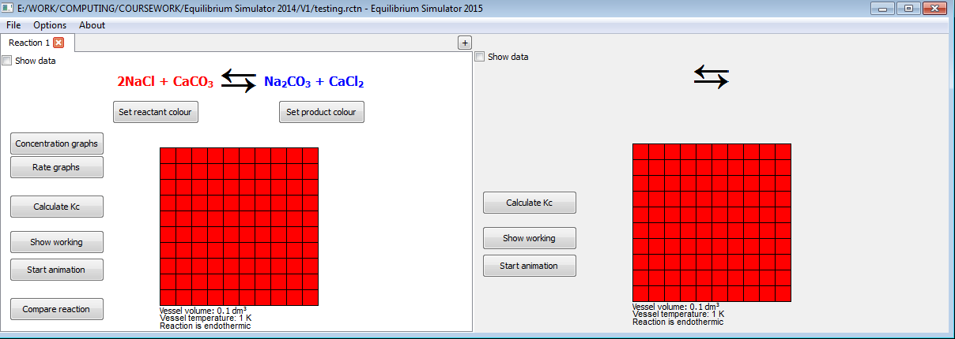

Figure 4.1.14: Window (left) closes, reaction updates and user can continue

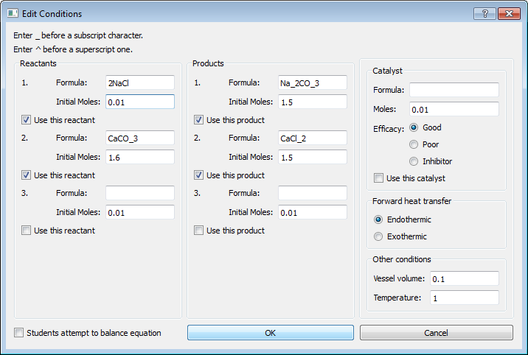 

Figure 4.1.15: Window (left) closes, reaction updates and user can continue

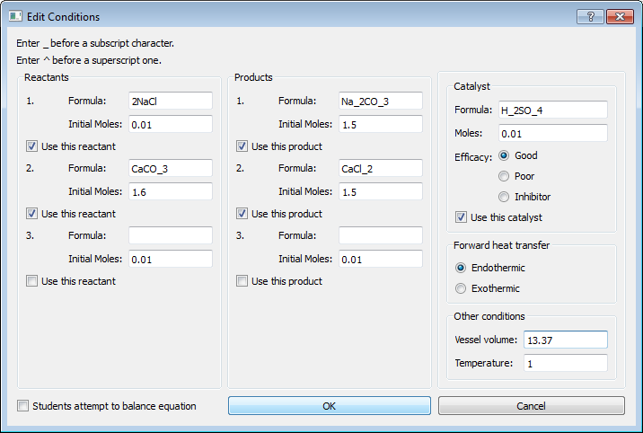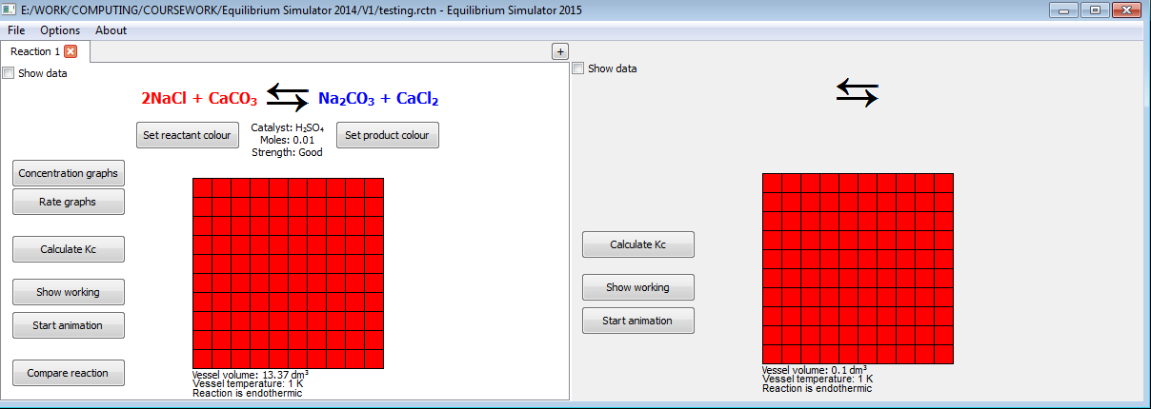

Figure 4.1.16: Window (left) closes, reaction updates and user can continue

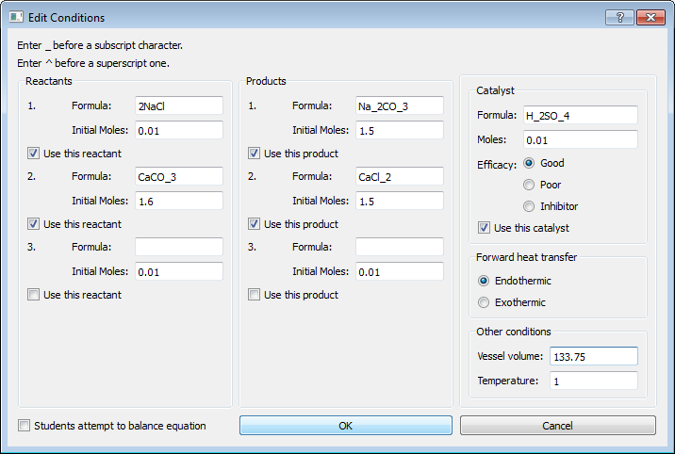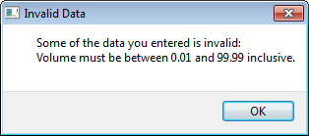

Figure 4.1.17: Popup box appears (right), explaining accepted range

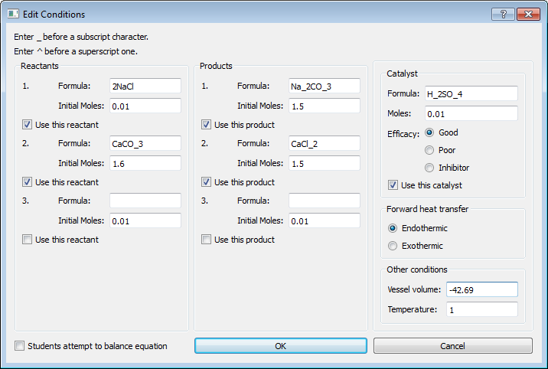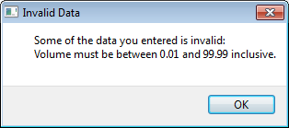

Figure 4.1.18: Popup box appears (right), explaining accepted range

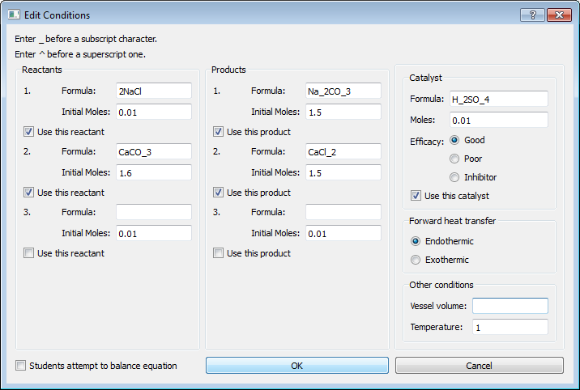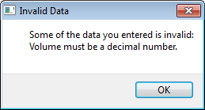

Figure 4.1.19: Popup box appears (right), explaining that a decimal number must be entered

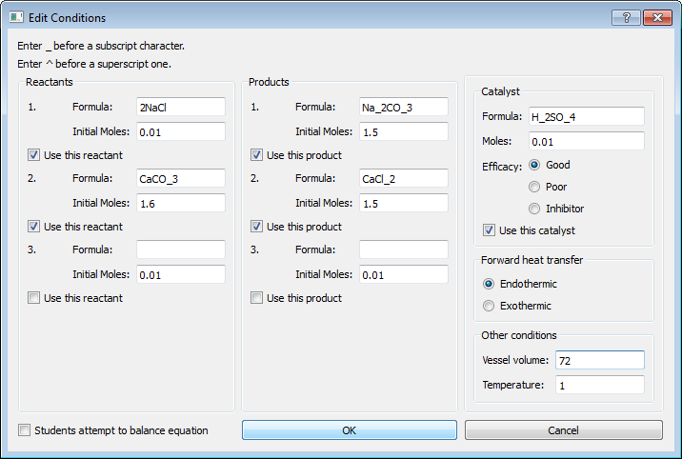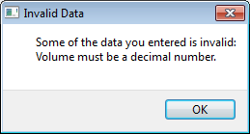

Figure 4.1.20: Popup box appears (right), explaining that a decimal number must be entered

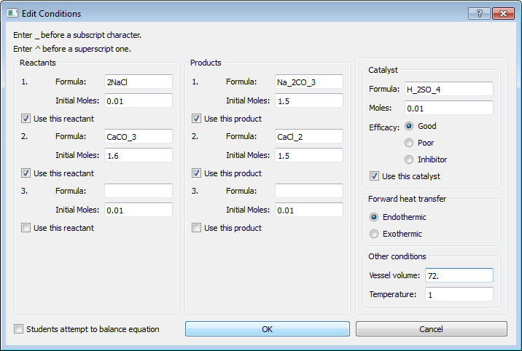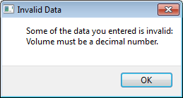

Figure 4.1.21: Popup box appears (right), explaining that a decimal number must be entered

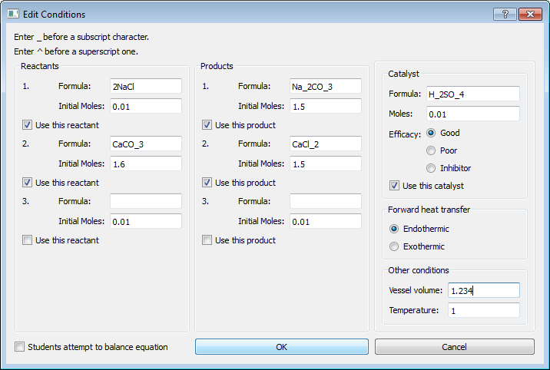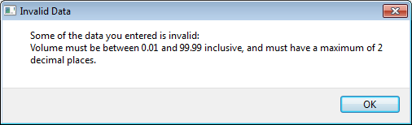

Figure 4.1.22: Popup box appears (right), explaining accepted value range and precision

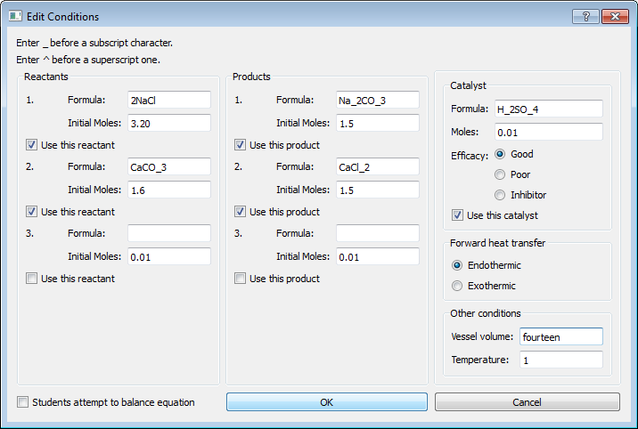 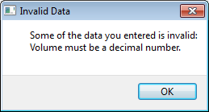

Figure 4.1.23: Popup box appears (right), explaining that a decimal number must be entered

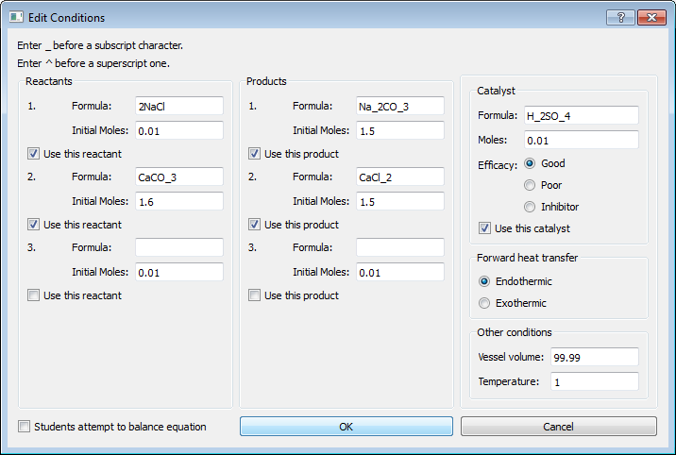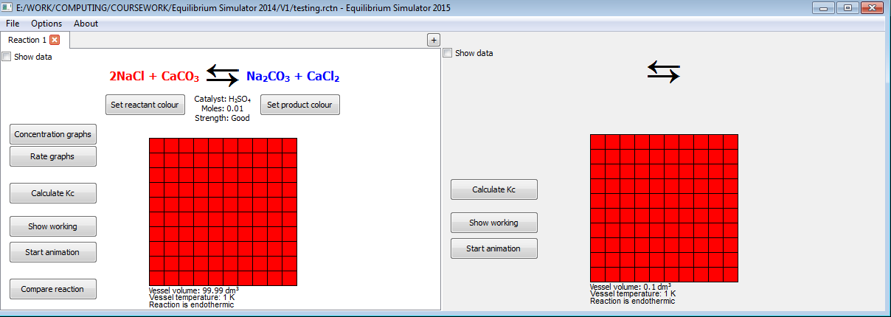

Figure 4.1.24: Window (left) closes, reaction updates and user can continue

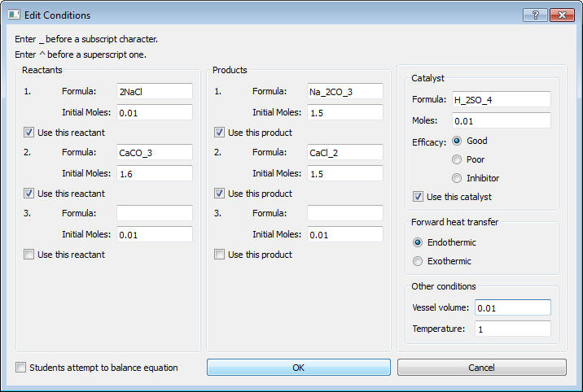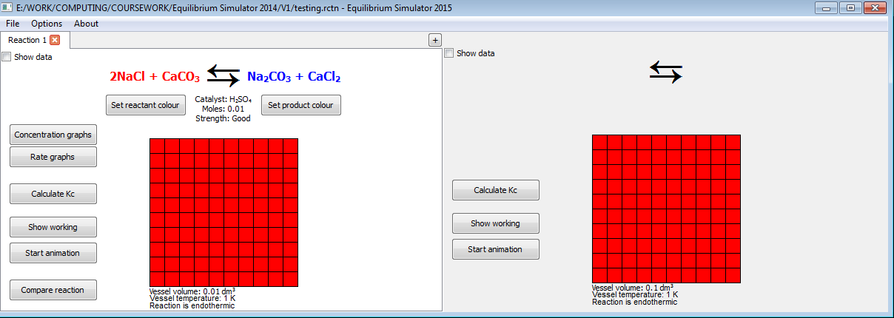

Figure 4.1.25: Window (left) closes, reaction updates and user can continue

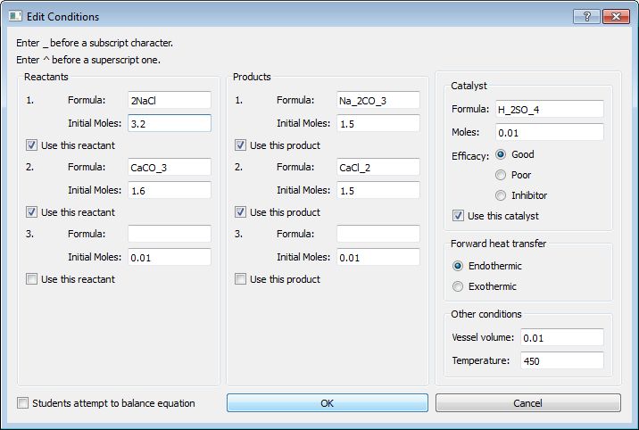 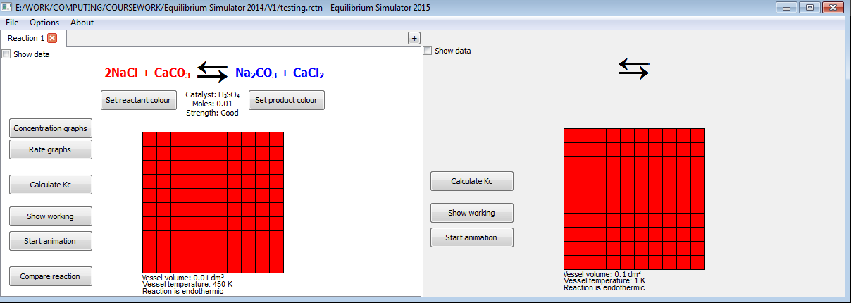

Figure 4.1.26: Window (left) closes, reaction updates and user can continue

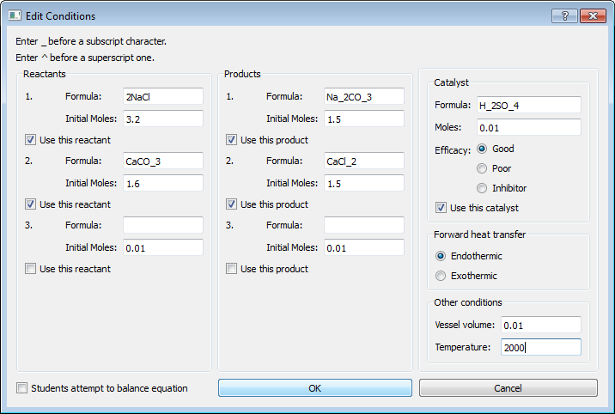 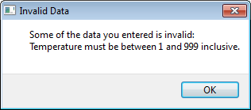

Figure 4.1.27: Popup box appears (right), explaining accepted range

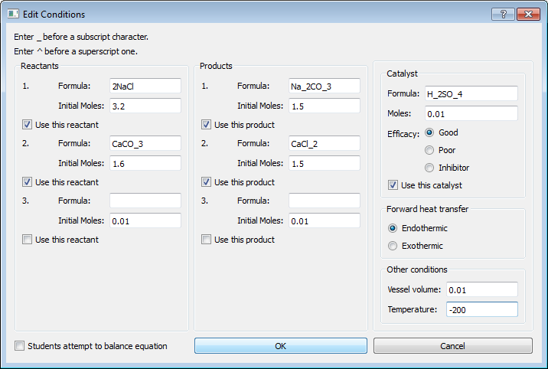 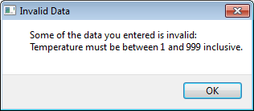

Figure 4.1.28: Popup box appears (right), explaining accepted range

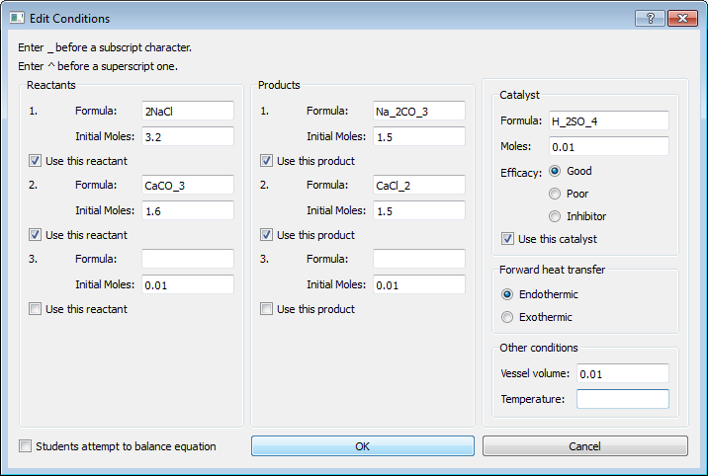 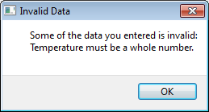

Figure 4.1.29: Popup box appears (right), explaining that an integer must be entered

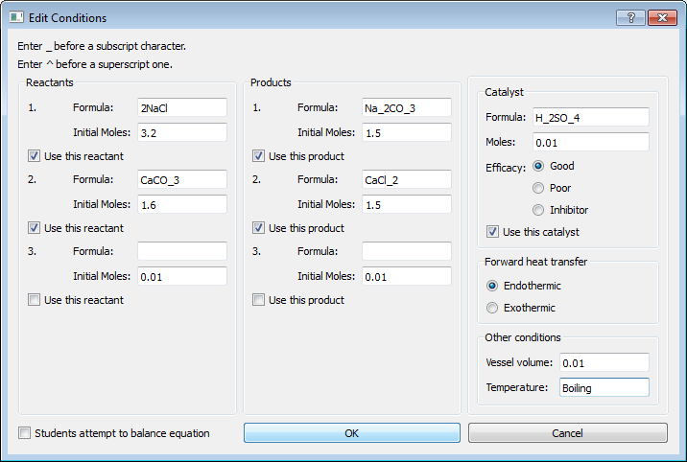 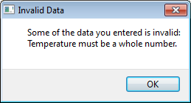

Figure 4.1.30: Popup box appears (right), explaining that an integer must be entered

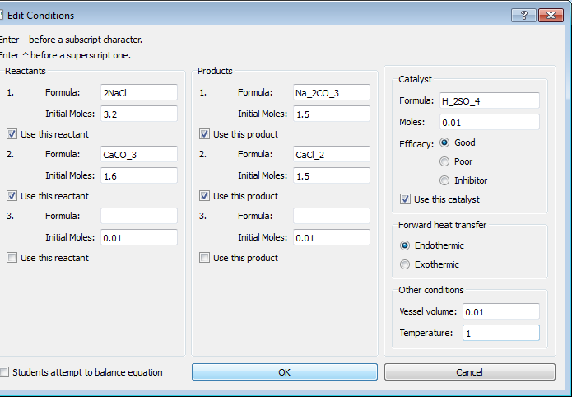 

Figure 4.1.31: Window (left) closes, reaction updates and user can continue

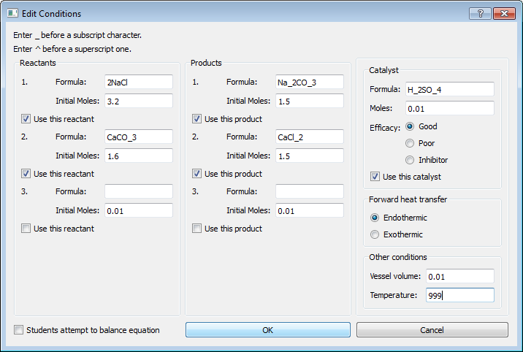 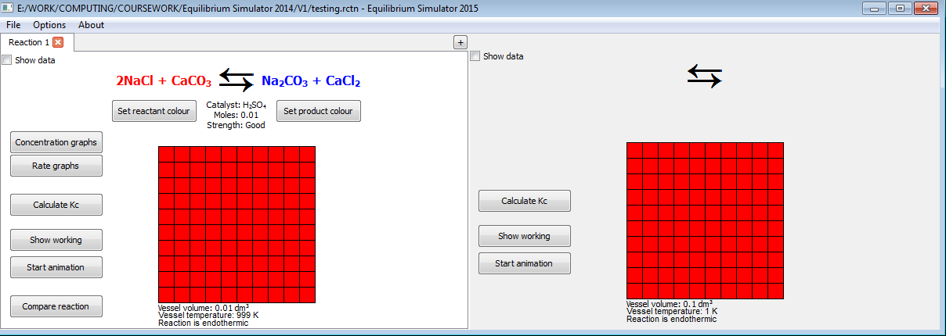

Figure 4.1.32: Window (left) closes, reaction updates and user can continue

4.2: Navigation

4.2.1: Tests performed

All tests performed use normal data (a button press).

The menus, as well as the “Select Color”, “Open...”, “Save As...” and “Print” dialogs, are produced by the framework, so they are not included in the test results. However, the functionality of each button in each menu and the custom widgets needs to be programmed so each button must be included in the test results.

Two tests are added here for the new Undo and Redo buttons.

The “File” menu

|  |  |  |  |
| --- | --- | --- | --- |
| Test number | Description | Result | Cross-reference |
| 1 | On clicking “New” | Pass | Figure 4.2.1 |
| 1a) | On clicking “Yes” in popup box | Partial fail – see section 4.2.2 | Figure 4.2.2 |
| 1b) | On clicking “No” in popup box | Pass | Figure 4.2.3 |
| 2 | On clicking “Open” | Pass | Figure 4.2.4 |
| 3 | On clicking “Save” | Pass | Figure 4.2.5 |
| 4 | On clicking “Save as” | Pass | Figure 4.2.6 |
| 5 | On clicking “Print” | Pass | Figure 4.2.7 |
| 6 | On clicking “Exit” | Pass | Figure 4.2.8 |

The “Options” menu

|  |  |  |  |
| --- | --- | --- | --- |
| Test number | Description | Result | Cross-reference |
| 7 | On clicking “Edit Conditions” | Pass | Figure 4.2.9 |
| 7a) | On clicking “Cancel” in “Edit Conditions” dialog | Pass | Figure 4.2.10 |
| 7b) | On clicking “OK” in “Edit Conditions” dialog (with invalid data) (“Students attempt to balance equation” unchecked) | Pass | Figure 4.2.11 |
| 7b)i) | On clicking “OK” in “Invalid Data” dialog | Fail – see section 4.2.2 | Figure 4.2.12 |
| 7c) | On clicking “OK” in “Edit Conditions” dialog (with invalid data) (“Students attempt to balance equation” checked) | Pass | Figure 4.2.13 |
| 7d) | On clicking “OK” in “Edit Conditions” dialog (with valid data) (“Students attempt to balance equation” unchecked) | Pass | Figure 4.2.14 |
| 7e) | On clicking “OK” in “Edit Conditions” dialog (with valid data) (“Students attempt to balance equation” checked) | Pass | Figure 4.2.15 |
| 7e)i) | On clicking “OK” in “Balance Equation” dialog | Pass | Figure 4.2.16 |

The “About” menu

|  |  |  |  |
| --- | --- | --- | --- |
| Test number | Description | Result | Cross-reference |
| 8 | On clicking “Version [version]” | Pass | Figure 4.2.17 |

The reaction windows

The buttons which appear for the left and right reaction viewing widgets function exactly the same way, so only the results for the buttons in the left widget are included.

|  |  |  |  |
| --- | --- | --- | --- |
| Test number | Description | Result | Cross-reference |
| 9 | On clicking “Set reactant colour” | Pass | Figure 4.2.18 |
| 10 | On clicking “Set product colour” | Pass | Figure 4.2.19 |
| 11 | On clicking “Concentration Graphs” | Pass | Figure 4.2.20 |
| 12 | On clicking “Rate Graphs” | Pass | Figure 4.2.21 |
| 13 | On clicking “Close” in “Compare Graphs” window | Pass | Figure 4.2.22 |
| 14 | On clicking “Calculate Kc” | Pass | Figure 4.2.23 |
| 15 | On clicking “Show working” | Pass | Figure 4.2.24 |
| 16 | On clicking “Start animation” | Pass | Figure 4.2.25 |
| 17 | On clicking “Compare reaction” | Pass | Figure 4.2.26 |
| 18 | On clicking “+” (open tab) button | Pass | Figure 4.2.27 |
| 19 | On clicking “X” (close tab) button when only 1 reaction in file | Pass | Figure 4.2.28 |
| 20 | On checking / unchecking “Show data” box | Pass | Figure 4.2.29 |

Additional tests

|  |  |  |  |  |
| --- | --- | --- | --- | --- |
| Test number | Description | Expected result | Actual result | Cross-reference |
| 21 | On clicking “Undo” in Options menu | Cancels last changes made to reaction | Pass | Figure 4.2.30 |
| 22 | On clicking “Redo” in Options menu | Restores cancelled changes to last reaction | Pass | Figure 4.2.31 |

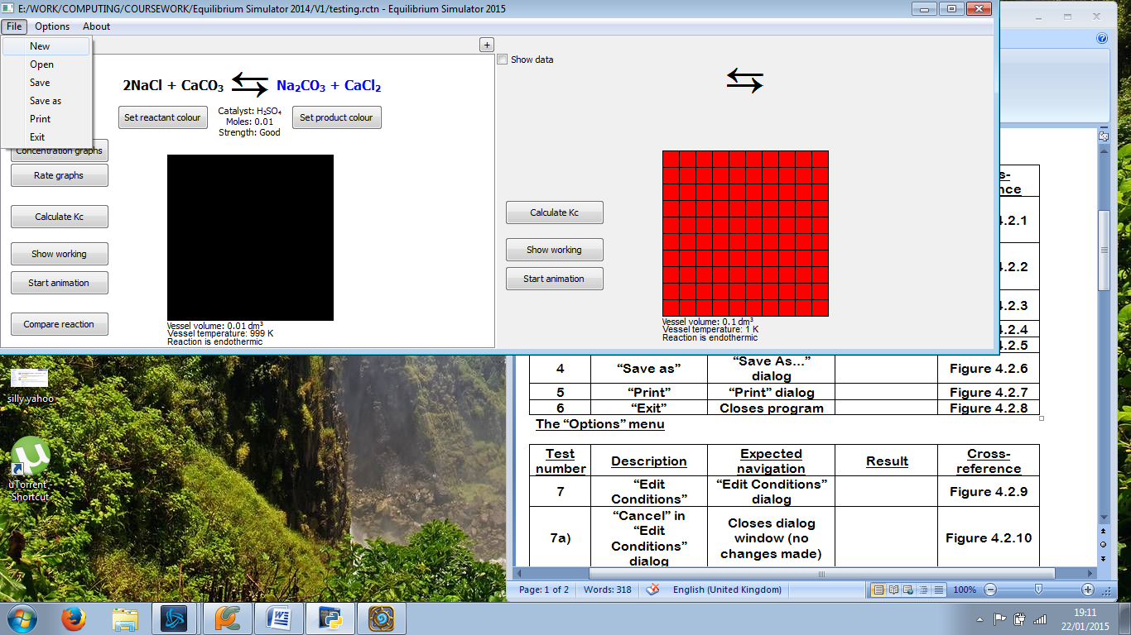 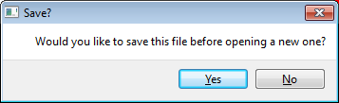

Figure 4.2.1: Popup box appears (right), asking user if they want to save

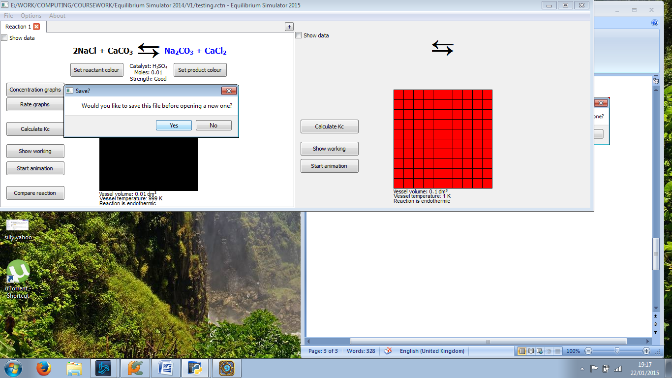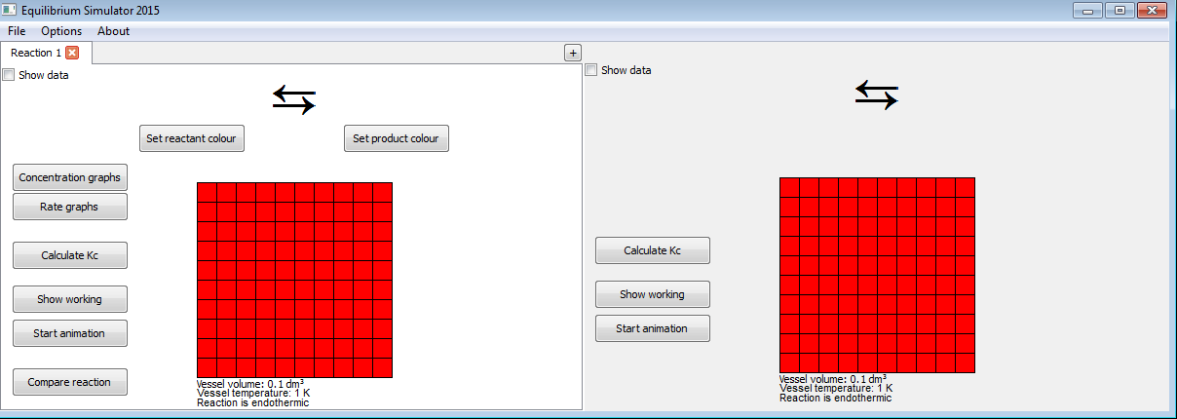

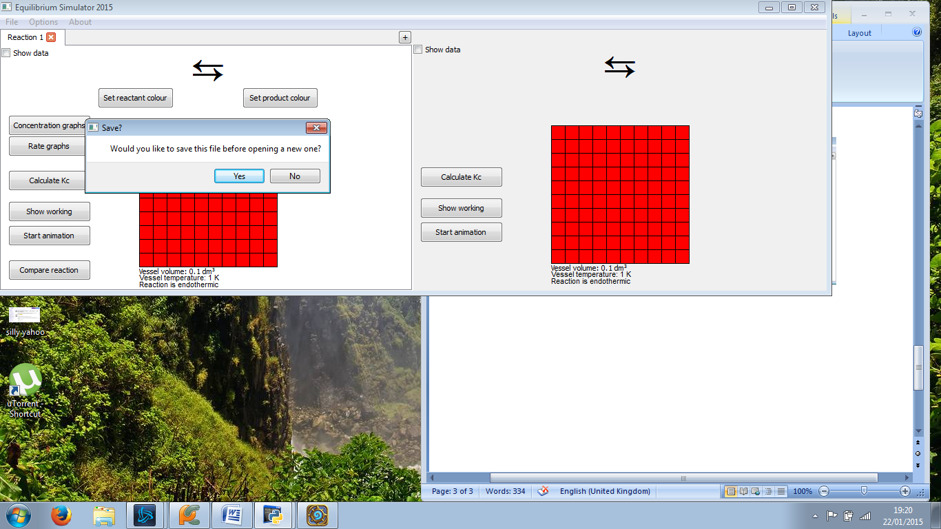

Figure 4.2.2: The file saves normally if a file has been saved before (top), but if not, the “Save As...” dialog is not opened (bottom)

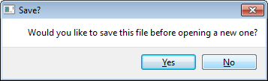

Figure 4.2.3: Popup box closes (left); left reaction window resets (right)

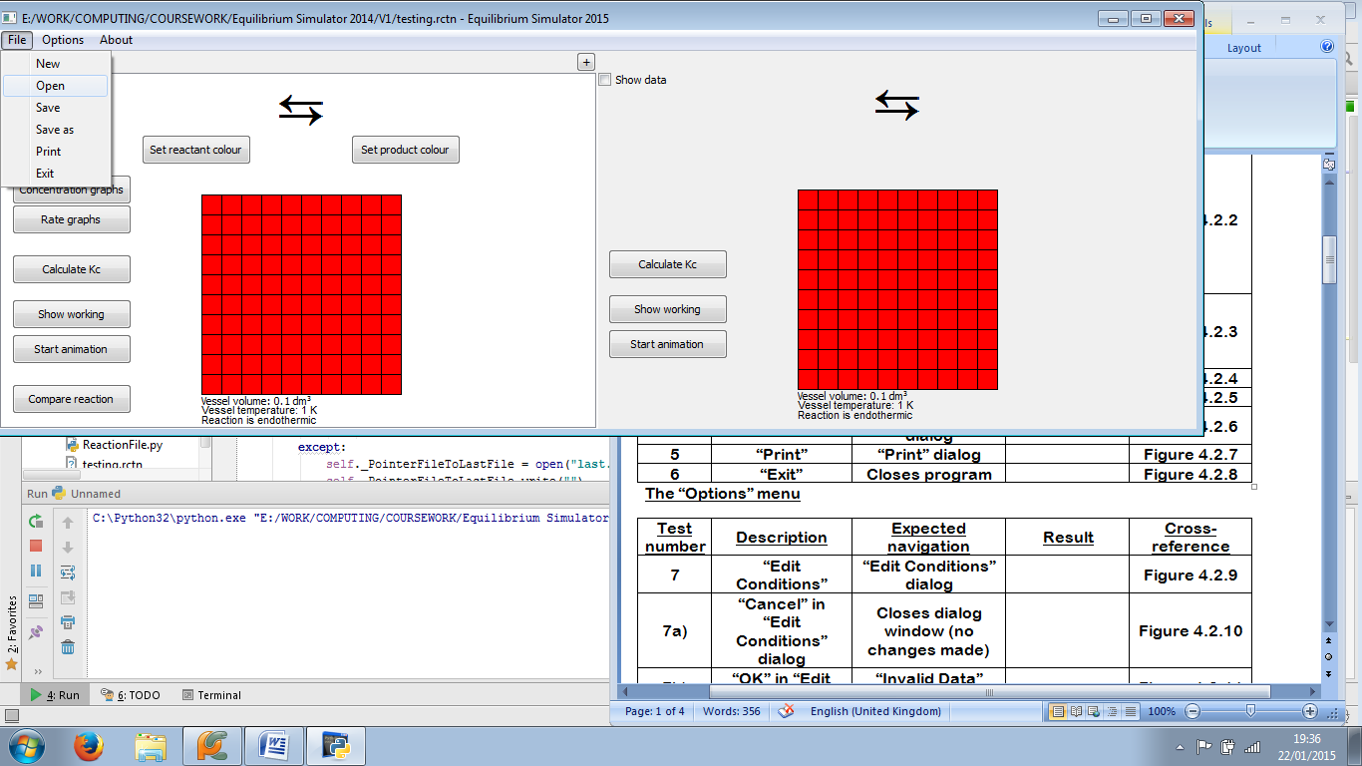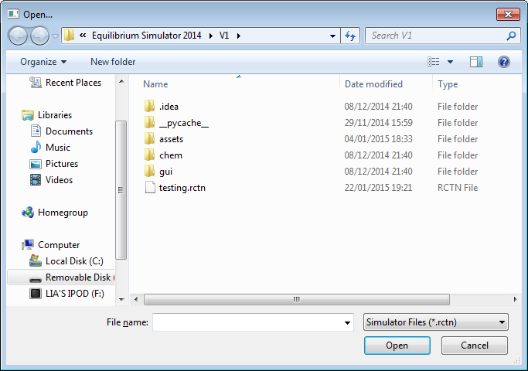

Figure 4.2.4: “Open...” dialog opens (right)

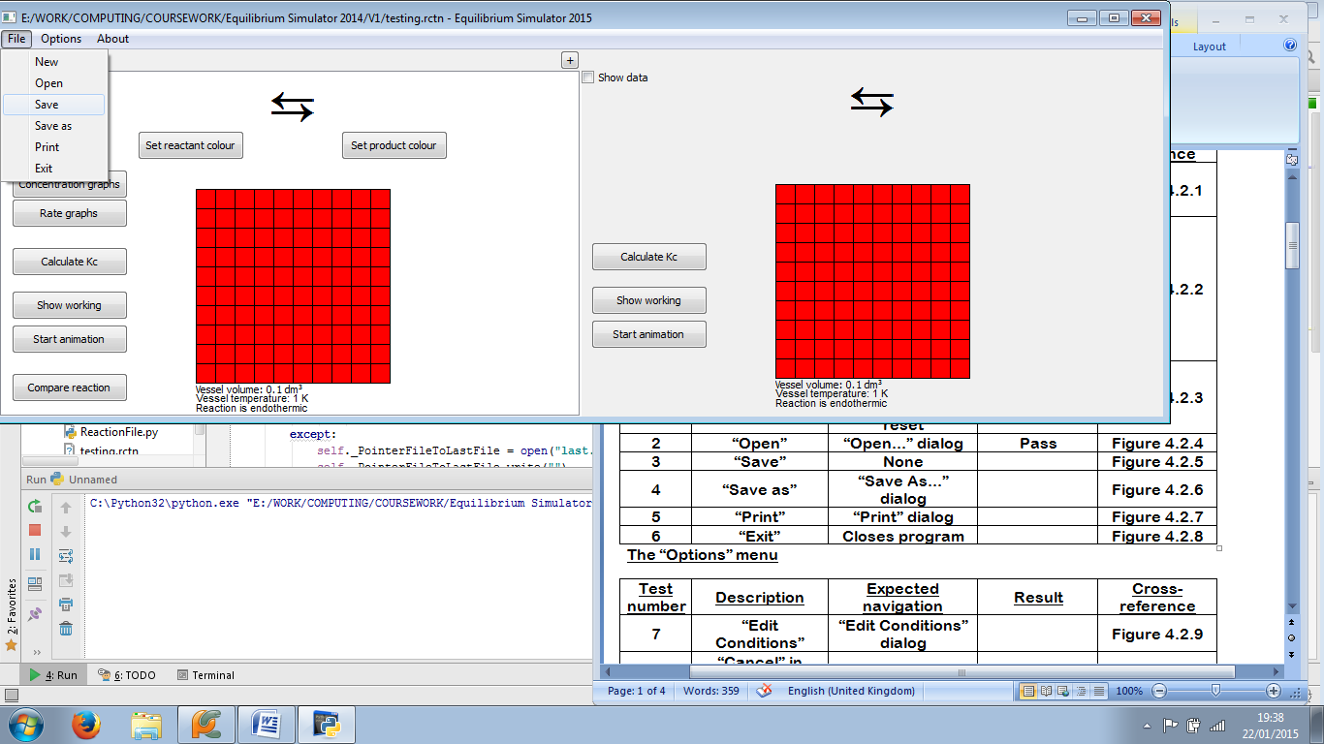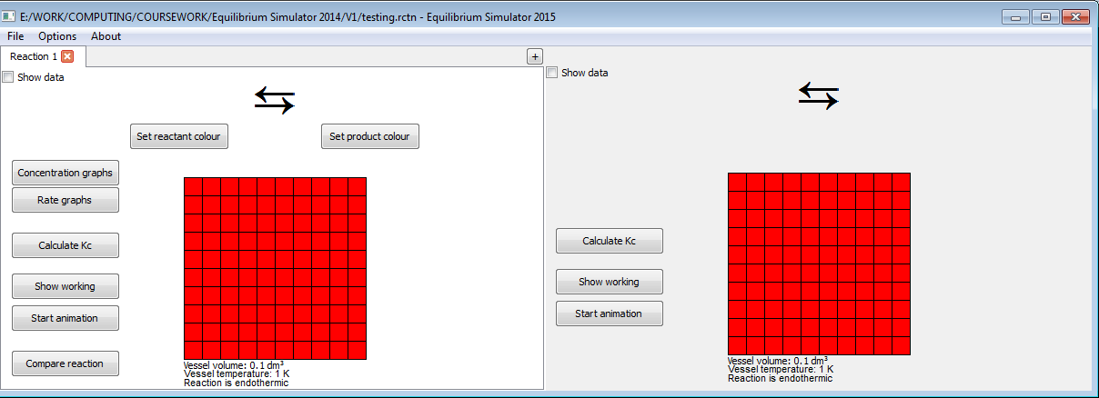

Figure 4.2.5: No navigation, as all that happens is the file saves

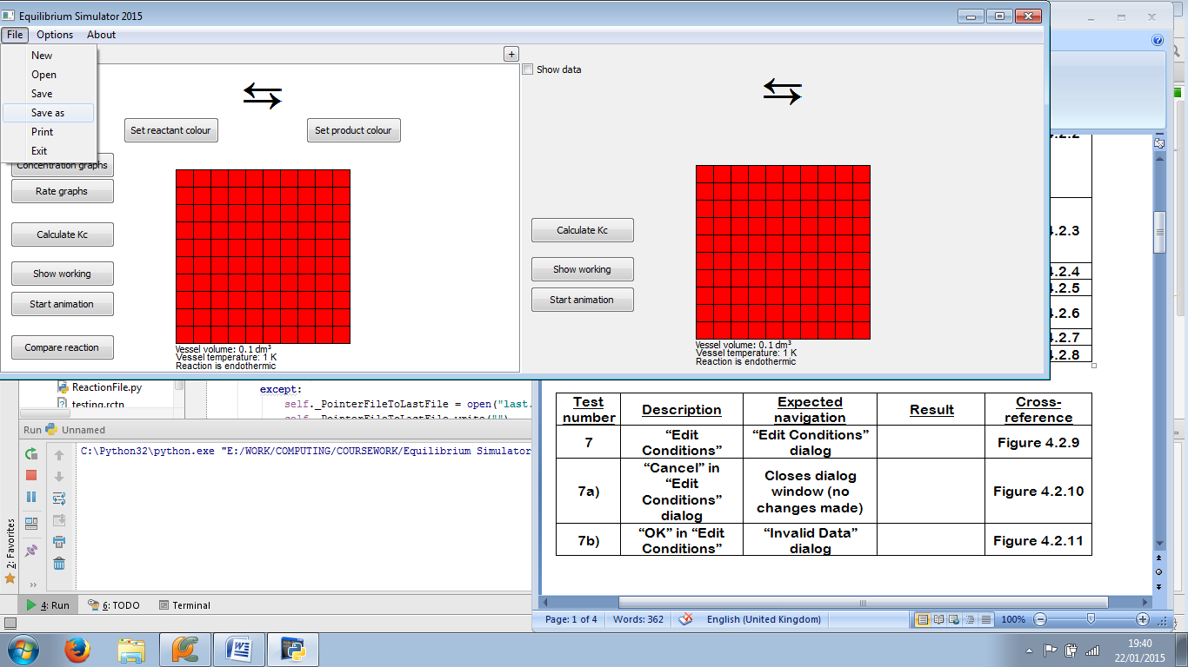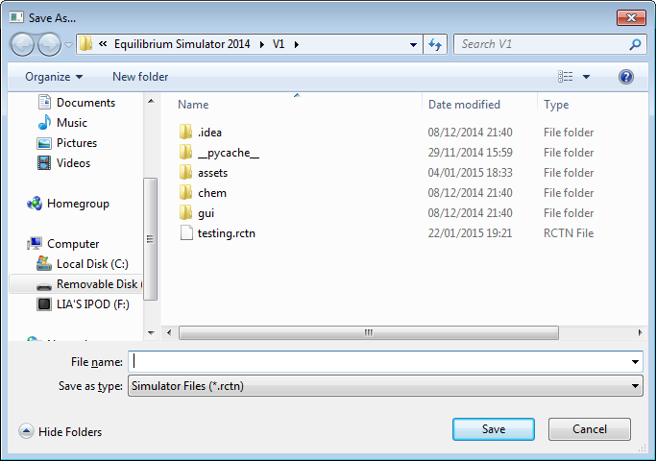

Figure 4.2.6: “Save As...” dialog opens (bottom)

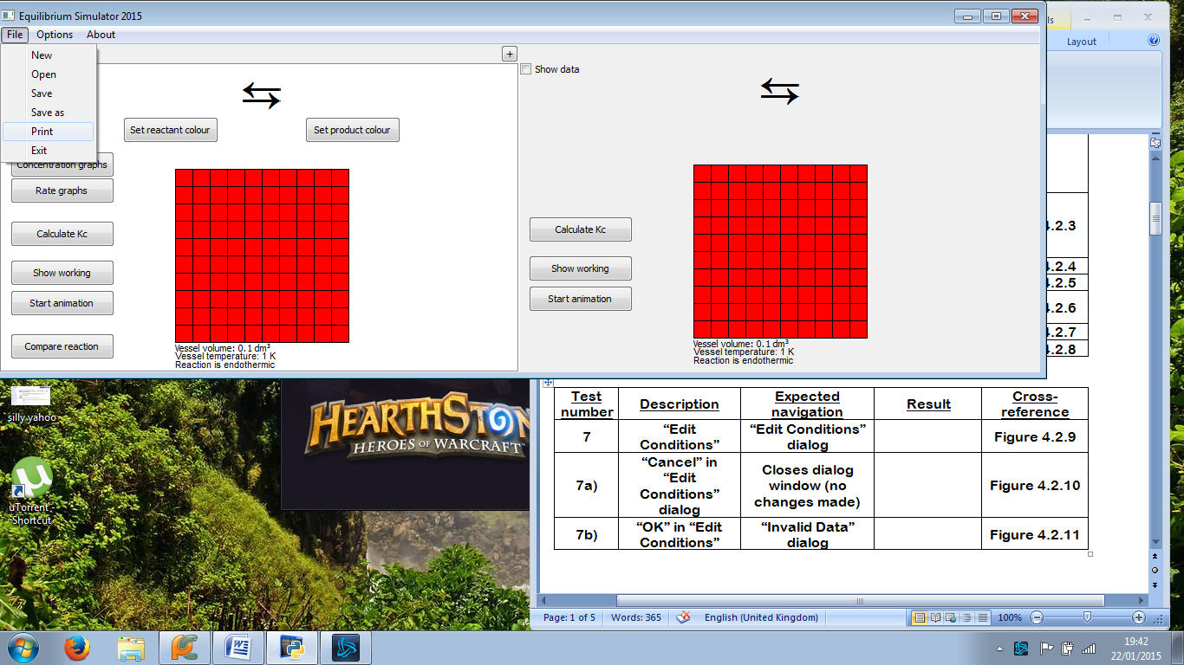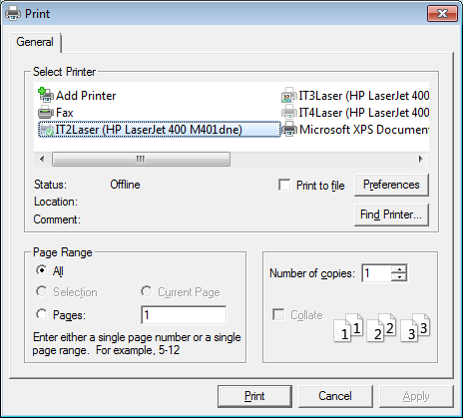

Figure 4.2.7: “Print” dialog opens (bottom)

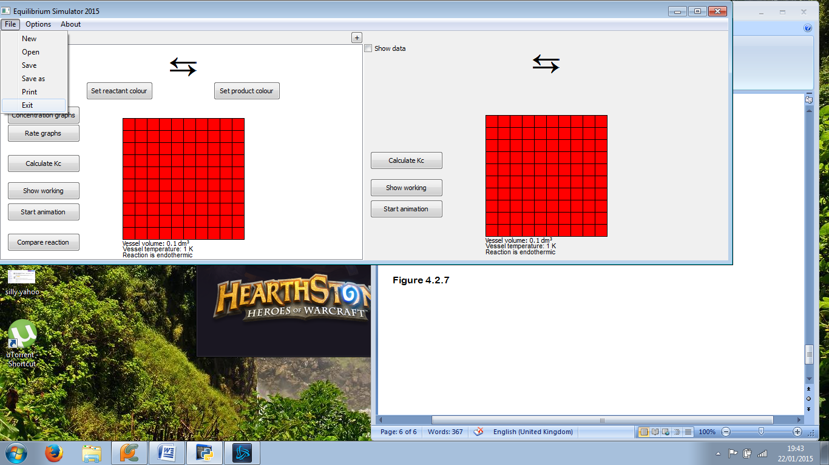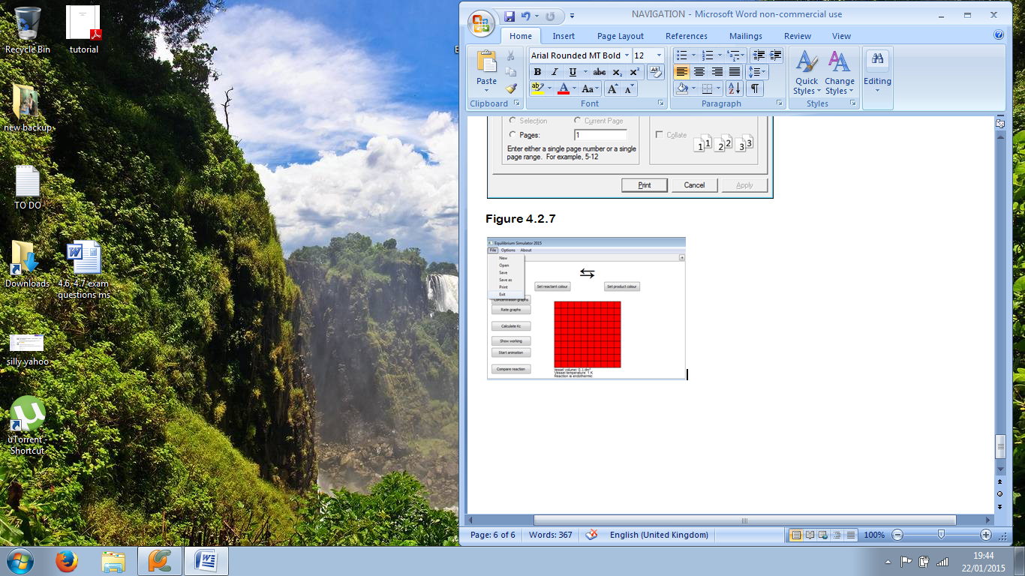

Figure 4.2.8: Program closes (right)

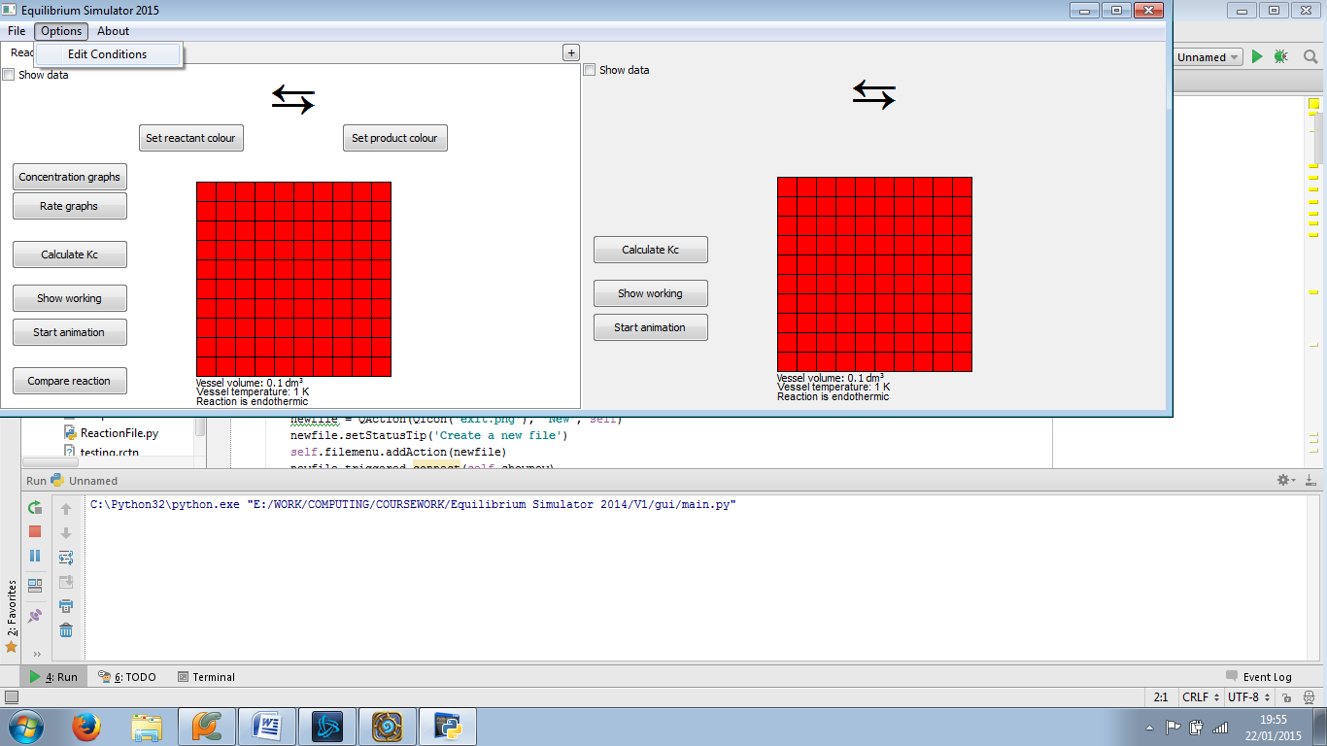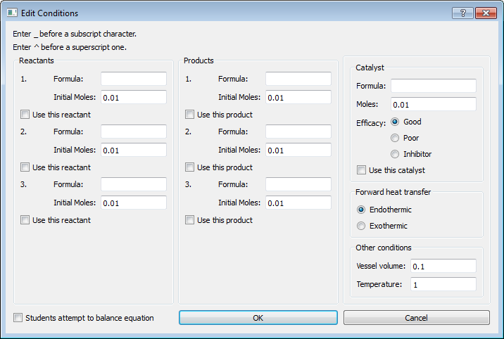

Figure 4.2.9: “Edit Conditions” dialog opens (right)

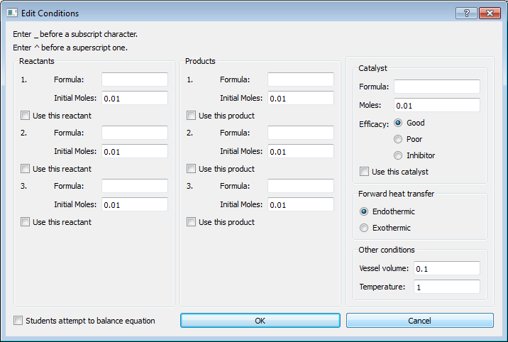

Figure 4.2.10: Dialog closes (right); focus changes to main window

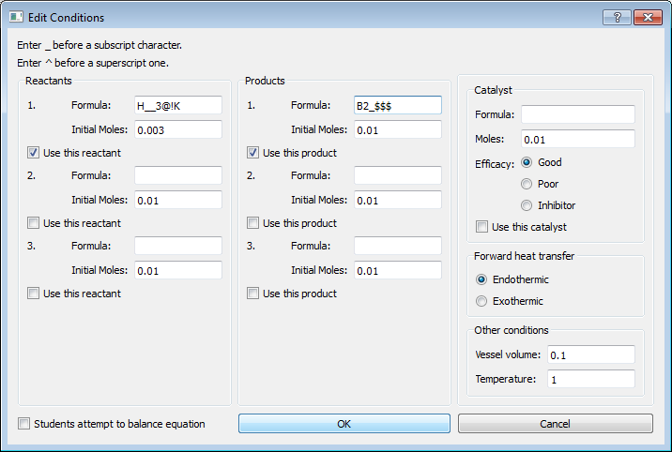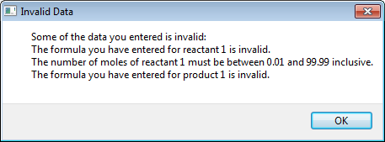

Figure 4.2.11: “Invalid Data” dialog opens (right)



Figure 4.2.12: “Invalid Data” dialog closes, but “Edit Conditions” dialog also closes (right)

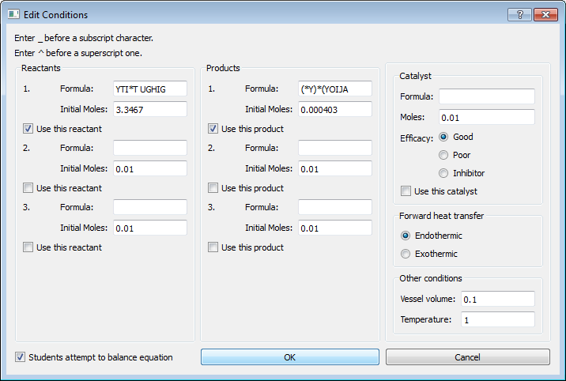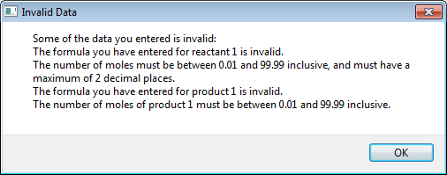

Figure 4.2.13: “Invalid Data” dialog opens (right)

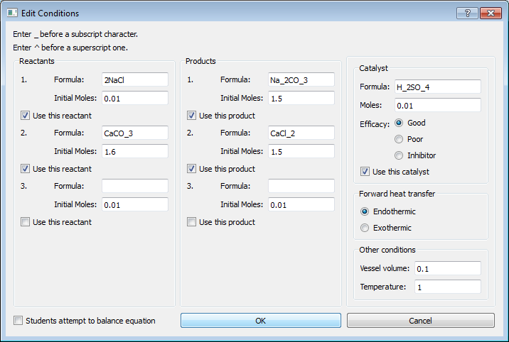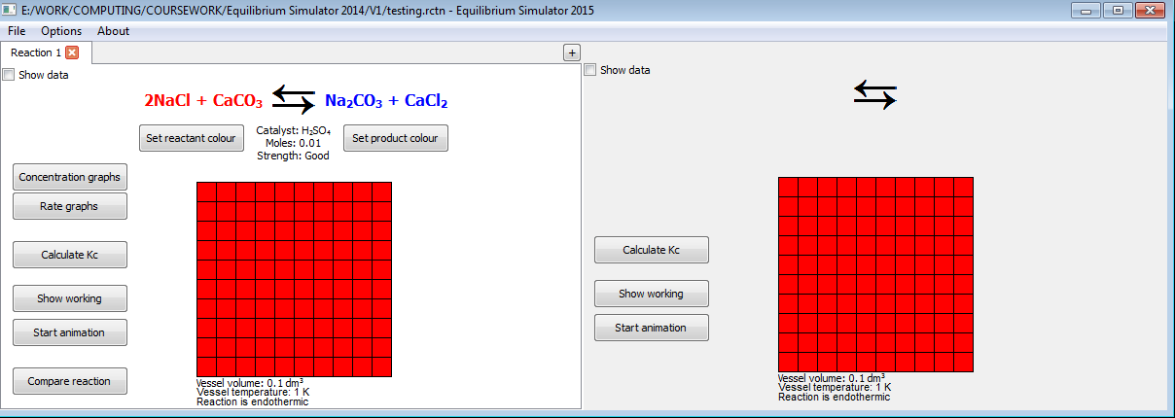

Figure 4.2.14: “Edit Conditions” window closes; reaction window updates (right)

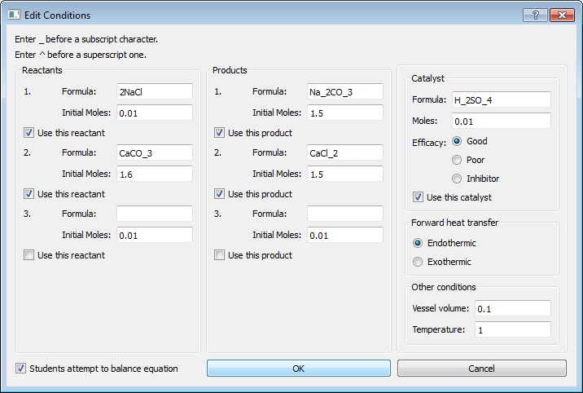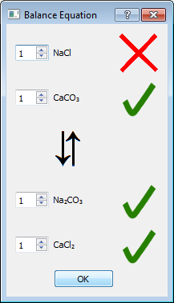

Figure 4.2.15: “Balance Equation” dialog opens (right)



Figure 4.2.16: “Balance Equation” and “Edit Conditions” windows close (right)

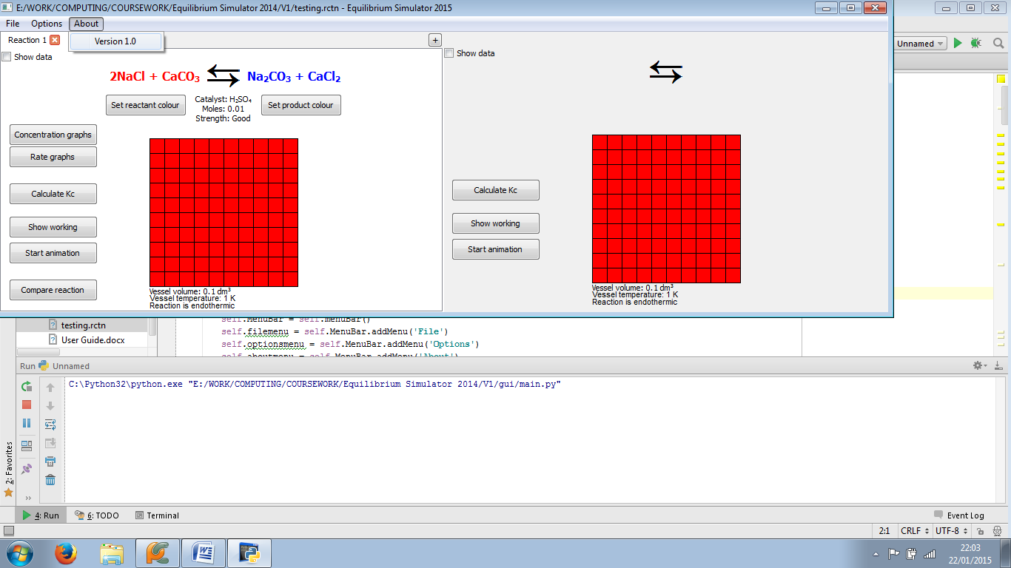

Figure 4.2.17: No navigation, as all that happens is the About menu closes

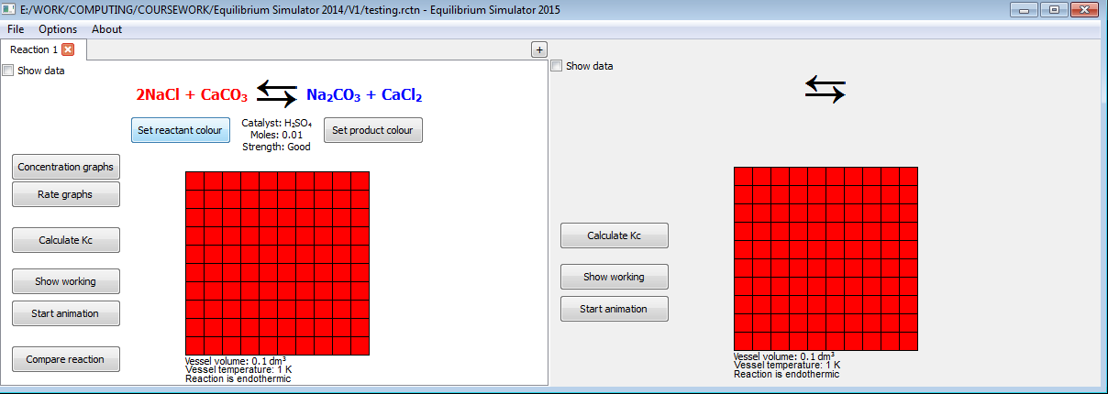 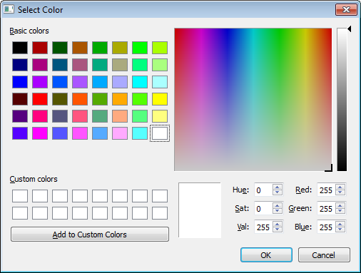

Figure 4.2.18: “Select Color” dialog opens (right)

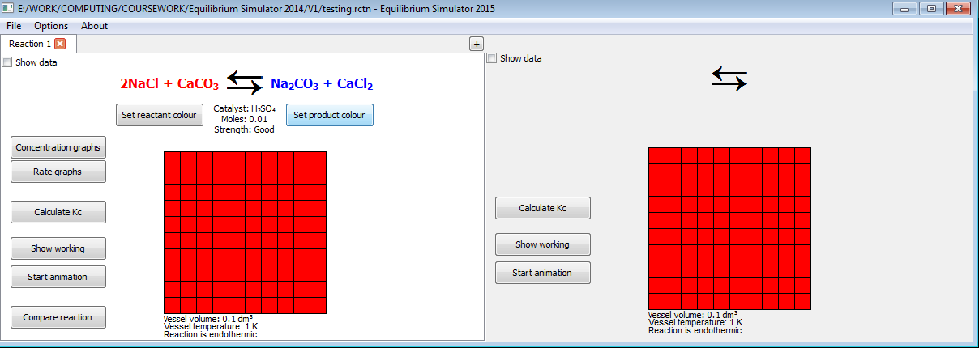 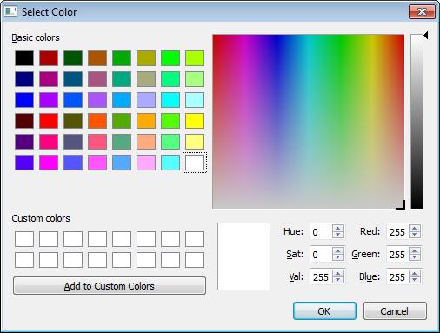

Figure 4.2.19: “Select Color” dialog opens (right)

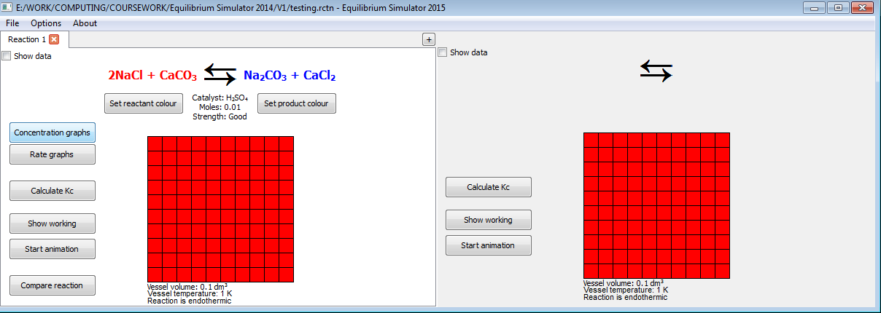 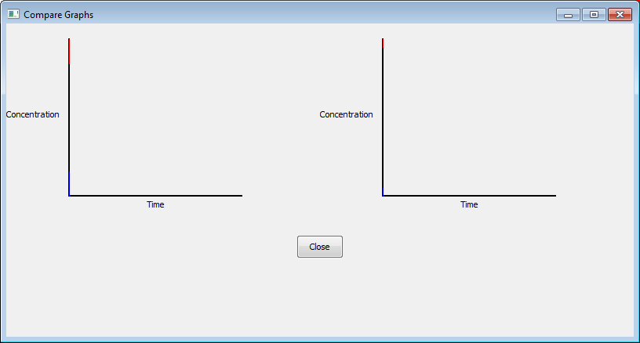

Figure 4.2.20: “Compare Graphs” window opens (right)

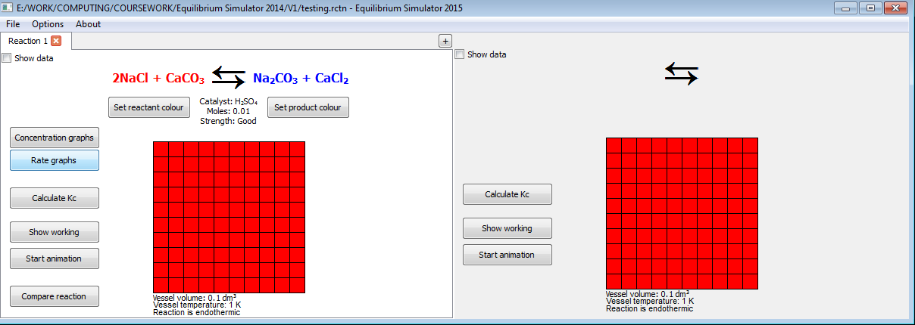 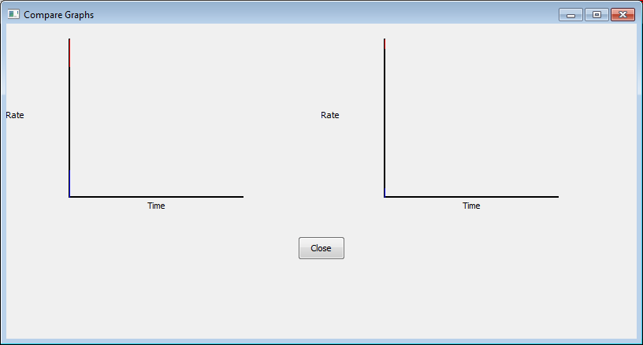

Figure 4.2.21: “Compare Graphs” window opens (right)

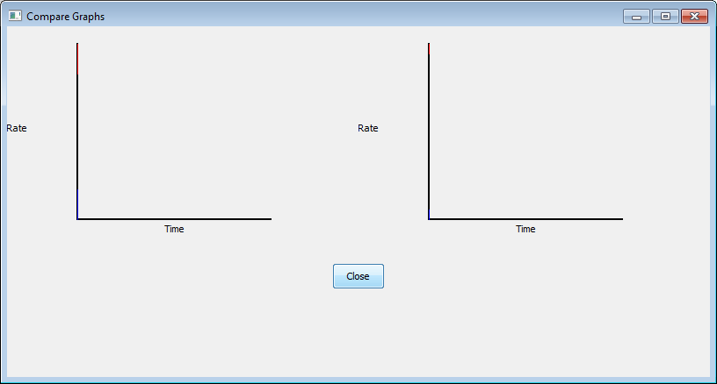 

Figure 4.2.22: “Compare Graphs” window closes; focus changes to reaction window again (right)

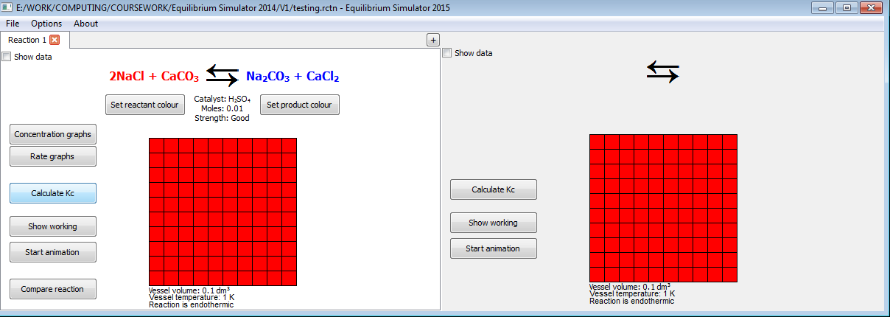 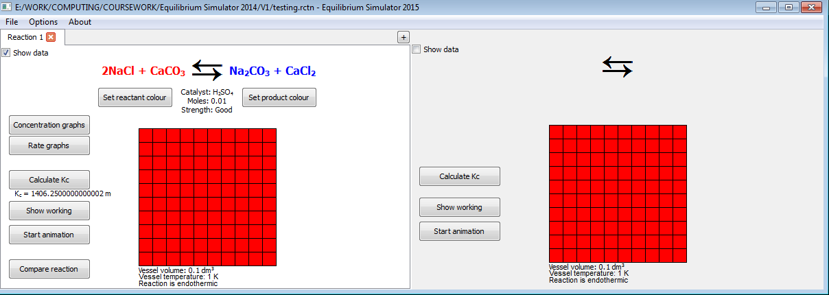

Figure 4.2.23: Value and units of Kc shown (right) so no navigation

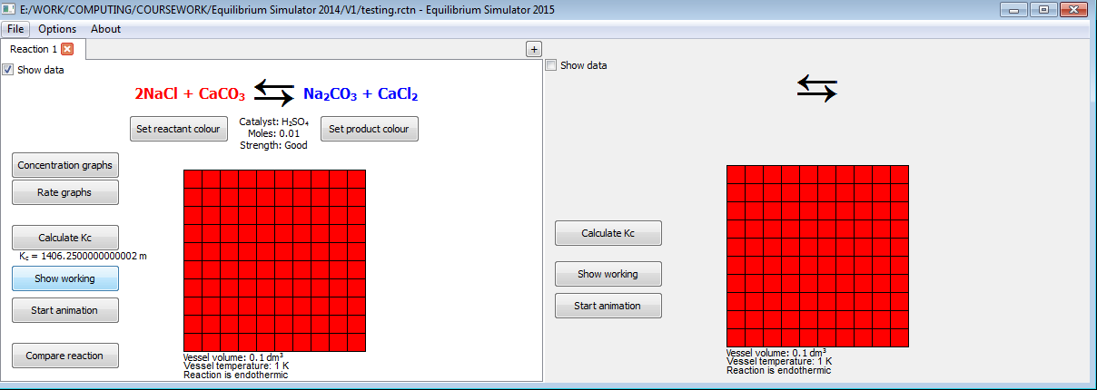 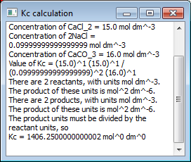

Figure 4.2.24: Small popup box appears (right), showing working in plain text

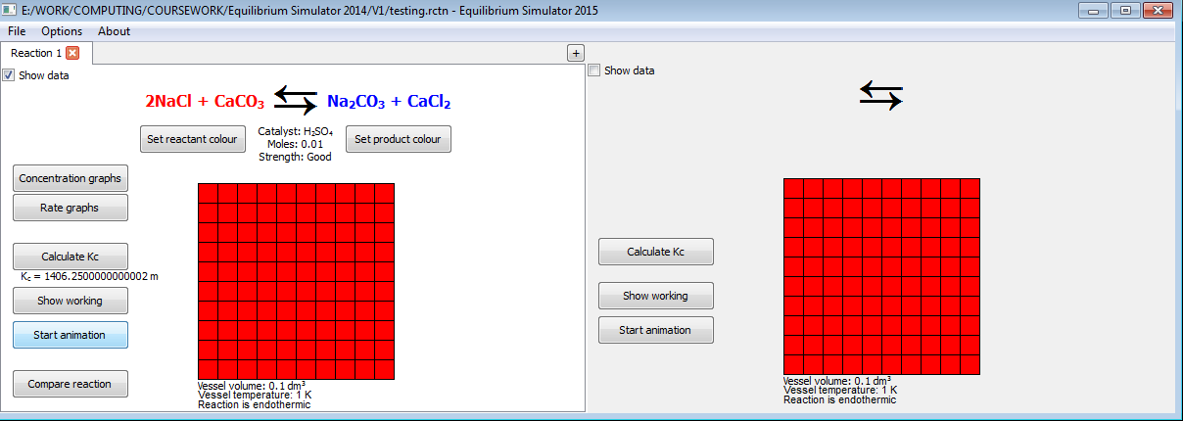 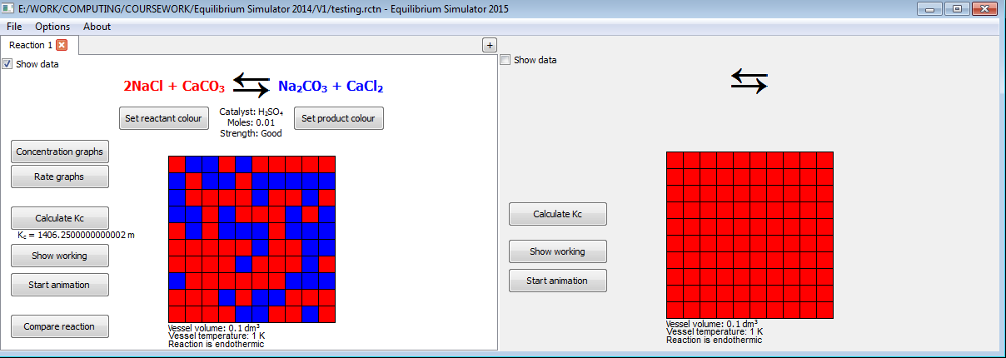

Figure 4.2.25: No navigation, as all that happens is animation begins

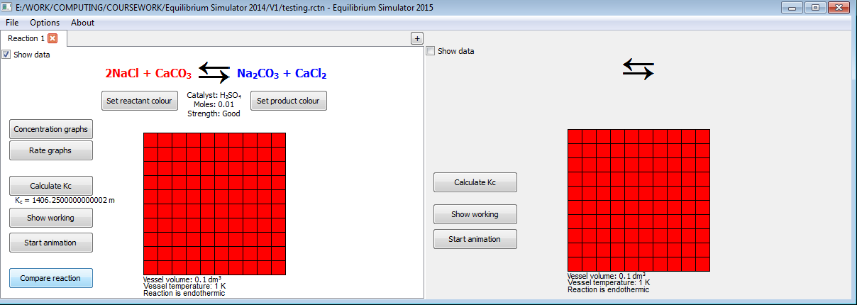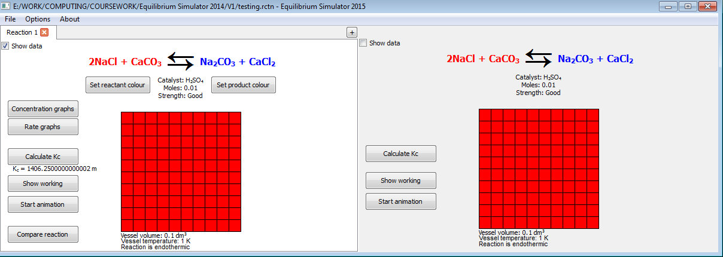  
Figure 4.2.26: No navigation, but right-hand-side reaction updated to a copy of left-hand-side reaction (bottom)

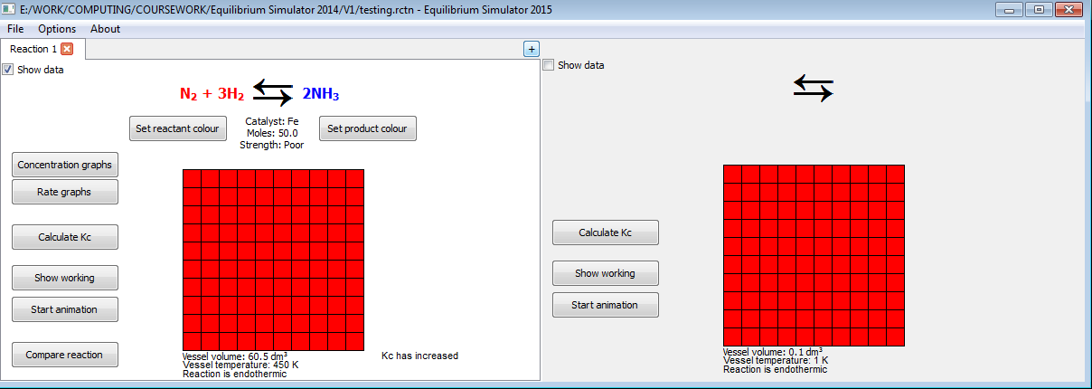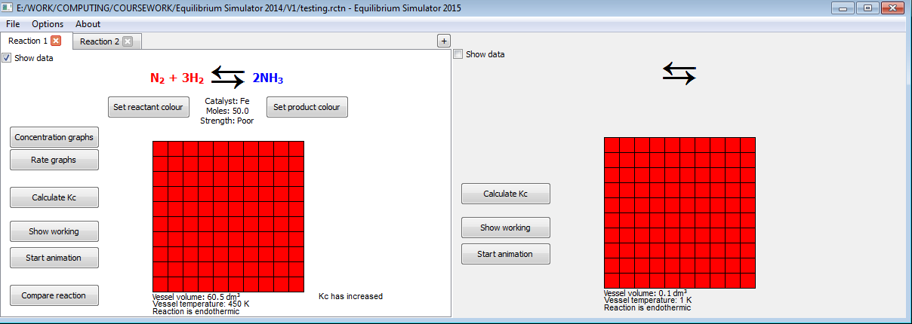

Figure 4.2.27: No navigation, but a new reaction tab is added (right)

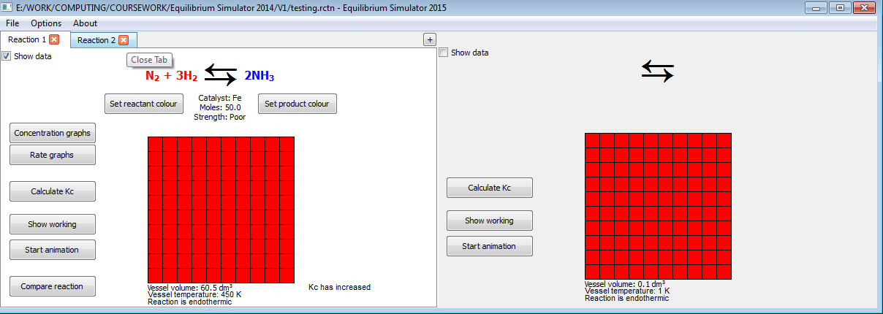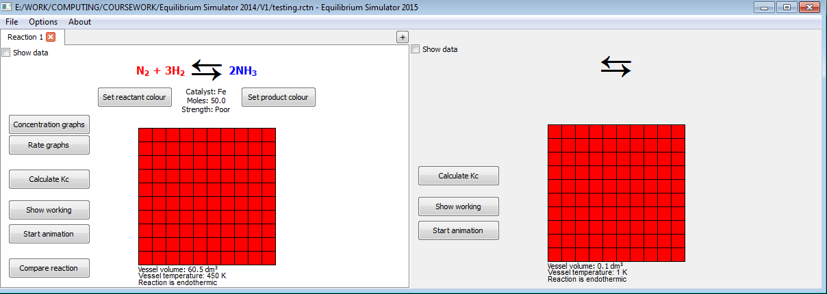

Figure 4.2.28: No navigation, but the reaction tab closes (right)

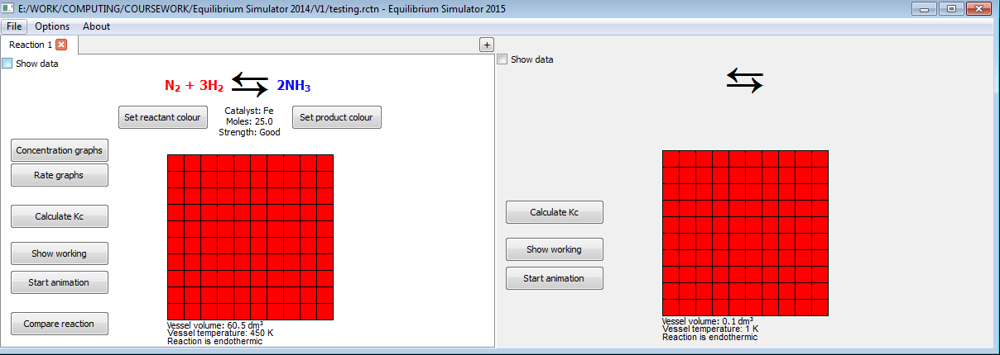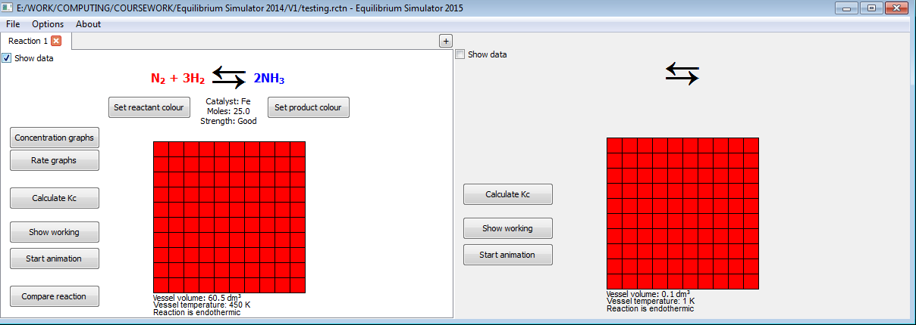

Figure 4.2.29: Toggling the check box toggles the appearance of certain data (not set to appear in this example), so no navigation takes place

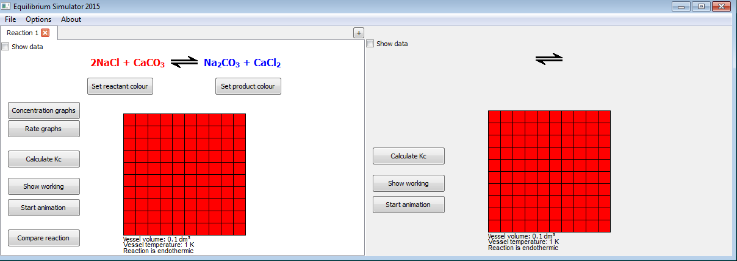 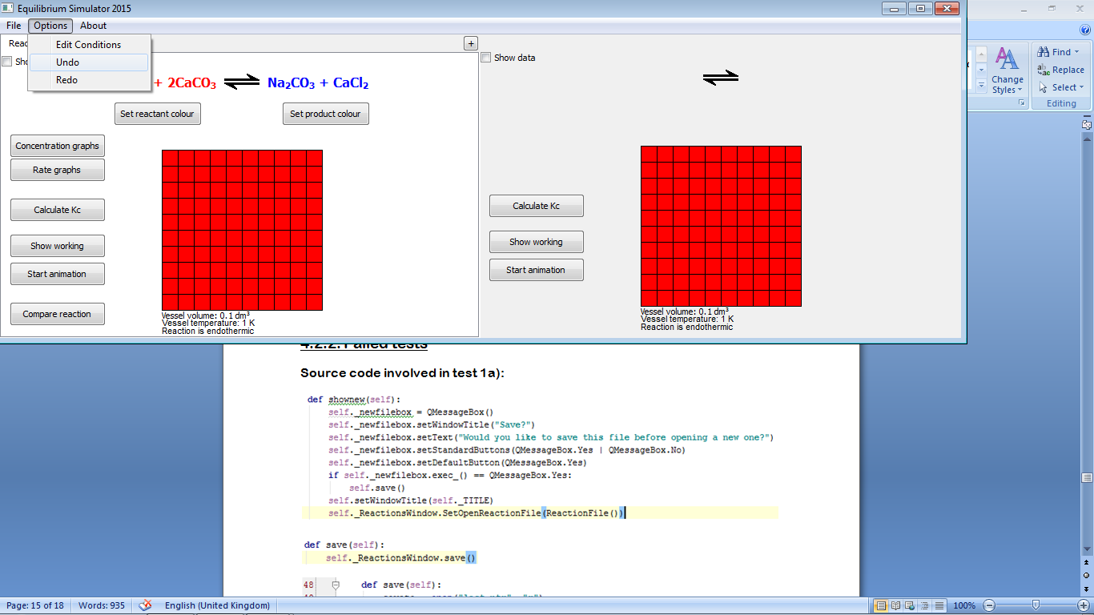

Figure 4.2.30: After a change is made (top right: a 2 is added to CaCO3), when “Undo” is pressed, the change is removed (bottom left)

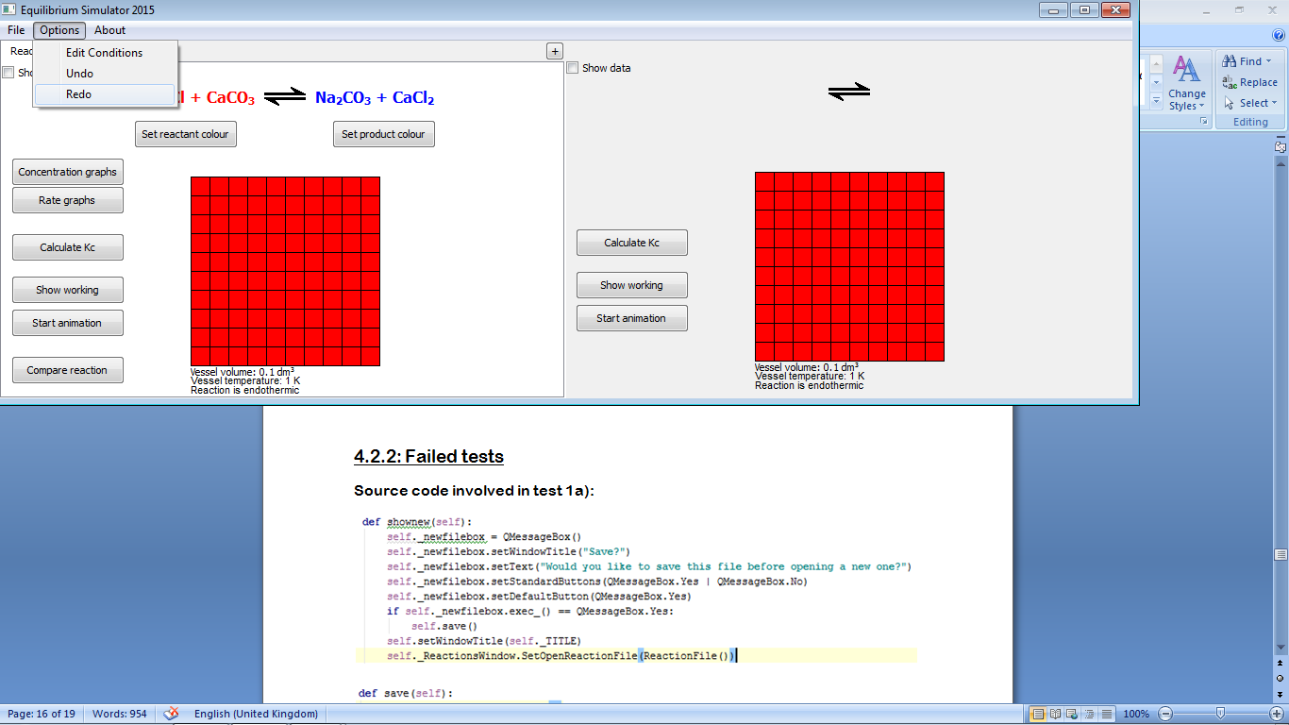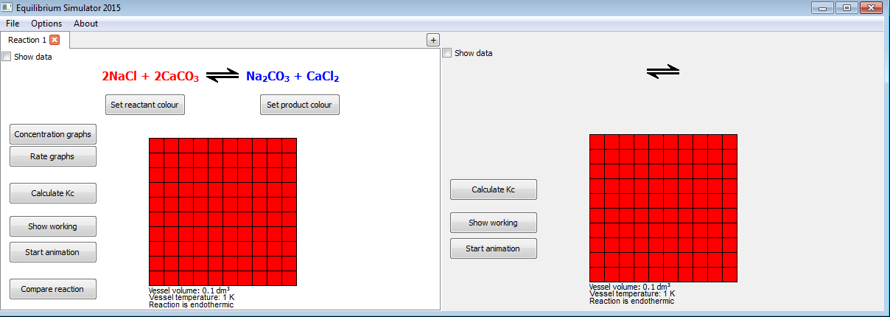

Figure 4.2.31: When “Redo” is pressed, the 2 (see Figure 4.2.30, top right) reappears (right), showing that the undone reaction has been restored

4.2.2: Failed tests

Source code involved in test 1a):

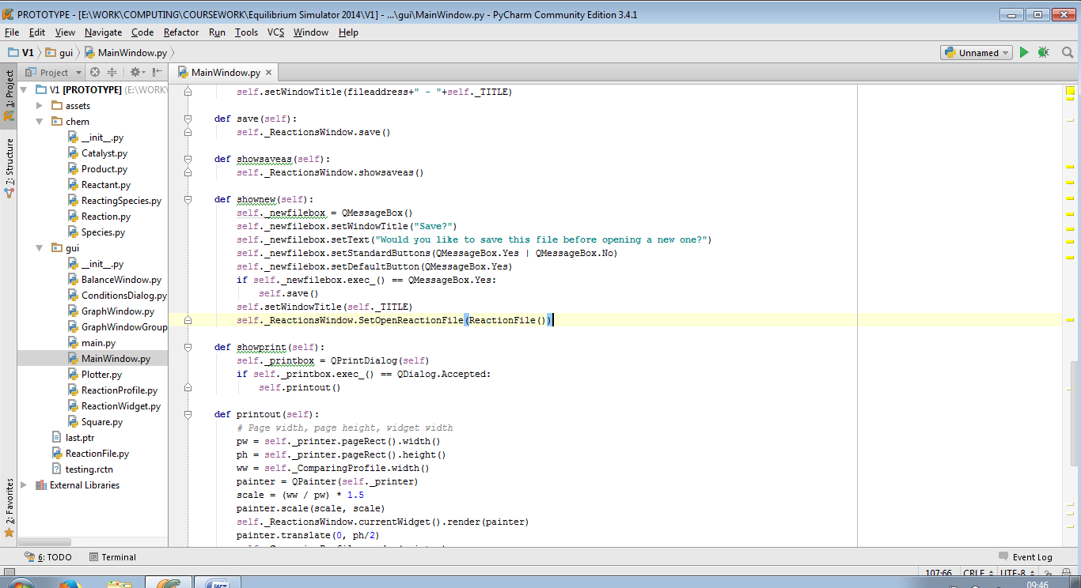

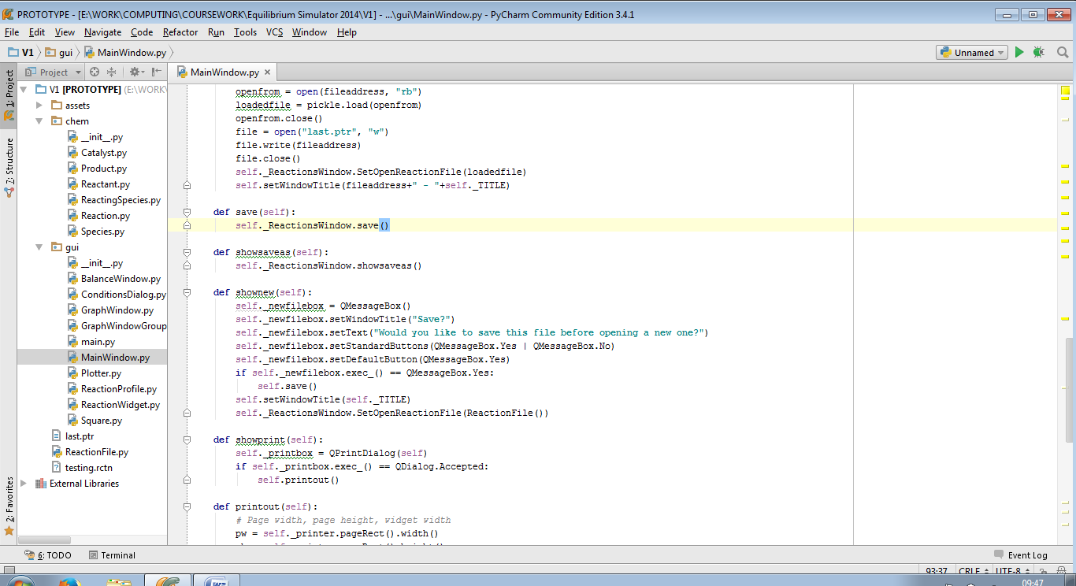

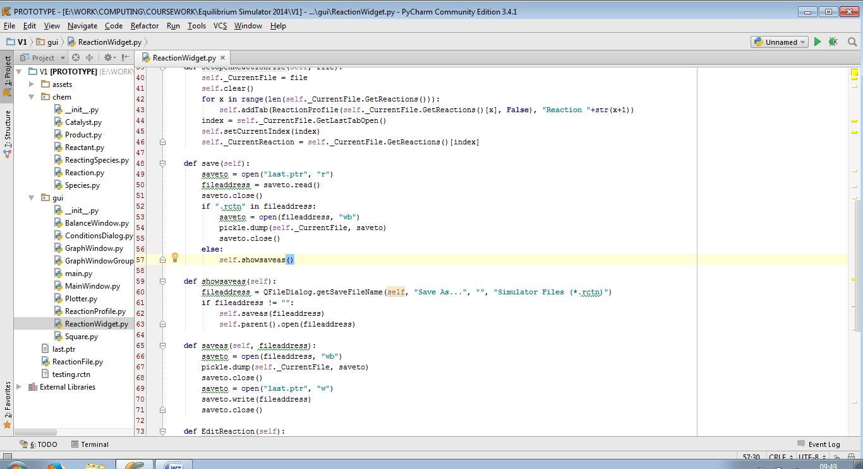

In the second save() procedure, the program checks if the last file opened was a .rctn file, and if so, saves to that file. However when a new file is opened, the address of the last file opened is not changed, so the new file overwrites the old one. This can be solved by editing the shownew() procedure to remove the path of the last open file, so that the “Save As...” dialog is shown.

Amended source code:

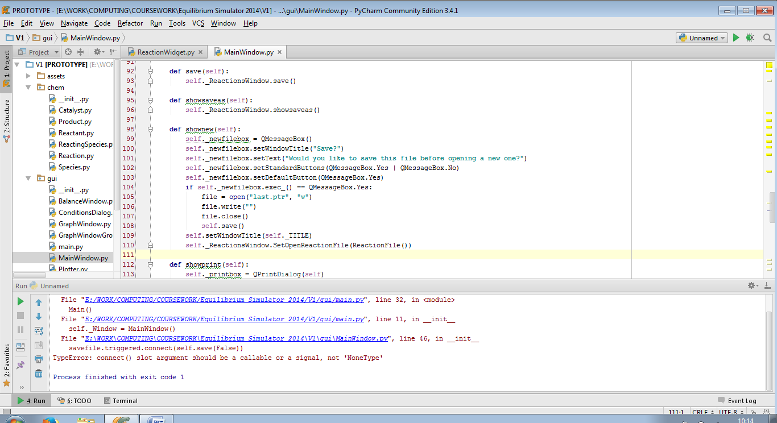

The code now passes test 1a):

|  |  |  |  |
| --- | --- | --- | --- |
| 1a) | On clicking “Yes” in popup box | Pass | Figure 4.2.32 |

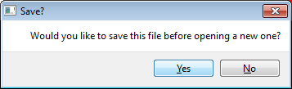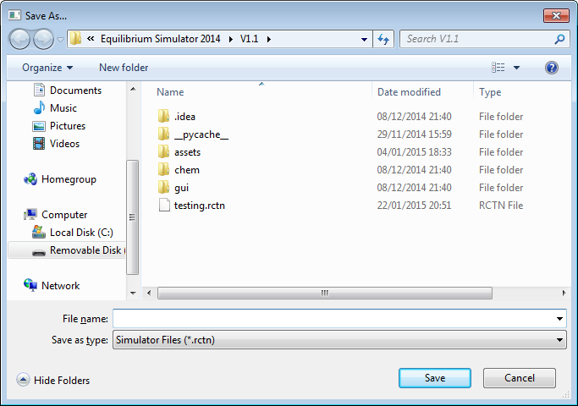

Figure 4.2.32: If nothing is saved before, the “Save As...” dialog is opened (right)

This is the source code involved in test 7b)i):

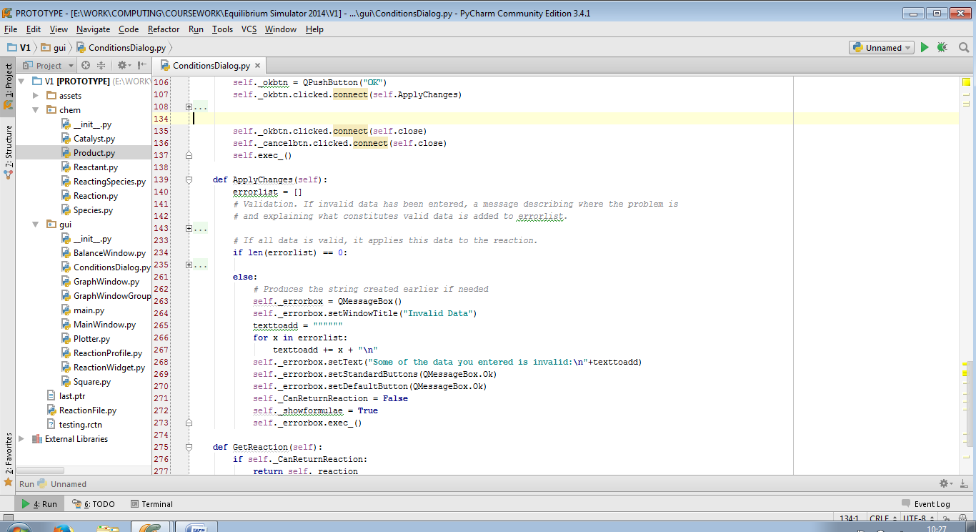

Here, the ‘signal’ of clicking the “OK” button is connected to two ‘slot’ procedures: ApplyChanges() and close(), which is a built-in method for closing widgets. This means that whether or not the changes are valid, the “Edit Conditions” dialog will close. This can be solved by only connecting the “OK” button to the ApplyChanges() slot, and only calling the close() method if all input data is valid.

Amended source code:

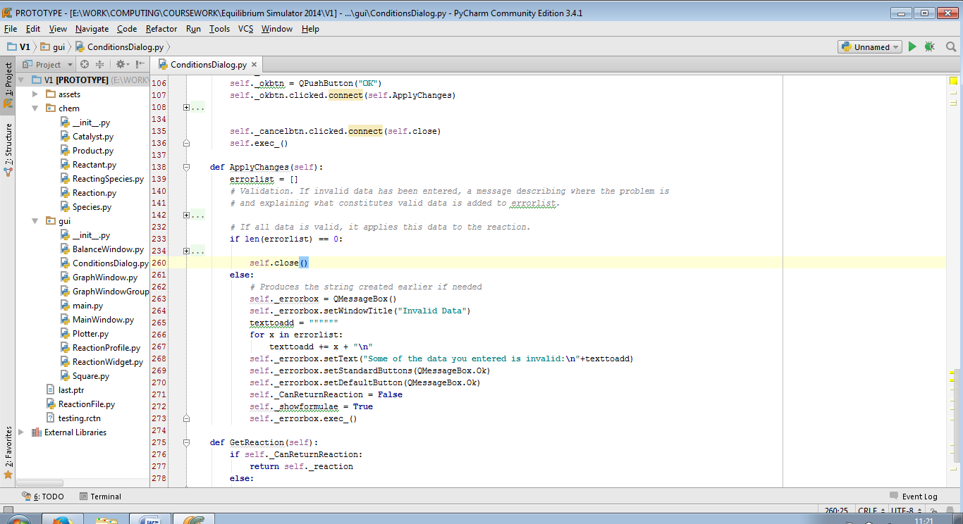

The code now passes test 7b)i):

|  |  |  |  |
| --- | --- | --- | --- |
| 7b)i) | On clicking “OK” in “Invalid Data” dialog | Pass | Figure 4.2.33 |

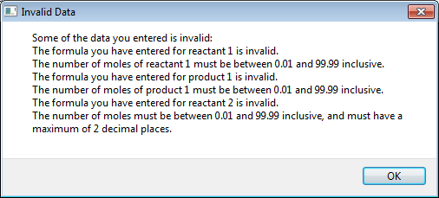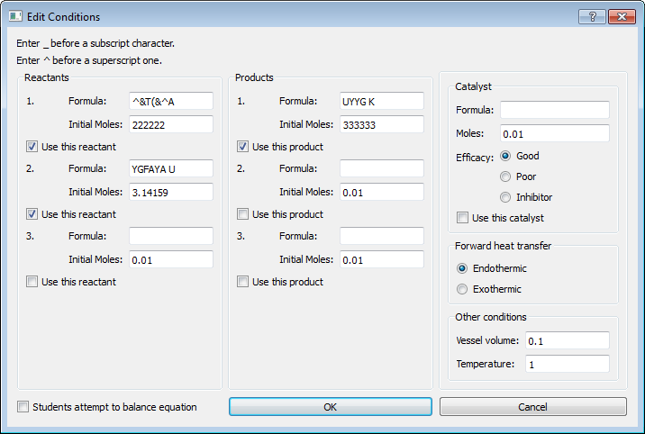

Figure 4.2.33: Dialog (top) closes; focus goes back to “Edit Conditions” dialog (bottom)

4.3: Logic

4.3.1: Tests performed

These are the results of tests performed with valid data. The animation and graph data are completely based on strength and number of moles of catalyst.

Animation

|  |  |  |  |
| --- | --- | --- | --- |
| Test number | Description | Result | Cross-reference |
| 1 | Comparing good catalyst at 25 and 75 moles | Pass | Video 1 |
| 2 | Comparing poor catalyst at  25 and 75 moles | Pass | Video 2 |
| 3 | Comparing unused catalyst at 25 and 75 moles | Pass | Video 3 |
| 4 | Comparing inhibitor catalyst at 25 and 75 moles | Pass | Video 4 |
| 5 | Comparing time taken by animation with each catalyst at 50 moles | Pass | Video 5 |

Graphs

|  |  |  |  |
| --- | --- | --- | --- |
| Test number | Description | Result | Cross-reference |
| 6 | Comparing good catalyst at 25 and 75 moles | Pass | Figure 4.3.1 |
| 7 | Comparing poor catalyst at 25 and 75 moles | Pass | Figure 4.3.2 |
| 8 | Comparing unused catalyst at 25 and 75 moles | Pass | Figure 4.3.3 |
| 9 | Comparing inhibitor catalyst at 25 and 75 moles | Pass | Figure 4.3.4 |
| 10 | Good catalyst  Poor catalyst  No catalyst  Inhibitor catalyst | Pass | Figure 4.3.5 |
| 11 | Testing if graph plots alongside animation | Pass | Video 6 |

Calculations

|  |  |  |  |
| --- | --- | --- | --- |
| Test number | Description | Result | Cross-reference |
| 12 | Showing working for Kc | Partial fail | Figure 4.3.6 |
| 13a) | Current reaction has lower temperature than reaction being compared (endothermic reaction) | Pass | Figure 4.3.7 |
| 13b) | Current reaction has lower temperature than reaction being compared (exothermic reaction) | Pass | Figure 4.3.8 |
| 14a) | Current reaction has higher temperature than reaction being compared (endothermic reaction) | Pass | Figure 4.3.9 |
| 14b) | Current reaction has higher temperature than reaction being compared (exothermic reaction) | Pass | Figure 4.3.10 |
| 15a) | Current reaction has same temperature as reaction being compared (endothermic reaction) | Pass | Figure 4.3.11 |
| 15b) | Current reaction has same temperature as reaction being compared (exothermic reaction) | Pass | Figure 4.3.12 |

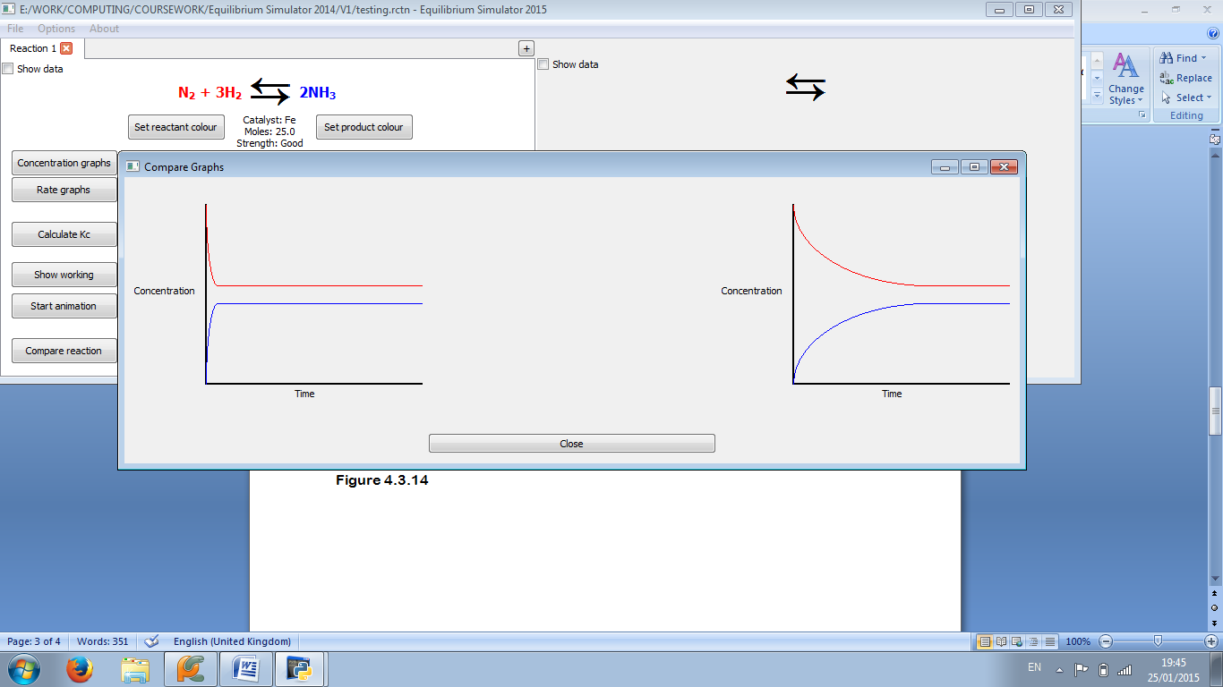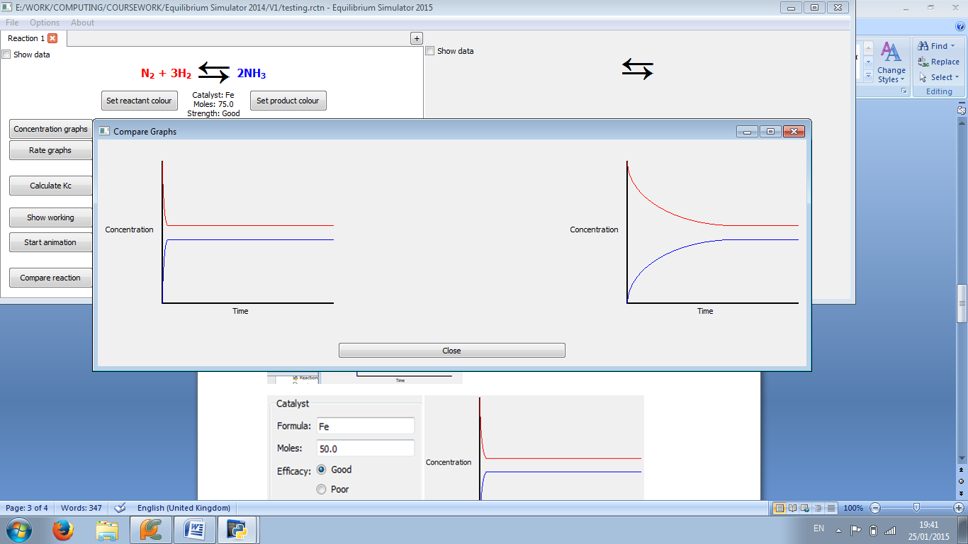

Figure 4.3.1: The graph is steeper at 75 moles (right) than at 25 (left)

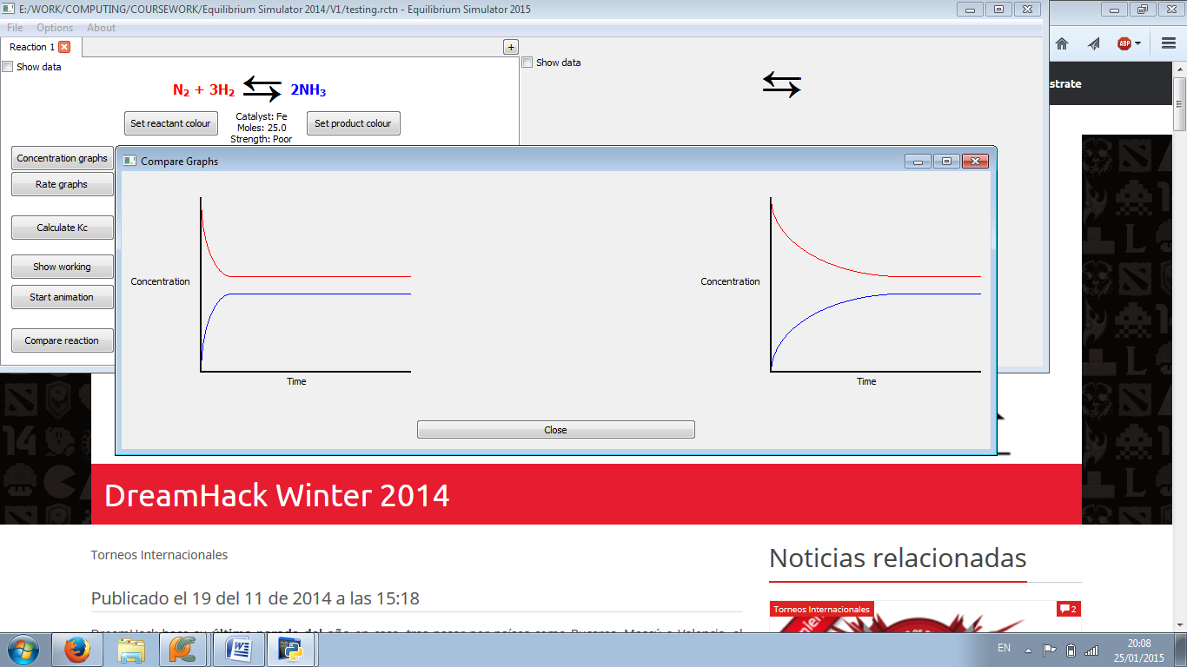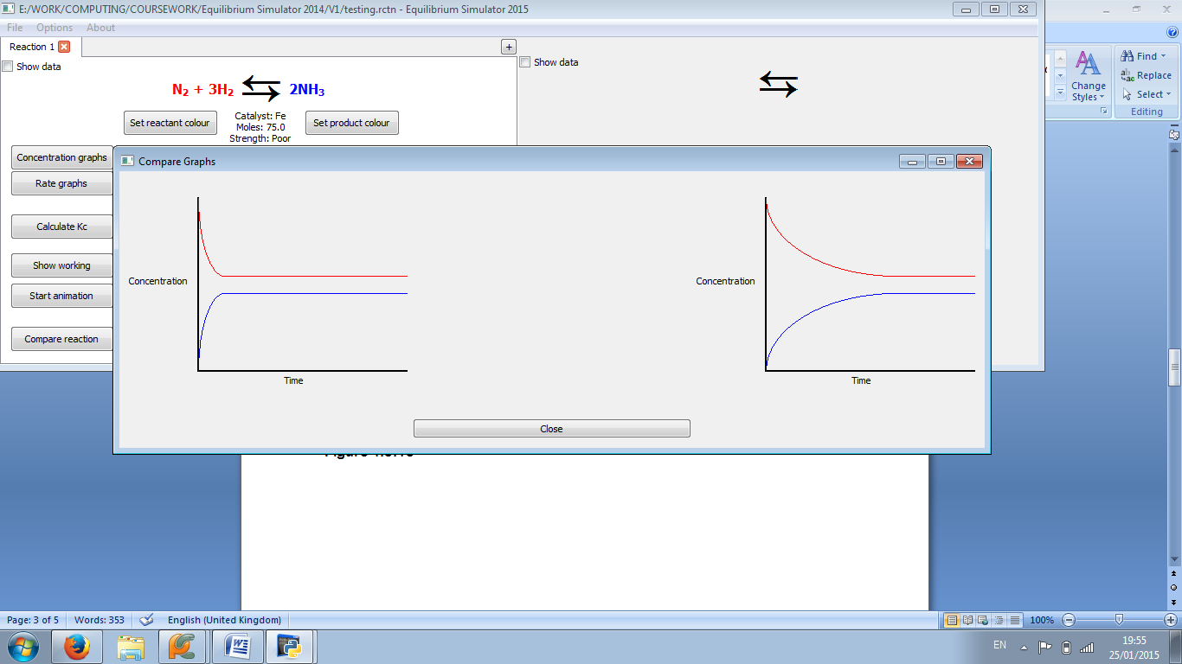

Figure 4.3.2: The graph is steeper at 75 moles (right) than at 25 (left)

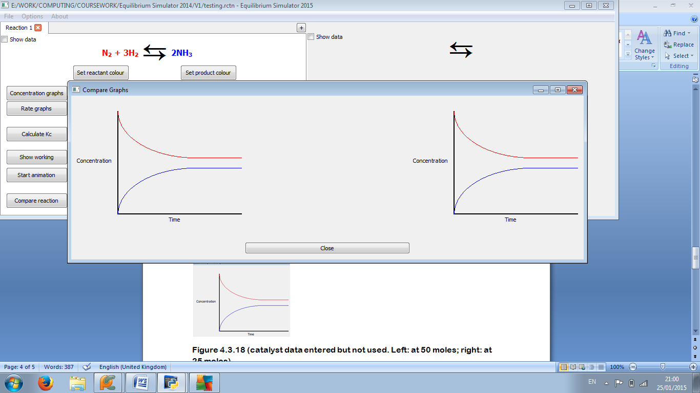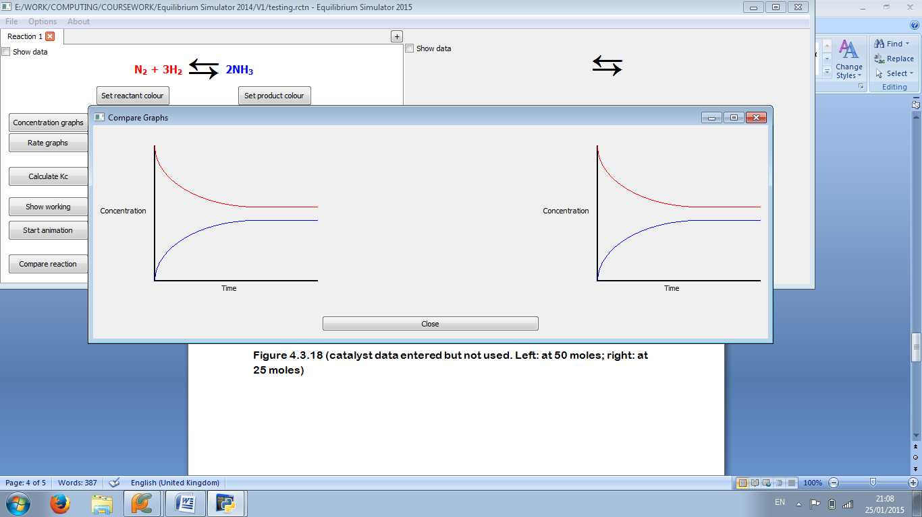

Figure 4.3.3: The two graphs are identical. (Catalyst data entered but not used. Left: at 25 moles; right: at 75 moles)

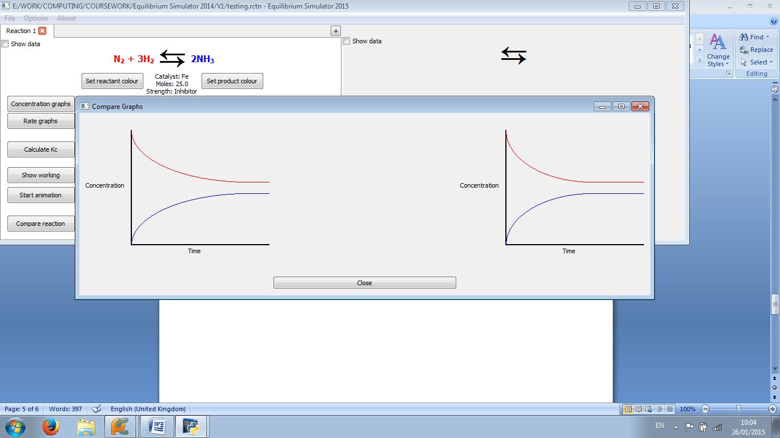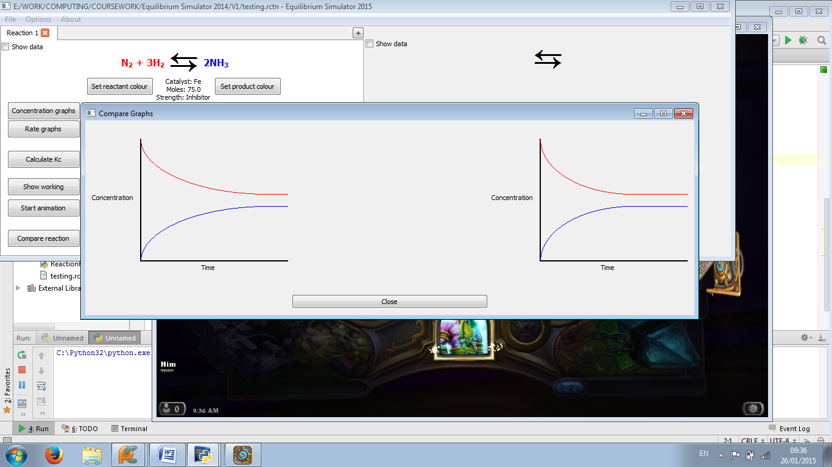

Figure 4.3.4: The graph is steeper at 25 moles (left) than at 75 (right)

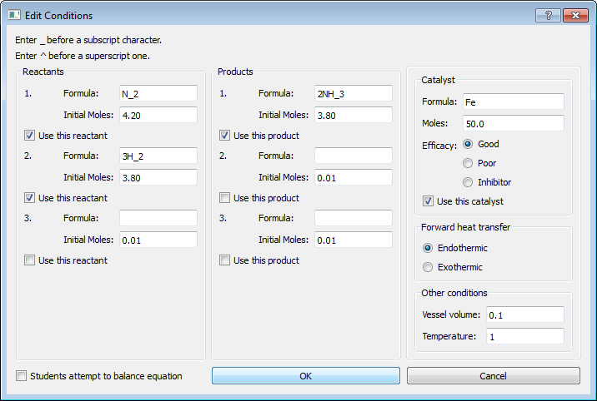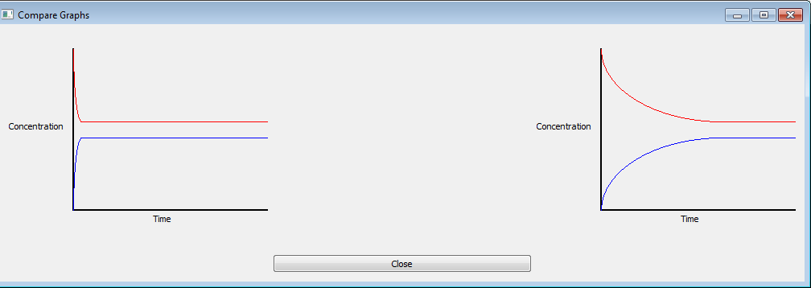  
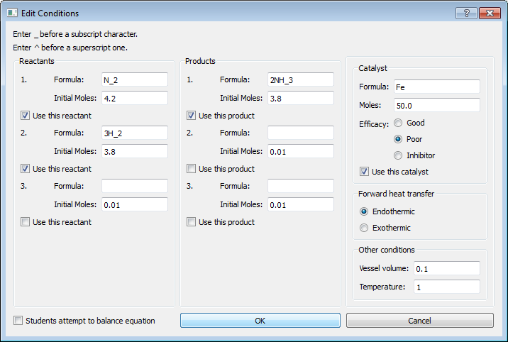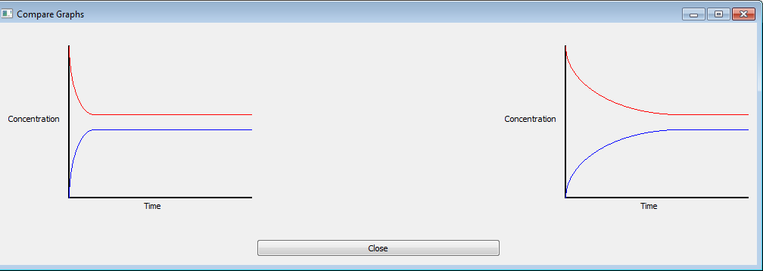  
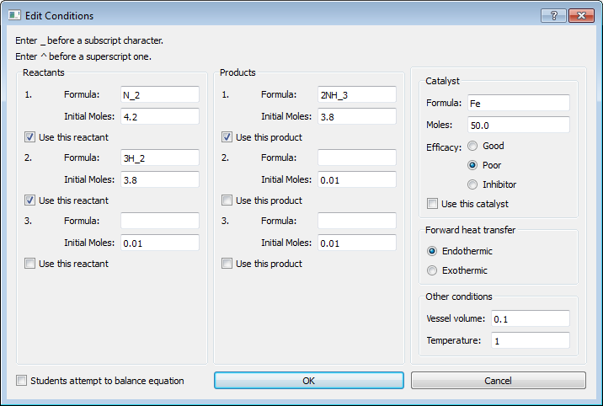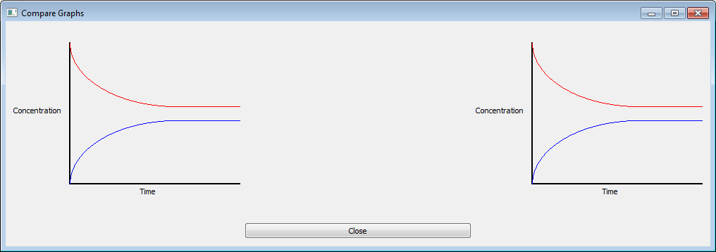  
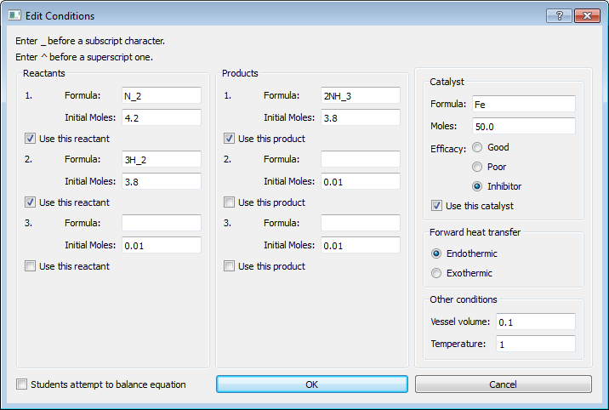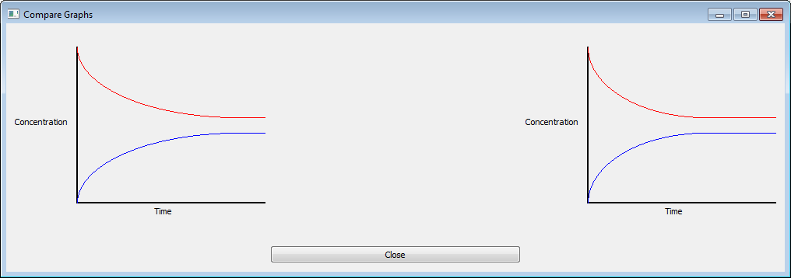

Figure 4.3.5: A clear decrease in steepness of the curve can be seen from good (top) to inhibitor (bottom) strength

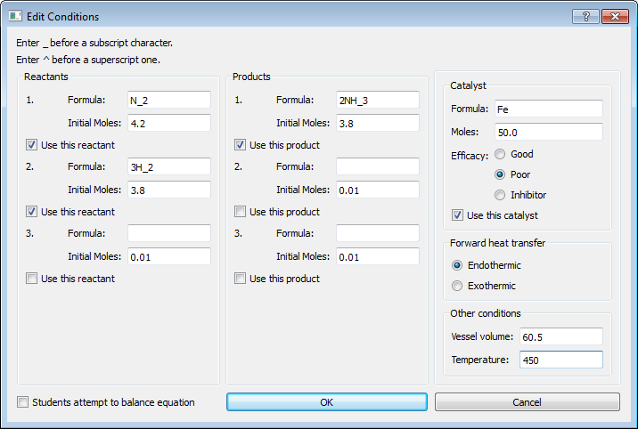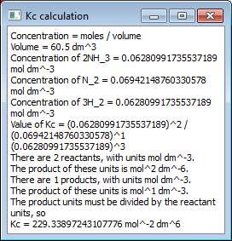

Figure 4.3.6: Popup box appears (right) showing correct working and calculation, except for units of Kc, which are initially miscalculated but not in the final answer

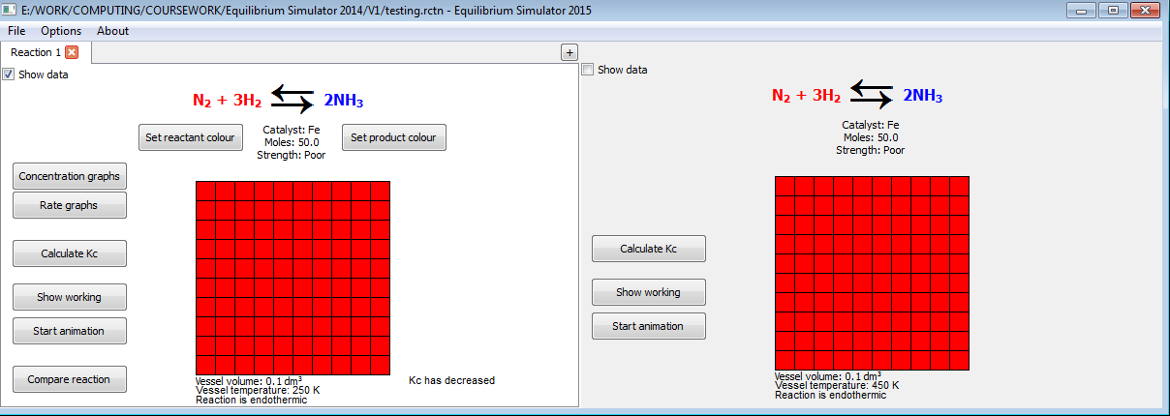

Figure 4.3.7: Text appears (left-hand side), explaining that Kc has decreased

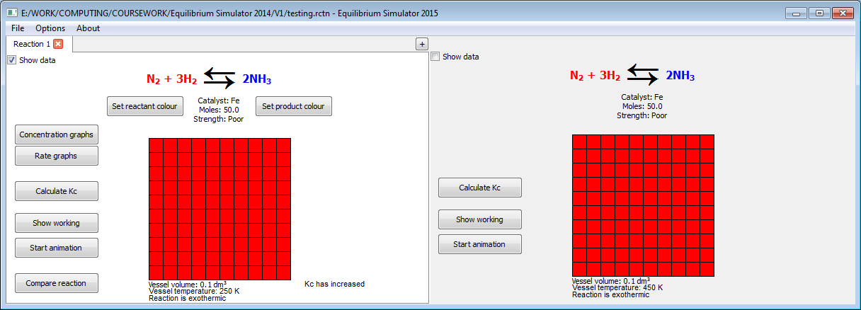

Figure 4.3.8: Text appears (left-hand side), explaining that Kc has decreased

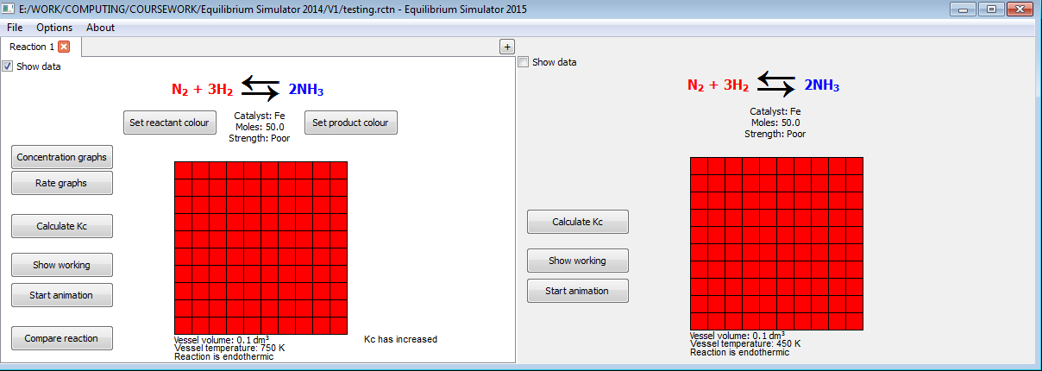

Figure 4.3.9: Text appears (left-hand side), explaining that Kc has increased

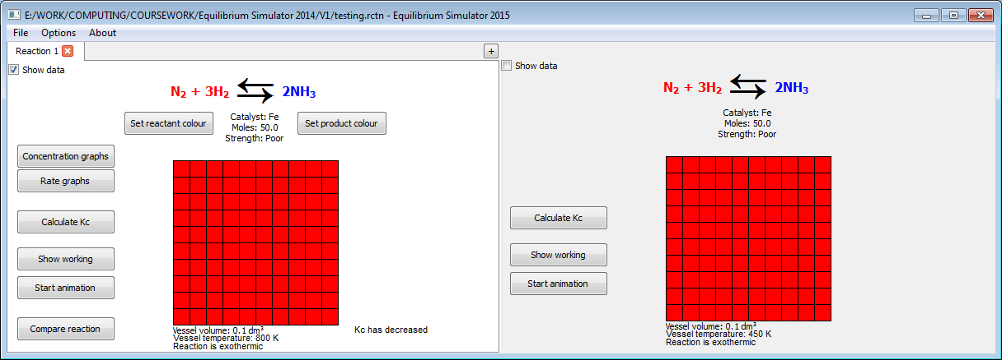

Figure 4.3.10: Text appears (left-hand side), explaining that Kc has decreased

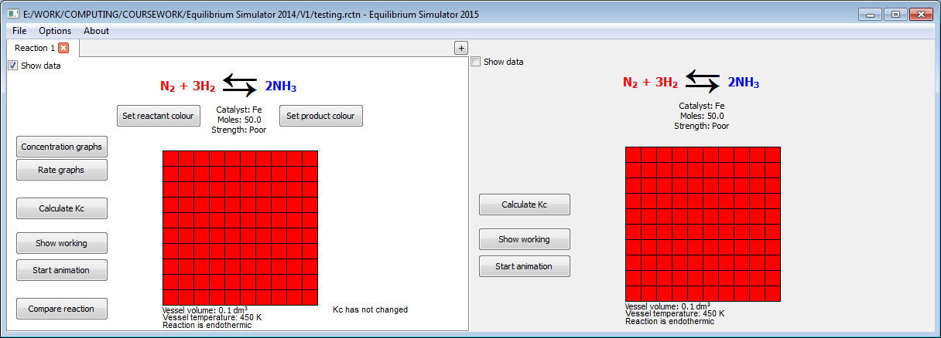

Figure 4.3.11: Text appears (left-hand side), explaining that Kc has not changed

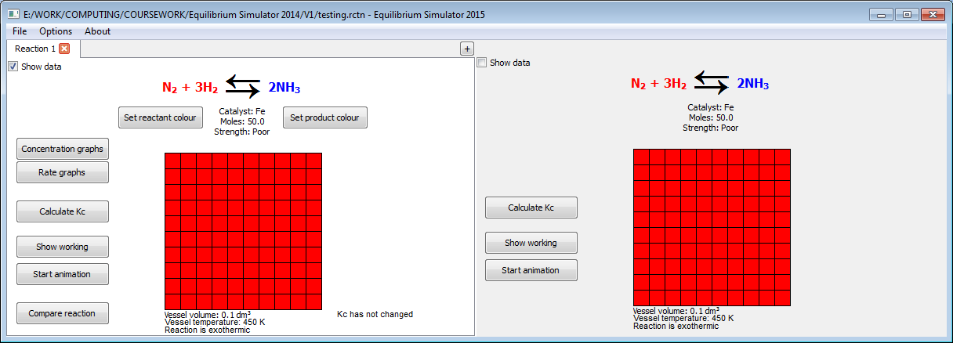

Figure 4.3.12: Text appears (left-hand side), explaining that Kc has not changed

4.3.2: Failed tests

Source code involved in test 11:

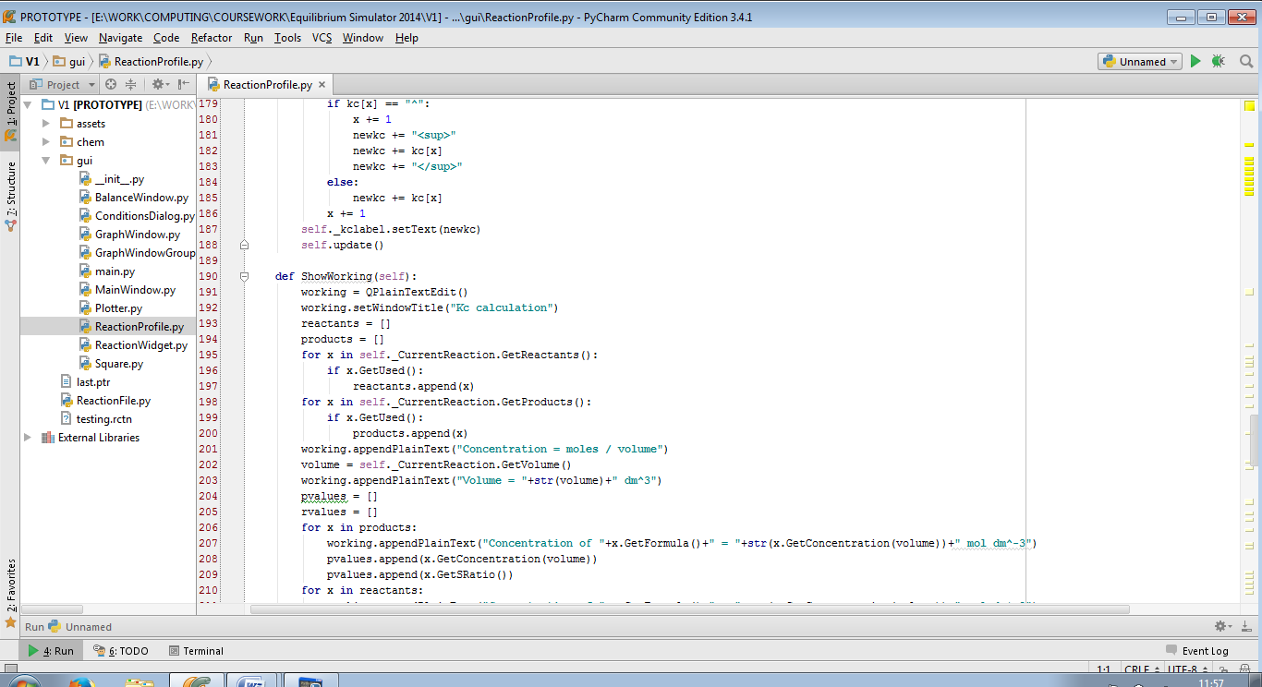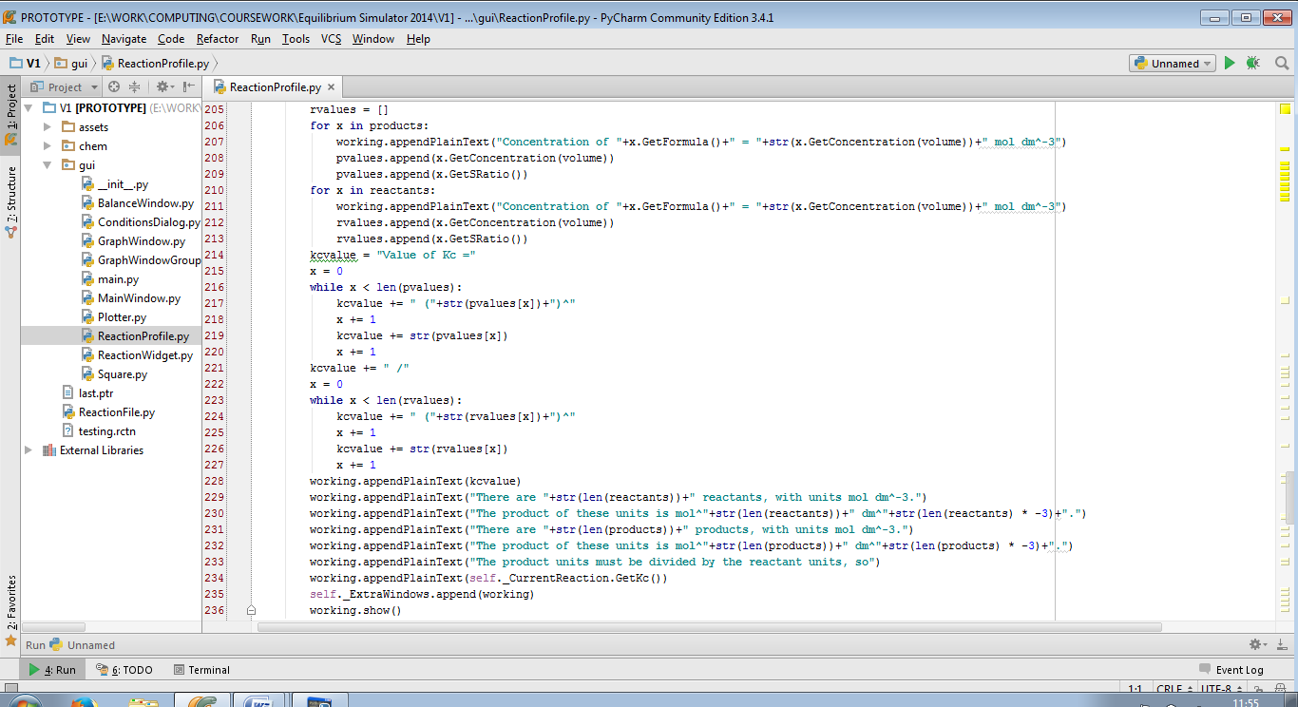

The code passed overall as it came to a final value which is actually more precise than the value calculated before testing. However, there is an error in some of the working produced: the powers involved in the concentration are calculated from an incorrect algorithm (lines 229-232).

Amended source code:

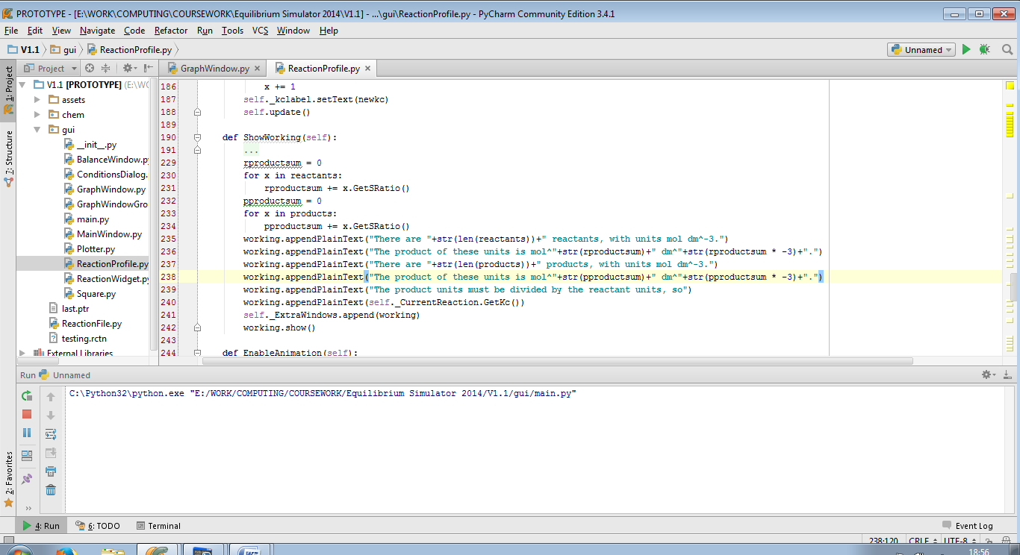

The code now fully passes test 11:

|  |  |  |  |
| --- | --- | --- | --- |
| 11 | On clicking “OK” in “Invalid Data” dialog | Pass | Figure 4.3.13 |

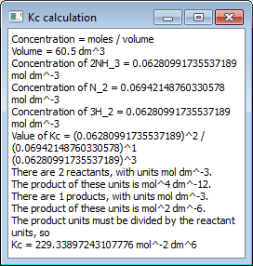

Figure 4.3.13: A popup box appears (right), showing all working correctly